DOI:
Available at (PDF):
UDC 624.131.6

INFORMATION MATERIALS FOR ASSESSING THE IMPACT OF CLIMATE FACTORS ON FORMING SOIL WATER REGIME ON DRAINED LANDS

G.V. Voropay¹, Ph.D. in Technical Sciences, I.V. Kotykovich², Ph.D. in Technical Sciences, L.V. Kuzmych³, Dr. in Technical Science, N.B. Moleshcha⁴, Ph.D. in Technical Sciences, O.I. Kharlamov⁵, Ph.D. in Technical Sciences, D.O. Stozhka⁶

¹ Institute of Water Problems and Land Reclamation of NAAS, Kyiv, 03022, Ukraine;
https://orcid.org/0000-0002-5004-0727; e-mail: voropaig@ukr.net;
² Institute of Water Problems and Land Reclamation of NAAS, Kyiv, 03022, Ukraine;
https://orcid.org/0000-0002-1492-3557; e-mail: ikotykovych@gmail.com
³Institute of Water Problems and Land Reclamation of NAAS, Kyiv, 03022, Ukraine;
https://orcid.org/0000-0003-0727-0508, e-mail: kuzmychlyudmyla@gmail.com;
⁴ Institute of Water Problems and Land Reclamation of NAAS, Kyiv, 03022, Ukraine;
https://orcid.org/0000-0002-3207-2573, e-mail: sdp_2010@ukr.net;
⁵ Institute of Water Problems and Land Reclamation of NAAS, Kyiv, 03022, Ukraine;
https://orcid.org/0000-0002-9019-3445, e-mail: lharlam91l@gmail.com;
⁶ Institute of Water Problems and Reclamation of NAAS, Kyiv, 03022, Ukraine;
https://orcid.org/0009-0008-5470-9409, e-mail: dimonstyozka@gmail.com

Abstract. The research results on creating information materials for assessing the impact of modern climatic factors on the formation of soil water regimes on drained lands are presented. By the results of the research, carried out at the "Romen" drainage and irrigation system (Sumy region), it was established that over the past 34 years, the average air temperature during the growing season has varied from 14,2 to 19,4 ºC. In general, there is a trend for its slight decrease (almost by 0,2 ºC). The highest average monthly air temperatures are recorded in July and August, and the lowest ones - in April. It was specified that the water regime of the active soil layer during the growing season is formed mainly due to moderate (4–14 mm – 44%) and significant (15–49 mm – 40%) precipitation, the total share of which in water reserves is 84%. There is a trend towards an increase in the share of significant precipitation (on average, up to 46–60 % of the total amount during the growing season) in years with high-water growing seasons, and its predominant amount falls in the range of 15–29 mm. There is also an increase in the share of moderate precipitation (up to 49% of the total amount during the growing season) in years with low-water growing seasons.
Information materials on the distribution of atmospheric precipitation by year in quantitative and percentage indicators, their recurrence in the growing seasons of 1990–2022 ("Romen" DIS, Sumy region), presented as an interactive visual report with graphic materials (dashboard) have been created. Informational materials in the form of dashboards enable us to monitor changes in climatic conditions, promptly providing up-to-date data when forecasting future trends in changes in the water supply of agricultural territories, in particular, the formation of the soil water regime on drained lands and addressing the challenges related to climate change.
Keywords: climate change, drained lands, precipitation, air temperature, information materials, soil water regime

Relevance of research. Global climate change is a modern challenge for the world, as it significantly affects agricultural production - one of the most climate-dependent sectors of the economy, and endangers food production [1-3]. Climate change can cost the world about 5% of GDP every year, and if the most pessimistic forecasts are implemented, this figure can grow to 20% [4]. The consequences of climate change are becoming more and more noticeable in Ukraine as well. Today, Ukraine is one of the leading producers and exporters of food in the world. Therefore innovative and investment development of the domestic agro-industrial complex is very relevant. At the same time, our country is already trying to implement its competitive advantages and consider its national interests. Therefore, despite all the existing risks and challenges under climate change and Russian military aggression, domestic agricultural production has to meet the requirements of national security [4, 5].
Modern climate change significantly affects agricultural production since it leads to a lack of available moisture on agricultural lands, which is the main limiting factor for the sustainable functioning of agriculture [6, 7]. The impact of weather conditions on yield productivity is about 52% [8].
Therefore, in modern conditions, agriculture needs the development and implementation of adaptive measures, which will enable us to reduce the negative effects of climate change and ensure the competitiveness and sustainable development of the agricultural sector.
Given that agriculture is one of the main branches of the Ukrainian economy, the share of which is 10% of GDP, there is a need to improve existing agricultural production models and optimize the management technologies in agriculture given modern climate change [5].
Analysis of the latest research and publications shows that the impact of climate change on the production of agricultural products will have a mostly negative effect. With a global warming of 2 °C, many countries will lose up to 20% of crop yields [3].
Climate changes in Ukraine are happening faster than global ones. Since 1991, each decade has been warmer than the previous one. The average annual temperature in Ukraine from 1961 to 1990 was +7,8 °C, and from 2010 to 2019 it has already reached +9,6 °C. The absolute maxima of air temperature have increased by 1–4 °C, and temperature indices are becoming more equal across the country's territory [3]. At the same time, in the drainage zone, the increase in average annual air temperature is quite significant: in the western regions – by 1,2–1,3 °C, in the northern and central regions – by 1,4–1,5 °C [9, 10].
According to the estimates of world and domestic climatologists, in the future, there is a high probability of a further increase in air temperature both on a global scale and in various natural and climatic regions of Ukraine [11, 12].
Atmospheric precipitation is one of the main factors determining the features of the regional climate. The amount and seasonal precipitation distribution are key factors in forming a water regime on agricultural lands.
Literary sources indicate that current fluctuations in average annual precipitation are within the climatic norm (5–10%). With a slight change in the precipitation amount, its nature and intensity have changed noticeably for the territory of Ukraine [13]. The number of cases when half or a monthly precipitation norm falls in a few hours has increased [14].
The study of precipitation in modern climate change conditions is relevant for adapting the economy, especially the agricultural sector [15]. A significant amount of scientific research, which uses various methods, databases, and scientific approaches, is devoted to studying the processes of precipitation formation and its structural features. The dynamics of precipitation, its spatial distribution, duration, and repeatability in different regions are evaluated [16, 17]. Domestic scientists mostly study the formation conditions and statistical characteristics of heavy rains and downpours and assess their impact on the natural environment [18,19].
Literary sources indicate that at the beginning of the XXI century, in Ukraine in general and in the drainage zone, there was a tendency to increase the number of heavy downpours (precipitation of 30 mm or more that falls in 1 hour or less). Heavy downpours from 1986 to 2015 were observed in Ivano-Frankivsk and Transcarpathian regions, slightly less in Kyiv, Cherkasy, Chernivtsi, and Lviv regions. From 2001 to 2010, the amount of heavy downpours increased more than twice compared to 1991–2000. And from 2011 to 2015, the amount of heavy downpours in Kyiv and Chernihiv regions increased significantly [20, 21].
Precipitation is one of the most variable meteorological factors in time and space. There are very few detailed studies today on the features of its structure, formation, and fluctuations. The reasons for precipitation fluctuations are also insufficiently studied, although some connections with solar activity and the rhythmicity of macro-scale synoptic processes have been identified. The reasons for cyclicity have not been definitively elucidated; there are only hypotheses about their origin [14, 16].
Despite the wide range of possible future changes in the average amount of atmospheric precipitation, it is predicted that extreme precipitation in all seasons may become more intense, which will cause an increase in the number of wettest days of the year by 10–25% as well as surface runoff and rain floods by the end of the century [10, 22].
Therefore, an increase in air temperature and uneven distribution, change in the nature, intensity, and structure of precipitation, as well as an increase in the number of heavy downpours, which have a local character in the warm period of the year, do not make it possible to ensure the effective accumulation of moisture in the soil. Given modern changes in natural moisture supply, an important limiting factor in efficiently managing agricultural production is moisture reserves in the active soil layer, the necessary amount of which is not provided during the growing season [6, 9].
It is necessary to obtain improved parameters of water regulation technologies that take into account the entire complex of factors affecting the formation of the moisture regime in the aeration zone to solve the modern problems of managing agricultural systems, namely, the water regime of the soil on drained lands in the conditions of climate change.
Given the results of analytical studies, the research of climate change at both the regional and local levels and the creation of informational materials for assessing the impact of modern climatic factors on the formation of soil water regimes are relevant today.
The purpose of the research is to create informational materials for assessing the impact of climatic factors on the formation of soil water regimes on drained lands.
Methods and objects of the research. Informational materials for assessing the impact of modern climatic factors on the formation of soil water regime were created, based on the results of meteorological measurements in the growing seasons of 1990–2023 on reclaimed lands of the drainage and irrigation system (DIS) "Romen" (Sumy region).
The basis of methodological approaches to field studies is applying generally accepted methods of conducting meteorological observations of air temperature and atmospheric precipitation during the growing season.
The values of average daily, decadal, and monthly air temperatures and daily, monthly, and yearly atmospheric precipitation were determined to obtain information materials on the impact of climatic factors on the formation of soil water regimes. Calculations, creation of smart tables, and interactive graphical and visual reports (dashboards) were made using the Microsoft Office Excel program.
Research results and discussion. To analyze the impact of climatic factors on the formation of soil water regimes, such meteorological factors as air temperature and atmospheric precipitation were considered.
Informational materials on air temperature values during the growing season of 1990–2023 on reclaimed lands of the "Romen" DIS are presented in Table 1 and Fig. 1.
According to the results of analyzing the given materials, it was established that the average air temperature during the growing season over the past 34 years varied from 14.2 to 19.4 ºC. There is a general trend towards a slight decrease (by almost 0.2 °C) in the average air temperature during the growing season. The highest average monthly air temperature values were recorded in July and August, and the lowest in April.
Atmospheric precipitation is one of the main factors that determines the features of regional climate, so their amount and distribution are determining indicators in the formation of the territory's moisture regime [23].
Informational materials on the distribution of atmospheric precipitation by months of the growing seasons of 1990–2023 on the reclaimed lands of the "Romen" DIS are given in the Table. 2.
The dynamics of atmospheric precipitation in the growing seasons of 1990–2023 on the reclaimed lands of the "Romen" DIS is shown in Fig. 2. The results of the analysis show the presence of a tendency to a slight decrease in the total amount of precipitation during the growing seasons. During the studied period, 2006, 1995, 2022, and 1990 years were the wettest with the precipitation amount for a growing season, 584,8, 540,5, 493,6, and 435,6 mm, respectively. The lowest precipitation for a growing season was recorded in 2011, 2017, and 2002, with the values 202.1, 209,7, and 210,1 mm, respectively.
1. Average monthly air temperature (ºC) for the growing season of 1990–2023 ("Romen" DIS)
Year | Month |  |  |  |  |  |  | Average for a growing season
 | April | May | June | July | August | September
1990 | 9.6 | 14.7 | 17.3 | 19.1 | 18.0 | 12.6 |  | 15.2
1991 | 9.0 | 14.0 | 20.3 | 21.9 | 19.0 | 17.8 |  | 17.0
1992 | 6.5 | 13.8 | 19.1 | 20.4 | 21.9 | 13.1 |  | 15.8
1993 | 7.4 | 16.1 | 16.6 | 18.1 | 17.0 | 9.7 |  | 14.2
1994 | 10.7 | 13.4 | 16.7 | 21.1 | 19.2 | 18.5 |  | 16.6
1995 | 9.2 | 14.2 | 21.5 | 21.7 | 19.2 | 14.2 |  | 16.7
1996 | 8.6 | 19.4 | 19.9 | 20.8 | 19.9 | 15.7 |  | 17.4
1997 | 6.8 | 16.6 | 20.3 | 19.4 | 18.3 | 10.4 |  | 15.3
1998 | - | 14.1 | 19.2 | 20.1 | 17.2 | 12.5 |  | 16.6
1999 | 10.7 | 15.7 | 22.1 | 22.1 | 19.1 | 12.6 |  | 17.1
2000 | 11.8 | 12.5 | 16.7 | 20.1 | 24.6 | 13.2 |  | 16.5
2001 | 10.7 | 13.2 | 16.0 | 23.6 | 20.2 | 12.8 |  | 16.1
2002 | 8.4 | 13.3 | 19.4 | 23.8 | 18.6 | 13.7 |  | 16.2
2003 | 4.8 | 17.6 | 17.5 | 21.0 | 18.3 | 12.9 |  | 15.4
2004 | 8.0 | 12.3 | 17.1 | 19.5 | 20.4 | 13.7 |  | 15.2
2005 | 9.8 | 17.0 | 17.3 | 21.6 | 19.7 | 14.3 |  | 16.6
2006 | 8.4 | 13.5 | 18.7 | 19.9 | 20.3 | 15.1 |  | 16.0
2007 | 7.3 | 18.4 | 20.4 | 21.2 | 21.7 | 14.5 |  | 17.3
2008 | 10.4 | 13.2 | 19.7 | 20.9 | 21.4 | 13.1 |  | 16.5
2009 | 7.5 | 13.2 | 20.6 | 21.9 | 18.9 | 16.3 |  | 16.4
2010 | 9.7 | 16.6 | 20.7 | 25.1 | 25.0 | - |  | 19.4
2011 | 8.1 | 17.5 | 22.5 | 24.2 | 21.3 | 15.4 |  | 18.2
2012 | 12.6 | 18.9 | 19.6 | 21.9 | 19.7 | 14.5 |  | 17.9
2013 | 7.1 | 18.9 | 20.3 | 20.1 | 18.1 | 8.2 |  | 15.5
2014 | 9.7 | 16.5 | 19.0 | 20.3 | 20.1 | 13.2 |  | 16.5
2015 | 9.2 | 15.3 | 18.4 | 19.7 | 21.1 | 17.2 |  | 16.8
2016 | 10.4 | 13.5 | 18.7 | 20.8 | 18.8 | 12.5 |  | 15.8
2017 | 7.8 | 11.1 | 16.4 | 19.5 | 20.2 | 13.7 |  | 14.8
2018 | 8.8 | 16.4 | 17.9 | 19.4 | 20.2 | 16.1 |  | 16.5
2019 | 8.8 | 14.6 | 20.4 | 17.4 | 17.5 | 12.8 |  | 15.3
2020 | 7.1 | 11.6 | 21.2 | 19.8 | 18.6 | 16.5 |  | 15.8
2021 | 6.3 | 13.1 | 19.4 | 23.9 | 21.3 | 11.2 | 15.9
2022 | 6.5 | 11.7 | 19.3 | 19.3 | 19.7 | 10.8 | 14.6
2023 | 9.1 | 13.8 | 17.8 | 19.7 | 21.6 | 16.5 | 16.4
Average | 8.7 | 14.9 | 19.1 | 20.9 | 19.9 | 13.8 | 16.3

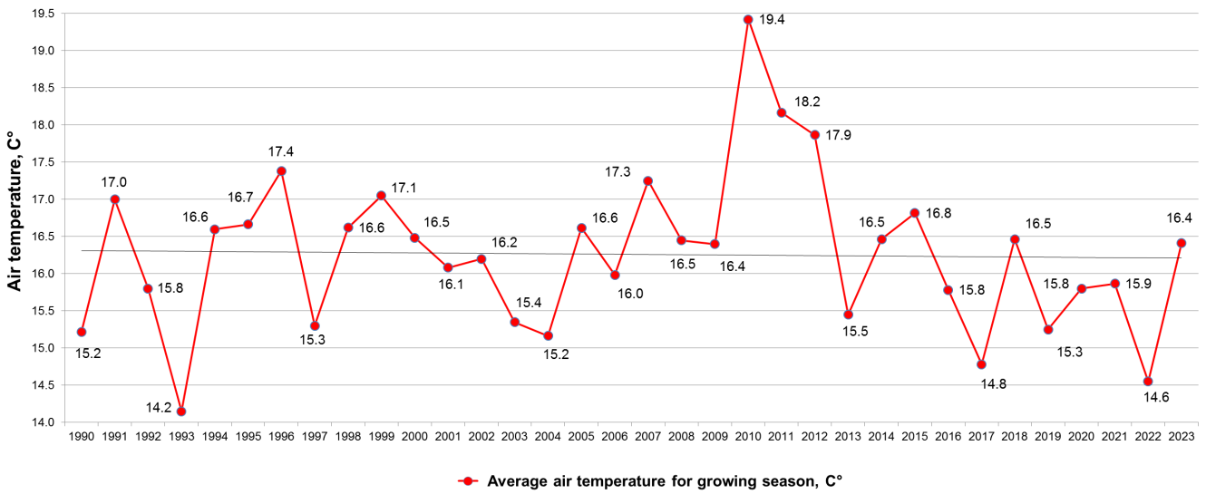
Fig. 1 Dynamics of the average monthly air temperature for the growing season of 1990–2023 ("Romen" DIS)

2. Atmospheric precipitation (mm) for the growing season of 1990–2023 ("Romen" DIS)
Year | Month |  |  |  |  |  | In total for a growing season
 | April | May | June | July | August | September
1990 | 92.5 | 63.3 | 70.9 | 87.6 | 70.8 | 50.5 | 435.6
1991 | 42.0 | 63.7 | 35.7 | 57.6 | 30.6 | 15.9 | 245.5
1992 | 38.1 | 38.7 | 21.8 | 58.6 | 14.2 | 65.1 | 236.5
1993 | 51.5 | 24.8 | 70.9 | 103.1 | 44.2 | 88.0 | 382.5
1994 | 31.3 | 61.2 | 51.4 | 23.8 | 46.4 | 23.4 | 237.5
1995 | 81.8 | 52.1 | 138.6 | 27.3 | 68.1 | 172.6 | 540.5
1996 | 16.8 | 48.0 | 76.2 | 36.7 | 78.1 | 84.0 | 339.8
1997 | 47.5 | 33.1 | 56.2 | 76.9 | 25.7 | 62.3 | 301.7
1998 | - | 53.4 | 9.9 | 144.8 | 134.4 | 57.7 | 400.2
1999 | 17.4 | 67.3 | 16.6 | 64.3 | 34.3 | 22.6 | 222.5
2000 | 40.6 | 34.4 | 42.4 | 97.0 | 12.0 | 136.7 | 363.1
2001 | 31.6 | 54.5 | 173.2 | 74.2 | 18.2 | 56.2 | 407.9
2002 | 22.9 | 74.5 | 23.6 | 6.2 | 31.7 | 51.2 | 210.1
2003 | 43.0 | 18.9 | 15.2 | 162.9 | 95.2 | 50.8 | 386.0
2004 | 22.3 | 68.9 | 49.2 | 102.6 | 16.3 | 61.2 | 320.5
2005 | 33.2 | 30.4 | 139.8 | 28.0 | 25.0 | 8.3 | 264.7
2006 | 35.7 | 152.1 | 95.1 | 117.6 | 108.3 | 76.0 | 584.8
2007 | 18.1 | 38.9 | 106.2 | 52.2 | 38.0 | 58.4 | 311.8
2008 | 49.7 | 37.5 | 93.8 | 119.8 | 9.3 | 51.3 | 361.4
2009 | 2.8 | 43.3 | 30.7 | 107.0 | 6.8 | 51.1 | 241.7
2010 | 18.3 | 32.8 | 27.5 | 114.5 | 19.7 | 39.8 | 252.6
2011 | 14.0 | 14.9 | 40.5 | 87.2 | 38.5 | 7.0 | 202.1
2012 | 53.7 | 14.7 | 33.5 | 21.2 | 67.6 | 45.4 | 236.1
2013 | 16.5 | 62.8 | 50.2 | 41.9 | 102.6 | 111.0 | 385.0
2014 | 35.7 | 105.5 | 51.3 | 98.6 | 14.2 | 39.9 | 345.2
2015 | 25.7 | 108.2 | 83.1 | 63.0 | 1.8 | 47.7 | 329.5
2016 | 52.3 | 145.4 | 87.1 | 77.5 | 46.1 | 4.3 | 412.7
2017 | 27.2 | 20.2 | 56.4 | 72.8 | 6.9 | 26.2 | 209.7
2018 | 11.3 | 28.1 | 123.1 | 78.9 | 7.0 | 55.5 | 303.9
2019 | 33.7 | 72.1 | 26.6 | 36.9 | 17.2 | 33.4 | 219.9
2020 | 37.1 | 148.8 | 73.4 | 71.9 | 12.4 | 17.2 | 360.8
2021 | 75.3 | 52.3 | 118.5 | 39.3 | 46.0 | 83.0 | 414.4
2022 | 89.5 | 32.3 | 69.8 | 106.1 | 55.3 | 140.6 | 493.6
2023 | 46.3 | 8.4 | 60.9 | 51.4 | 56.6 | 11.0 | 232.9
Average | 36.9 | 56.0 | 65.3 | 73.8 | 41.2 | 56.0 | 329.2
% | 11.2 | 17.0 | 19.8 | 22.4 | 12.5 | 17.0 | 100.0

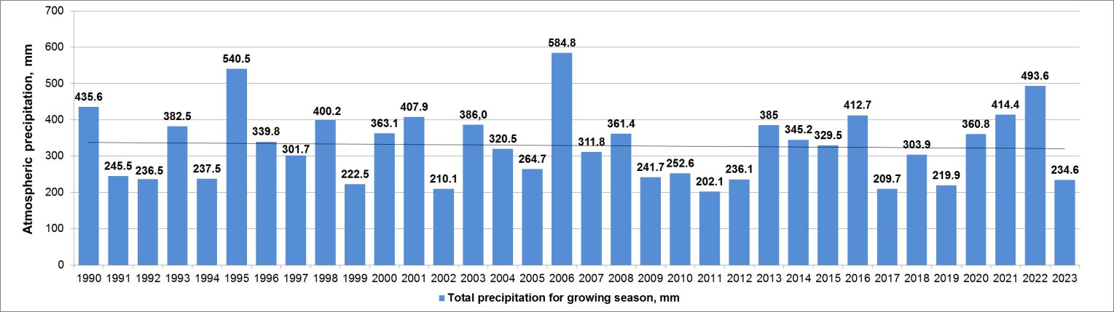
Fig. 2 Dynamics of atmospheric precipitation for the growing season of
1990–2023 ("Romen" DIS)

Atmospheric precipitation is one of the main factors that determines the features of regional climate, so their amount and distribution are determining indicators in the formation of the territory's moisture regime [23].
The categorization of precipitation amounts was made by the instruction on meteorological forecasting following the gradation: light (<3 mm), moderate (4–14 mm), significant (15–29 mm, 30–39 mm and 40–49 mm), heavy (50–59 mm, 60–69 mm and 70–79 mm) and extreme precipitation (80–89 mm and 90–100 mm) [24].
It was determined that the water regime of the active soil layer during the growing season is formed mainly due to moderate (4–14 mm – 44%) and significant (15–49 mm – 40%) precipitation, the total share of which is 84%.
The distribution of precipitation (by repetition and average intensity) by months of the growing season (1990–2022) is shown in Fig. 3.
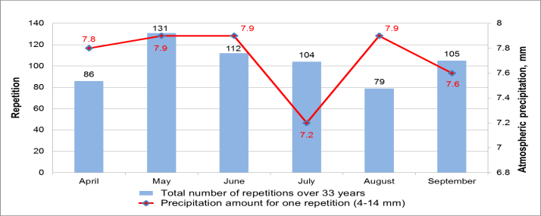  а | 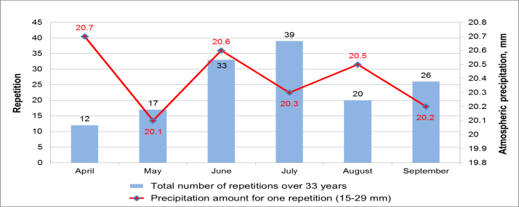  б
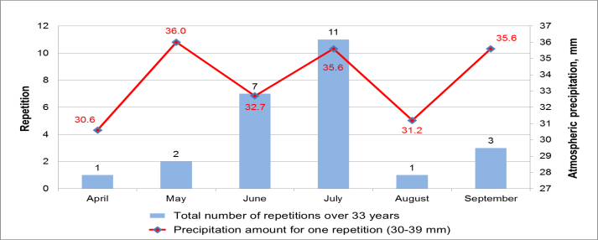  в | 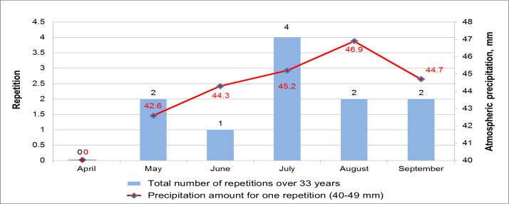  г

Fig. 3 Distribution of moderate and significant precipitation (by repetition and average intensity) for the growing season of 1990–2022 ("Romen" DIS):
a – moderate (4–14 mm); b – significant (15–29 mm); c – significant (30–39 mm); d – significant (40–49 mm)

The trend towards an increase in the share of significant precipitation can be traced in years with high-water growing seasons. Thus, in 2006, the total amount of precipitation for the growing season was 584,8 mm. At the same time, the share of moderate precipitation was 33,4% (195,4 mm), and significant – 59,7% (349,3 mm) for the growing season (Fig. 4). The predominant amount (221,1 mm) of significant precipitation falls in the range of 15–29 mm. The largest amount of precipitation for the growing season was recorded in May (152,1 mm) and July (117,6 mm) (Table 2).
In 2022, the total amount of precipitation for the growing season was 493.6 mm. At the same time, the share of moderate precipitation was 39,7% (196,1 mm), and significant – 49,6% (244,6 mm) for the growing season (Fig. 5). The predominant amount (111.4 mm) of significant precipitation falls in the range of 15–29 mm. The largest amount of precipitation for the growing season was recorded in September (140,6 mm) and July (106,1 mm) (see Table 2).
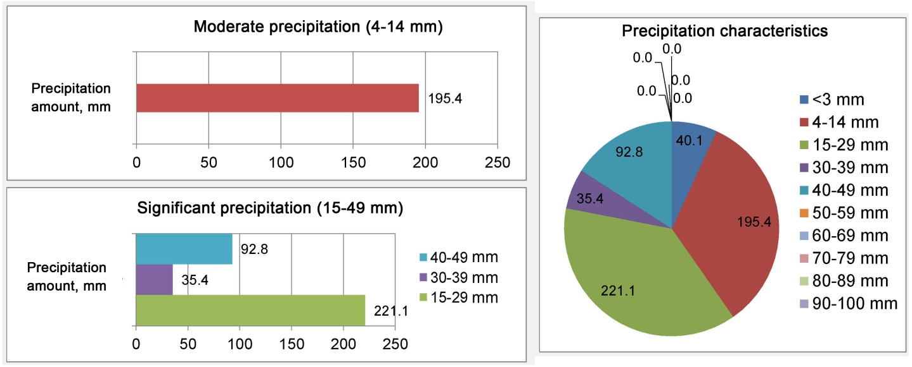
Fig. 4 Distribution of precipitation for the growing season of 2006
(following the gradation by [25]), "Romen" DIS

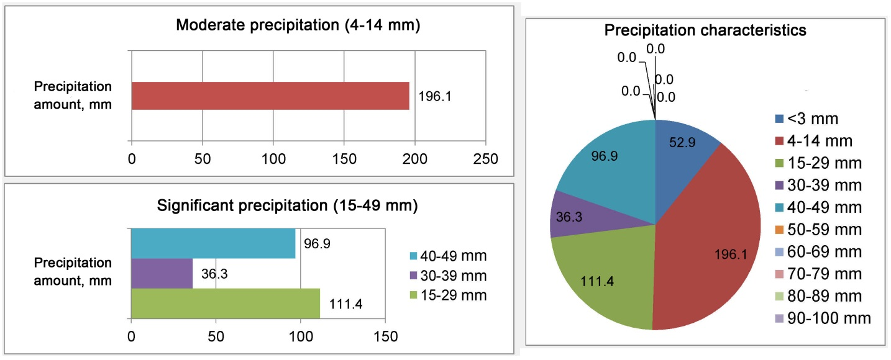
Fig. 5 Distribution of precipitation for the growing season of 2022
(following the gradation by [25]), "Romen" DIS

In 1990, the total precipitation amount for the growing season was 435.6 mm. The growing season of the year was characterized by an increase in the share of significant precipitation, which amounted to 46,0 % (200,3 mm) compared to the average values for the studied period (1990–2023). The share of moderate precipitation was 39,3% (171,3 mm) (Fig. 6). Most significant precipitation (165,0 mm) fell in the range of 15–29 mm. The largest precipitation amount during the growing season was recorded in April (92,5 mm) and July (87,6 mm) (see Table 2).
At the same time, there is a trend towards an increase in the share of moderate precipitation in years with low-water growing seasons.
Thus, in 2011, the total precipitation amount for the growing season was 202.1 mm. At the same time, the share of moderate precipitation was 48.9% (98,6 mm), and significant – 30,1% (61,0 mm) (Fig. 7). Significant precipitation fell in the range of 15–29 mm. The largest precipitation amount for the growing season was recorded in July (87,2 mm) and June (40,5 mm) (see Table 2).

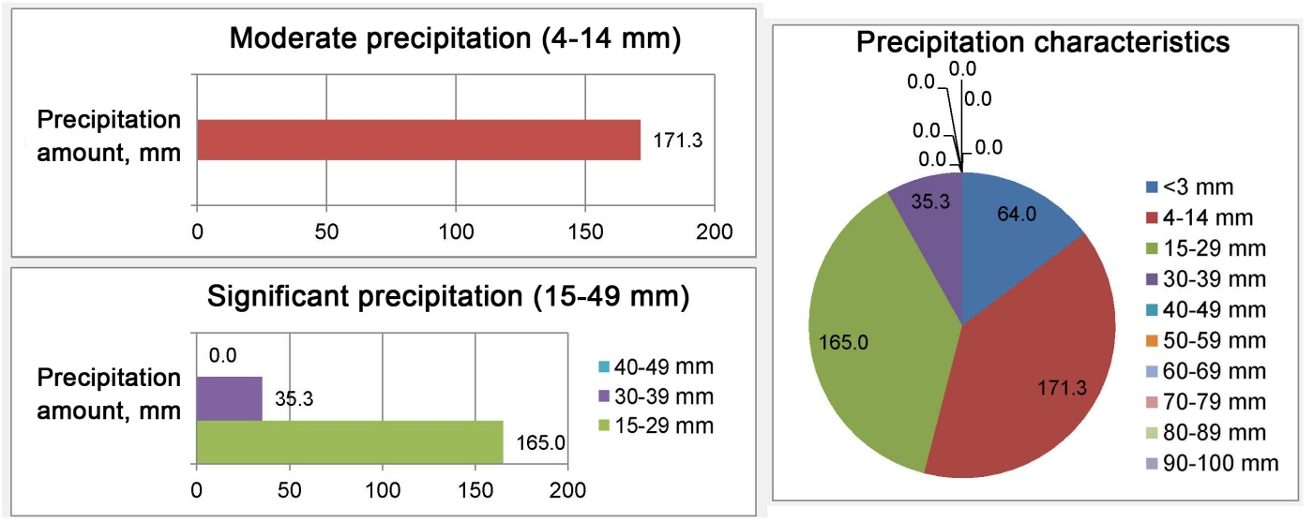
Fig. 6 Distribution of precipitation for the growing season of 1990
(following the gradation by [25]), "Romen" DIS
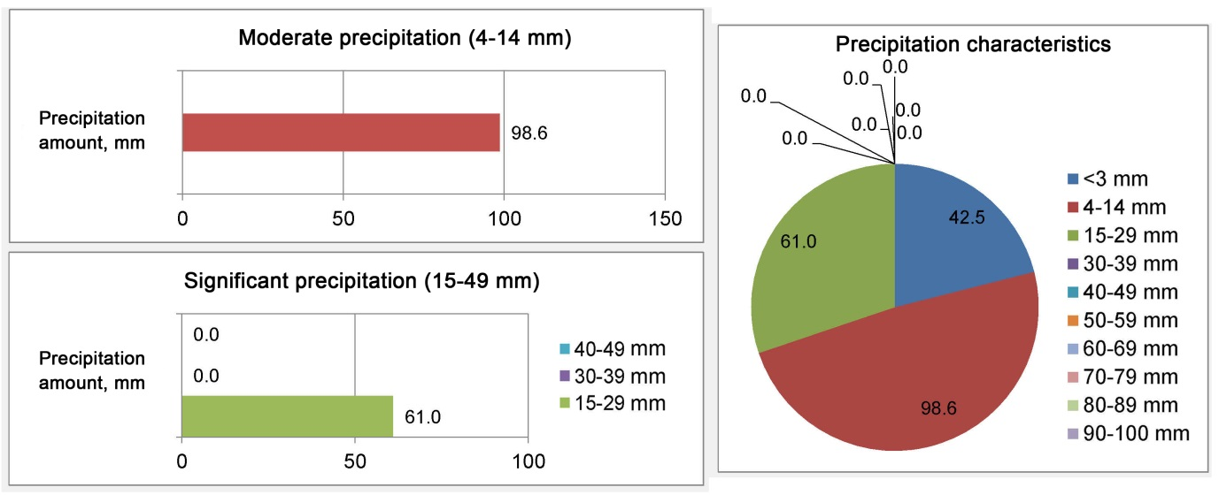
Fig. 7 Distribution of precipitation for the growing season of 2011
(following the gradation by [25]), "Romen" DIS

Similarly, in 2017, the total precipitation amount for the growing season was 209,7 mm. At the same time, the share of moderate precipitation was 49,0% (102,9 mm), and significant – 33,0% (69,0 mm) (Fig. 8). Significant precipitation in almost the same amount (33,8 and 35,2 mm) fell on the ranges of 15–29 and 30–39 mm. The largest precipitation amount for the growing season was recorded in July (72,8 mm) and June (56,4 mm) (see Table 2).

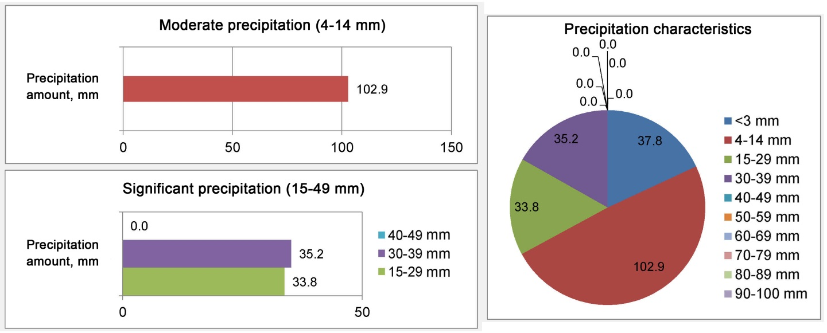
Fig. 8 Distribution of precipitation for the growing season of 2017
(following the gradation by [25]), "Romen" DIS
Information materials on the distribution of atmospheric precipitation by year in quantitative and percentage values, its repetitions for the growing seasons of 1990–2022 ("Romen" DIS, Sumy region) are presented as interactive visual reports (dashboards) with graphic materials that can be the basis of forming an assessment system for soil water regime. Dashboards enable us to visualize data and metrics in a convenient and understandable format, which makes it possible to quickly analyze and make decisions.
A fragment of the developed dashboard is shown in Fig. 9.
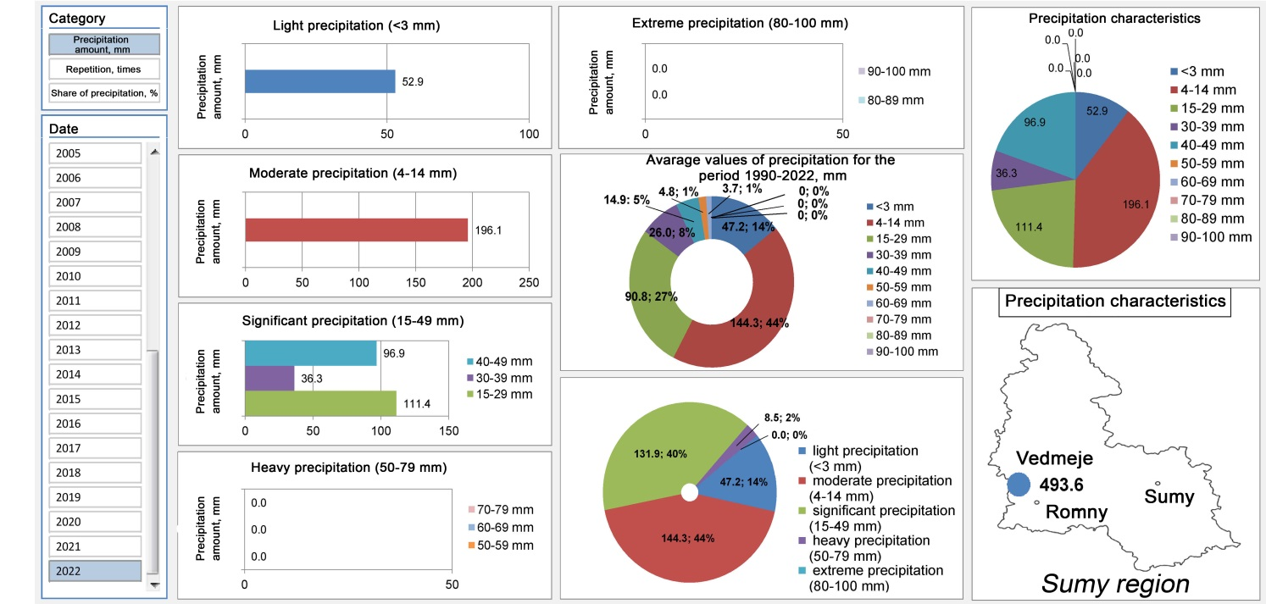
Fig. 9 Fragment of the dashboard for the growing season of 2022 ("Romen" DIS)

The created dashboard consists of graphic materials that display all necessary metrics of precipitation distribution in quantitative and percentage values and its repetitions on one screen. It was made based on smart tables, where the AutoFilter function was added to each header column, which, in turn, determines what should be displayed or, conversely, not displayed at a specific time. Smart tables are a type of formatting, and after applying them to the specified range of data, their array acquires certain properties. First of all, after that, the program begins to consider it not as a range of cells but as a complete element. If an entry is made in any of the cells of a row or column, located directly near the boundaries of a “smart” table, this row or column will be automatically included in the table range [25, 26].
When using smart tables, the perception of an electronic worksheet improves, and data processing becomes easier, as they are adjusted to a certain system. Their use allows you to effectively use the time for data preparation by reducing manual operations, effectively making tables, and quickly using graphic elements.
This possibility proved its effectiveness in processing a large array of data, and the use of dashboards made it possible to display relevant information, form the necessary input data for making the right decision, and monitor the process of changing meteorological data [27, 28].
In general, the creation of information materials with the use of dashboards helps to monitor the changes in climatic conditions, promptly providing relevant data when forecasting future trends of changes in water availability of agricultural areas and solving challenges related to climate change.
Conclusions. To solve the modern problems of managing agricultural systems, namely soil water regime on drained lands in modern conditions of climate change, it is relevant today to study climate change both at the regional and local levels and to create informational materials for assessing the impact of modern climatic factors on forming soil water regime.
According to the results of research carried out at the "Romen" DIS (Sumy oblast), it was established that the average air temperature for the growing seasons over the past 34 years has varied from 14,2 to 19,4 ºC. In general, there is a tendency to a slight decrease (almost by 0,2 ºC) in the average air temperature for a growing season. The highest average monthly air temperatures were recorded in July and August, and the lowest in April.
It was determined that the water regime of the active soil layer during the growing season is formed mainly due to moderate (4–14 mm – 44%) and significant (15–49 mm – 40%) precipitation, the total share of which is 84%. There is an increasing trend in the share of significant precipitation (on average, up to 46–60% of the total amount for a growing season) in the years of high-water growing seasons, and most of it is in the range of 15–29 mm. There is also an increase in the share of moderate precipitation (up to 49% of the total for a growing season) in the years of low-water growing seasons.
Information materials on the distribution of atmospheric precipitation by year in quantitative and percentage values, and their repetitions for the growing seasons of 1990–2022 ("Romen" DIS, Sumy region) were made and presented as interactive visual reports (dashboards) with graphic materials. Dashboards enable us to visualize data and metrics in a convenient and understandable format, which makes it possible to quickly analyze and make decisions. They can be an important component of the information assessment system for forming soil water regimes, which makes it possible to monitor changes in climatic conditions and quickly provide relevant information for forecasting future trends in changing water availability of agricultural areas.

References
- World Meteorological Organization. (2019). The Global Climate in 2015–2019. Retrieved from: www.wmo.int. [in Ukrainian]
- Zhurakovska, L. A.(2021). Priorytety polityky adaptatsii ahrosektoru Ukrainy do zminy klimatu [Priorities of the adaptation policy of the agricultural sector of Ukraine to climate change]. National Institute for strategic studies. Retrieved from: https://niss.gov.ua/doslidzhennya/ekonomika/priorytety-polityky-adaptatsiyi-ahrosektoru-ukrayiny-do-zminy-klimatu [in Ukrainian]
- Adamenko, T. (2022). Tse ne strashylky, a prohnozy zminy klimatu ta yoho vplyvu na ahrovyrobnytstvo [These are not horror stories, but forecasts of climate change and its impact on agricultural production]. APK-INFORM "PIDSUMKY", 09 (75). Retrieved from: https://www.apk-inform.com/uk/exclusive/opinion/1514243 [in Ukrainian]
- Tymchuk, V.M., Tymchuk, S.M. (2016). Vplyv klimatychnykh zmin na vedennia ahrobiznesu [Impact of climate change on agribusiness]. Ahrobiznes Sʹohodni. Retrieved from: https://agro-business.com.ua/agro/idei-trendy/item/8377-vplyv-klimatychnykh-zmin-na-vedennia-ahrobiznesu.html [in Ukrainian]
- Davydovych, V., Varetska, N., Varetskyy, B. (2022). Analiz hlobalnykh zmin klimatu ta ikh vplyv na prodovolchu bezpeku derzhavy [Analysis of global climate changes and their impact on the country's food security]. Klimatychni zminy ta silske hospodarstvo. Vyklyky dlia ahrarnoi nauky ta osvity: zbirnyk materialiv V Mizhnarodnoi naukovo-praktychnoï konferentsii, 15 lystopada 2022 r., Naukovo-metodychnyy̆ tsentr VFPO. Kyiv, 2-7. [in Ukrainian]
- The National Academy of Agrarian Sciences of Ukraine. (2020). V umovakh suchasnykh zmin klimatu riven zvolozhennia na terytorii Ukrainy ye holovnym chynnykom, yakyi obmezhuie produktyvnist roslynnytstva ta potentsial zemlerobstva [In the conditions of modern climate changes, the level of moisture in the territory of Ukraine is the main factor that limits the productivity of crop production and the potential of agriculture]. Retrieved from: http://naas.gov.ua/slide/v-umovakh-suchasnikh-zm-n-kl-matu-r-ven-zvolozhennya-na-teritor-ukra-ni-golovnim-chinnikom-yakiy-obm/ [in Ukrainian]
- Kuzmych, L., Furmanets, O., Usatyi, S., Kozytskyi, O., Mozol, N., Kuzmych, A., Polishchuk, V., & Voropai, H. (2022). Water Supply of the Ukrainian Polesie Ecoregion Drained Areas in Modern Anthropogenic Climate Changes. Archives of Hydro Engineering and Environmental Mechanics, 69(1), 79–96. [in Ukrainian] https://doi.org/10.2478/heem-2022-0006.
- Nechyporenko, O. (2018). Stan ta perspektyvy adaptatsi ahrarnoho sektoru ekonomiky Ukrainy do hlobalnykh zmin klimatu [State and prospects of adaptation of the agricultural sector of the economy of Ukraine to global climate changes]. Ekonomist, 11, 10–14. [in Ukrainian].
- Romashchenko, M. I., Husev, Yu. V., Shatkovskyi, A. P., Saidak, R. V., Yatsiuk, M. V., Shevchenko, A. M., & Matiash, T. V. (2020). Vplyv suchasnykh klimatychnykh zmin na vodni resursy ta silskohospodarske vyrobnytstvo [ Impact of climate change on water resources and agricultural production] Melioratsiia i vodne hospodarstvo, 1, 5−22. [in Ukrainian].
- Wilson, L., New, S., Daron, J., & Golding, N. (2021). Climate Change Impacts for Ukraine. Met Office. Retrieved from: https://mepr.gov.ua/wp-content/uploads/2023/07/2_Vplyv-zminy-klimatu-v-Ukrayini.pdf
- Ukrinform. (2015). Meteorologists are concerned about the dangerous trend growth droughts in Ukraine. (n.d.). www.ukrinform.ua. Retrieved from: https://www.ukrinform.ua/rubric-presshall/1912344-vpliv-zminklimatu-na-vodozabezpechennya- vodospojivannya-i-prodovolchu-bezpeku-zala-1.html.
- UkrHMI. (2013). Zvit pro naukovo-doslidnu robotu «Rozroblennia stsenariiv zminy klimatychnykh umov v Ukraini na seredno- i dovhostrokovu perspektyvu z vykorystanniam danykh hlobalnykh i rehionalnykh modelei» [Development of scenarios of changes in climatic conditions in Ukraine for the medium and long term using data from global and regional models] 135 p. [in Ukrainain]
- Kyrychenko, O. S. (2020). Suchasni osoblyvosti klimatu Ukrainy [Modern features of the climate of Ukraine]. Teoretychni ta prykladni aspekty doslidzhen z biolohii, heohrafii ta khimii: materialy III Vseukrainskoi naukovoi konferentsii studentiv ta molodykh uchenykh. Sumy: FOP Tsoma S.P., 113–116. [in Ukrainian].
- Balabukh V. O. (2018). Zmina intensyvnosti konvektsii v Ukraini: prychyny ta naslidky. [Change in the intensity of convection in Ukraine: causes and consequences.]. Ukrayinsʹkyy hidrometeorolohichnyy tsentr. Retrieved from: http://meteo.gov.ua/files/content/docs/Vinnitsa/UkrGMI.pdf.
- Tatarchuk, O. H. (2019). Kharakterystyka ta rozpodil sylnykh zlyv po terytorii Ukrainy v umovakh suchasnoho klimatu [Characteristics and distribution of heavy downpours on the territory of Ukraine in the conditions of the modern climate] // Vplyv klimatychnykh zmin na prostorovyi rozvytok terytorii Zemli: naslidky ta shliakhy vyrishennia: Zbirnyk naukovykh prats II Mizhnarodnoi naukovo-praktychnoi konferentsii (Kherson, 13-14 chervnia 2019 roku). Kherson: DVNZ «KhDAU», P. 178–181 [in Ukrainian].
- Balabukh V. O. (2008). Minlyvist duzhe sylnykh doshchiv ta sylnykh zlyv v Ukraini [Variability of very heavy rains and heavy downpours in Ukraine]. Naukovi pratsi UkrNDHMI, Vol. 257, 61–72. [in Ukrainian].
- Kulbida M., Babichenko V., Nikolaieva N., & Hushchyna L. (2004). Osoblyvosti prostorovo-chasovoho rozpodilu duzhe sylnoho doshchu v Ukraini za ostannie dvadtsiatyrichchia [Peculiarities of spatio-temporal distribution of very heavy rain in Ukraine over the last twenty years] // Ukraina: heohrafichni problemy staloho rozvytku. T.III. Kiyv.: Obrii, P. 138–140 [in Ukrainian].
- Balabukh V. O. (2004). Traiektorii tsykloniv, shcho zumovliuiut nebezpechnu i stykhiynu kilkist opadiv v Ukraini u teplyy period roku. [Trajectories of cyclones causing dangerous and spontaneous rainfall in Ukraine in the warm period of the year.] Naukovi pratsi UkrNDHMI, Vol. 253, 37–49 [in Ukrainian].
- Stykhiyni meteorolohichni yavyshcha na terytorii Ukrainy za ostannie dvadtsiatyrichchia (1986–2005 rr.). (2006) [Natural meteorological phenomena on the territory of Ukraine for the last twenty years (1986–2005).] Kyiv: Nika-Tsentr, 311 p. [in Ukrainian].
- Tatarchuk O., Tymofieiev V. (2017). Sylni zlyvy na terytorii Ukrainy na rubezhi XX–XXI stolit [Heavy downpours on the territory of Ukraine at the turn of the 20th–21st centuries]. Visnyk Kyivskoho natsionalnoho universytetu imeni Tarasa Shevchenka. 1(66)/2(67), 89–93. [in Ukrainian].
- Ohliady pohody ta stykhiinykh hidrometeorolohichnykh yavyshch na terytorii Ukrainy za 1991–2015 [Surveys of weather and spontaneous hydrometeorological phenomena on the territory of Ukraine for 1991–2015]. Kyiv: UkrHMTs, TsHO. [in Ukrainian]
- Coppola, E. Nogherotto R., Ciarlo J., Giorgi F., & van Meijgaard E., et al. (2021). Assessment of the European Climate Projections as Simulated by the Large EURO-CORDEX Regional and Global Climate Model Ensemble. J. Geophys. Res. Atmos. 126, e2019JD032356
- Martazynova V. F., Ivanova E. K., & Chayka D. Yu. (2007). Izmenenie atmosfernoy tsyrkuliatsyui v Severnom polusharyi v techenye peryoda hlobalnoho poteplenyi v XX veke [Changes in atmospheric circulation in the Northern Hemisphere during the period of global warming in the 20th century]. Ukr. heohr. Zhurnal, 3, 10−19. [in Russian].
- L. Humonenko. (2019). Nastanova z meteorolohichnoho prohnozuvannia [Guidance on meteorological forecasting.]. Kyiv: Ukrainskyi hidrometeorolohichnyi tsentr [in Ukrainian]
- Yak stvoryty dashbord v Excel (2022). [How to create a dashboard in Excel]. Retrieved from: https://laba.ua/blog/3287-kak-sozdat-dashbord-v-excel.
- Fedorenko, O. (2020). Shcho take dashbord: pryklady i sposoby zastosuvannia. [What is a dashboard: examples and methods of application.]. Retrieved from: https://waytobi.com/ua/blog/kpi-dashboards.html.
- Kuzmych, L., Voropai, H., Kharlamov, O., Kotykovych, I., & Kuzmych S. (2023). Study of contemporary climate changes in the Ukrainian humid zone (on the example of the Volyn Region) ISCES-2023.IOP Conf. Series: Earth and Environmental Science.1269. 012022.IOP Publishing. DOI:10.1088/1755-1315/1269/1/012022.
- Kuzmych, L., Voropay, G., Moleshcha, N., & Babitska, O. (2021). Improving Water Supply Capacity of Drainage Systems at Humid Areas in the Changing Climate. Archives of Hydro-Engineering and Environmental Mechanics, Vol. 68(1), 29–40.

УДК 624.131.6

ІНФОРМАЦІЙНІ МАТЕРІАЛИ ДЛЯ ОЦІНЮВАННЯ ВПЛИВУ КЛІМАТИЧНИХ ФАКТОРІВ НА ФОРМУВАННЯ ВОДНОГО РЕЖИМУ ҐРУНТУ НА ОСУШУВАНИХ ЗЕМЛЯХ

Г.В. Воропай¹, канд. техн. наук, І.В. Котикович², канд. техн. наук, Л.В. Кузьмич³, д-р. техн. наук, Н.Б. Молеща⁴, канд. техн. наук, О.І. Харламов⁵, канд. техн. наук, Д.О. Стьожка⁶

¹ Інститут водних проблем і меліорації НААН, м.Київ, 03022, Україна;
https://orcid.org/0000-0002-5004-0727; e-mail: voropaig@ukr.net;
² Інститут водних проблем і меліорації НААН, м.Київ, 03022, Україна;
https://orcid.org/0000-0002-1492-3557; e-mail: ikotykovych@gmail.com
³ Інститут водних проблем і меліорації НААН, м.Київ, 03022, Україна;
https://orcid.org/0000-0003-0727-0508, e-mail: kuzmychlyudmyla@gmail.com;
⁴ Інститут водних проблем і меліорації НААН, м.Київ, 03022, Україна;
https://orcid.org/0000-0002-3207-2573, e-mail: sdp_2010@ukr.net;
⁵ Інститут водних проблем і меліорації НААН, м.Київ, 03022, Україна;
https://orcid.org/0000-0002-9019-3445, e-mail: lharlam91l@gmail.com;
⁶ Інститут водних проблем і меліорації НААН, м.Київ, 03022, Україна;
https://orcid.org/0009-0008-5470-9409, e-mail: dimonstyozka@gmail.com

Анотація. Наведено результати досліджень щодо створення інформаційних матеріалів для оцінювання впливу сучасних кліматичних факторів на формування водного режиму ґрунту на осушуваних землях. За результатами досліджень на ОЗС «Ромен» (Сумська обл.) встановлено, що за останні 34 роки середня температура повітря у вегетаційний період змінювалася у межах від 14,2 до 19,4 ^{о}С, загалом відзначається тенденція до незначного її зниження (майже на 0,2 ^{о}С). Найвищі показники середньомісячної температури повітря припадають на липень та серпень, а мінімальні – на квітень. Визначено, що водний режим активного шару ґрунту у вегетаційний період формується, головним чином, за рахунок помірних (4–14 мм – 44 %) та значних (15–49 мм – 40 %) опадів, загальна частка яких становить 84 %. Простежується тенденція до зростання частки значних опадів (у середньому до 46–60 % загальної кількості у період вегетації) у роки з багатоводними вегетаційними періодами, а переважаюча їх кількість припадає на діапазон 15–29 мм. Відзначається також зростання частки помірних опадів (до 49 % загальної кількості за період вегетації) у роки з маловодними вегетаційними періодами. Створено інформаційні матеріли щодо розподілу атмосферних опадів за роками в кількісному та відсотковому показниках, їх повторюваності у вегетаційний період 1990–2022 рр. (ОЗС «Ромен», Сумська обл.), які подані у вигляді інтерактивного візуального звіту з графічними матеріалами (дашборду). Інформаційні матеріали у вигляді дашбордів дають змогу відстежувати зміни кліматичних умов, оперативно надаючи актуальні дані під час прогнозування майбутніх тенденцій зміни водозабезпеченості сільськогосподарських територій, зокрема і формування водного режиму ґрунту на осушуваних землях, та розв’язанні завдань відповідно до викликів, пов'язаних зі змінами клімату.
Ключові слова: зміни клімату, осушувані землі, атмосферні опади, температура повітря, інформаційні матеріали, водний режим ґрунту

