DOI
Available at (PDF):
UDC 691.175.699.8

TECHNOLOGY OF STRUCTURAL REPAIR OF CONCRETE AND REINFORCED CONCRETE STRUCTURES OF WATERWORKS

I.V. Voitovych¹ Ph.D. in Technical Sciences, N.D. Briuzghina² Ph.D. in Technical Sciences, O.P. Muzyka³ Ph.D. in Technical Sciences, Y.V. Limachov⁴, Ph.D. student

¹ Institute of Water Problems and Land Reclamation of NAAS, Kyiv, 03022, Ukraine ;
https://orcid.org/0000-0002-1543-3955; e-mail: ivan.v.voytovich@gmail.com;
² Institute of Water Problems and Land Reclamation of NAAS, Kyiv, 03022, Ukraine;
https://orcid.org/0000-0002-7659-2810; e-mail: natalya-51@i.ua;
³ Institute of Water Problems and Land Reclamation of NAAS, Kyiv, 03022, Ukraine ;
https://orcid.org/0000-0002-3388-3001; e-mail: muzyka_iwpim@ukr.net;
⁴ Institute of Water Problems and Land Reclamation of NAAS, Kyiv, 03022, Ukraine;
https://orcid.org/0009-0008-5217-763X; e-mail: leman4767@gmail.com

Abstract. The assessment of the current state of the water and land reclamation engineering infrastructure facilities, which was carried out on the basis of the analysis of technical documentation, visual, and instrumental examination of the structures’ technical condition, confirms that as a result of long-term operation of the waterworks without proper reparation and restoration measures, their technical condition has significantly deteriorated.
The most promising for the repair of concrete and reinforced concrete structures are cement-based materials modified with polymers (polymer concrete), which are dry mixtures of cement, sand, redispersible polymer powder (RPP) and other modifying additives. The research results of the redispersing polymer powders influence on the adhesive properties of repair composites are presented. It is shown that the modification of cement-sand solutions of RPP leads to a significant increase in the adhesive properties of repair composites. The optimally effective concentration of RPP in repair compositions has been found.
The article highlights the technology of structural repair of concrete and reinforced concrete structures of the waterworks with the use of modern composite materials, which makes it possible to restore the design geometric indicators and the load-bearing capacity of the structures. The proposed technology and effective repair compositions help to carry out repair and restoration work on hydrotechnical structures of the water management and reclamation complex, in particular those destroyed or damaged as a result of the military aggression of the Russian Federation against Ukraine. The main principles of choosing the optimal technology for the structural repair of concrete and reinforced concrete structures of the waterworks, depending on the nature and degree of damage, the influence of technological and operational conditions on the structures’ geometric indicators restoration during the modernization and reconstruction of reclamation systems in the post-war period, are revealed.
Keywords: hydraulic structures, composite materials, modifiers, compatibility, adhesion, structural repair

Relevance of research. To ensure the efficient operation of irrigation systems in Ukraine, a large number of waterworks have been constructed and are in operation. The waterworks on canals make it possible to distribute and regulate the amount of water supplied to the reclamation system, to its individual sections, farms or fields; regulate water levels in canals; emergency discharge of water excess or emptying of individual sections of canals.
As a result of long-term operation of the waterworks without proper repair and restoration works, their technical condition has significantly deteriorated. On-site inspections of waterworks of irrigation systems, conducted in accordance with DSTU-NB V.1.2-18:2016 by scientists of the Institute of Water Problems and Land Reclamation of National Academy of Agrarian Sciences of Ukraine [1, 2, 3], testify to the progressive deterioration of their technical condition. Passive cracks with different opening widths on the surface of structures, peeling of the protective layer of concrete, sinks, chips, potholes, depressurized seams in prefabricated buildings are becoming more typical. These damages are the centers of further active structures destruction. The emergence of filtration zones and cavities in the body of the structures leads to a decrease in the carrying capacity of the waterworks, a decrease in the design indicators and the reliability of the structures as a whole, which causes water loss. Therefore, the restoration of reinforced concrete structures of the of reclamation systems’ waterworks to the design operational indicators is an urgent problem today.
Analysis of recent research and publications. On-site inspections of water management and reclamation systems’ waterworks showed that these structures simultaneously have a whole complex of damages, for the elimination of which there is no universal technology and material. Restoration is possible through the combined use of the most promising new technologies and materials. Depending on the nature of damage, concrete structures are restored using structural or non-structural repair methods. According to the nature of the impact on the bearing capacity, damages are divided into 4 categories:
1 – standardized, 2 – satisfactory, 3 – not suitable for normal operation, 4 – emergency.
Non-structural repair methods are used to eliminate concrete defects that are spread to a depth less than the surface protective layer. These defects include: shrinkage cracks, spalling of concrete, high porosity, insufficient thickness of the surface protective layer of the reinforced concrete structure, etc. Timely elimination of damage by methods of non-structural repair makes it possible to protect structures from the aggressive action of the environment and avoid their further destruction. The main technologies used for the restoration of concrete structures by methods of non-structural repair include surface impregnation, elastomeric sealing, penetrating waterproofing, pressure injection, coating waterproofing [4, 5].
Pressure injection technology is used to increase the waterproofing capacity and corrosion resistance of concrete and reinforced concrete structures of waterworks. The technological process of injection consists in injecting liquid waterproofing material under pressure into defective areas of concrete. The technology is used to restore the monolithicity and density of waterworks the concrete and to eliminate filtration through it.
Also, in order to increase the waterproofing capacity and corrosion resistance of concrete and reinforced concrete structures of waterworks, the technology of penetrating waterproofing is used in order to exclude the water filtration through the concrete structure, which has an extensive network of pores, capillaries and microcracks. Penetrating waterproofing is the gradual penetration of the waterproofing material into the base through the concrete capillary system and complete clogging of the concrete pores. The speed and depth of penetration of active chemical components depends on the chemical composition, humidity, concrete’s density and porosity, and the ambient temperature. As a rule, for quality materials, the depth of penetration into concrete reaches 10–12 cm.
Coating waterproofing is used for external protection of structures from soil and atmospheric water and internal protection from capillary moisture. Coating waterproofing is a single-layer or multi-layer coating with a thickness from a millimeter to several centimeters.
To strengthen the protective layer of operational reinforced concrete structures, the technology of surface impregnation of concrete with low-viscosity compositions is used, followed by their polymerization (hardening) in concrete. After surface impregnation, the compressive and tensile strength of the original concrete increases by 3-4 times, waterproofness - by 1,5-1,6 times, frost resistance - by 3-6 times, impact strength - by 1,5-3 times.
For the repair and sealing of deformation joints and active cracks in concrete and reinforced concrete structures of reclamation systems’ waterworks in order to increase their waterproofness and durability, repair technology with elastomeric compositions is used.
For fixing concrete and soil structures that have filtering zones of loose soil or concrete, destruction or mechanical damage in the form of caverns, sinks, wide-opening cracks on the structure’s surface; for the repair of local structural damage of concrete and reinforced concrete structures for the purpose of their anti-filtration protection; to eliminate water filtration paths at waterworks of reclamation systems tamponage technology is used.
Structural repair technology is used to repair damage to reinforced concrete structures of waterworks, which during operation have suffered from the protective layer destruction or mechanical damage in the form of caverns, shells, chips, possibly with exposed reinforcement, or passive cracks with an opening width of up to 10 mm on the surface of the structures. Structural repair of concrete facilities is carried out in case of damage to the structures to a depth greater than the surface protective layer. The main purpose of carrying out structural repairs is to restore the parameters of the structures to the design indicators. For application of repair compositions for the structural repair of the waterworks, it is necessary to take into account the specific operating conditions of the structures. Such conditions are the location of the concreteof the structure relative to the water and the nature of the interaction with it. From this point of view, the concrete structure of facilities can be divided into three zones.
1. Underwater (underground) zone of the concrete structure. It is characterized by the fact that this zone is constantly in water and interacts with it and its components with varying intensity, which depends on the nature of the water action (under pressure or without pressure), the chemical composition (aggressiveness) of the water environment, as well as the composition and structure of facilities’ material.
In this case, the stability of the structure’s or facility’s concrete is achieved by the correct choice of the raw material type, the increased density of the structure due to the rational selection of the concrete composition, in particular, the repair concrete, the reduction of the water-binding ratio, the introduction of modifying additives of synthetic and mineral origin.
2. Zone of variable water level. This zone is particularly tough to the action of a combination of natural factors, and the concrete of this zone has the highest requirements for corrosion resistance, wear resistance (abrasive and cavitation), frost resistance, mechanical strength under compression and tension, and water resistance. The stability of concrete in this case is achieved by a more careful selection of high-quality raw materials with increased physical and mechanical properties, an increase in the concrete density and mechanical strength, minimal intergranular voids, thanks to the rational selection of the concrete composition, the use of modifying additives, polymer materials.
3. Above water zone. The concrete of the above-water zone is subjected to episodic action of water (splashes), solar radiation, wind, etc. Therefore, in such conditions, the stability of concrete is achieved by complying with the specified class in terms of compressive strength and weather resistance.
In the case when it comes to restoring the load-bearing capacity of the structure to project indicators, structural repair technologies are used, which are aimed at restoring the structures geometric shapes, eliminating damage in the form of loosening of the concrete protective layer, chips, sinks, potholes, passive cracks with the width of the opening on the constructions’ surface up to 10 mm and deconsolidation of butt joints.
The aim of the study. To determine technical and technological solutions for carrying out structural repairs of concrete and reinforced concrete structures of the waterworks.
Methods and objects of research. The research is based on the results analysis of the surveys of the technical condition of waterworks during the past years, the systematization of materials of experimental and field studies of the operation department of the Institute of Water Problems and Land Reclamation, the European standards requirements for the repair materials characteristics, as well as research materials of other authors published in open access. The research was conducted in laboratory conditions and at the facilities of the water management and reclamation systems of Ukraine.
The actual value of the parameters obtained as a result of the visual inspection was compared with the quantitative and qualitative criteria foreseen by the design, operational and regulatory documentation.
The survey methodology included the following operations:
˗ assessment of the actual operational conditions of facilities and their elements;
˗ detection of violations and deviations from normal operational conditions;
˗ inspection of engineering infrastructure objects to check compliance with the actual and design structural schemes;
˗ determination of the state of nodes connecting elements and structures;
˗ detection of poor performance of works during preliminary repairs;
˗ identification of places with damages and defects;
˗ determination of the damage degree and wear of equipment and metal structures.
The conducted surveys made it possible to reveal the presence of typical destructions on waterworks that are constantly in contact with water.
Research results and discussion. The assessment of the current state of the engineering infrastructure facilities of the water management and reclamation systems was carried out on the basis of the analysis of technical documentation, visual and instrumental examination of the facilities’ technical state, their elements, control of material properties and estimated calculations.
As an object of research, the assessment of the technical condition of waterworks in the following Interregional Water Management Departments (IWMDs): Bortnytskyi, Irpin IWMD and Basin Water Management Department (BWMD) of the Tysa river were considered.
Bortnytskyi IWMD. During the inspection of the reinforced concrete waterworks of Bortnytska irrigation system, the following damages were found: cracks in the head of the water discharge into the main canal, violation of the structural integrity of the pumping station heads. The length of the cracks reached 120 cm, the depth - up to 4,5 cm (Fig. 1).

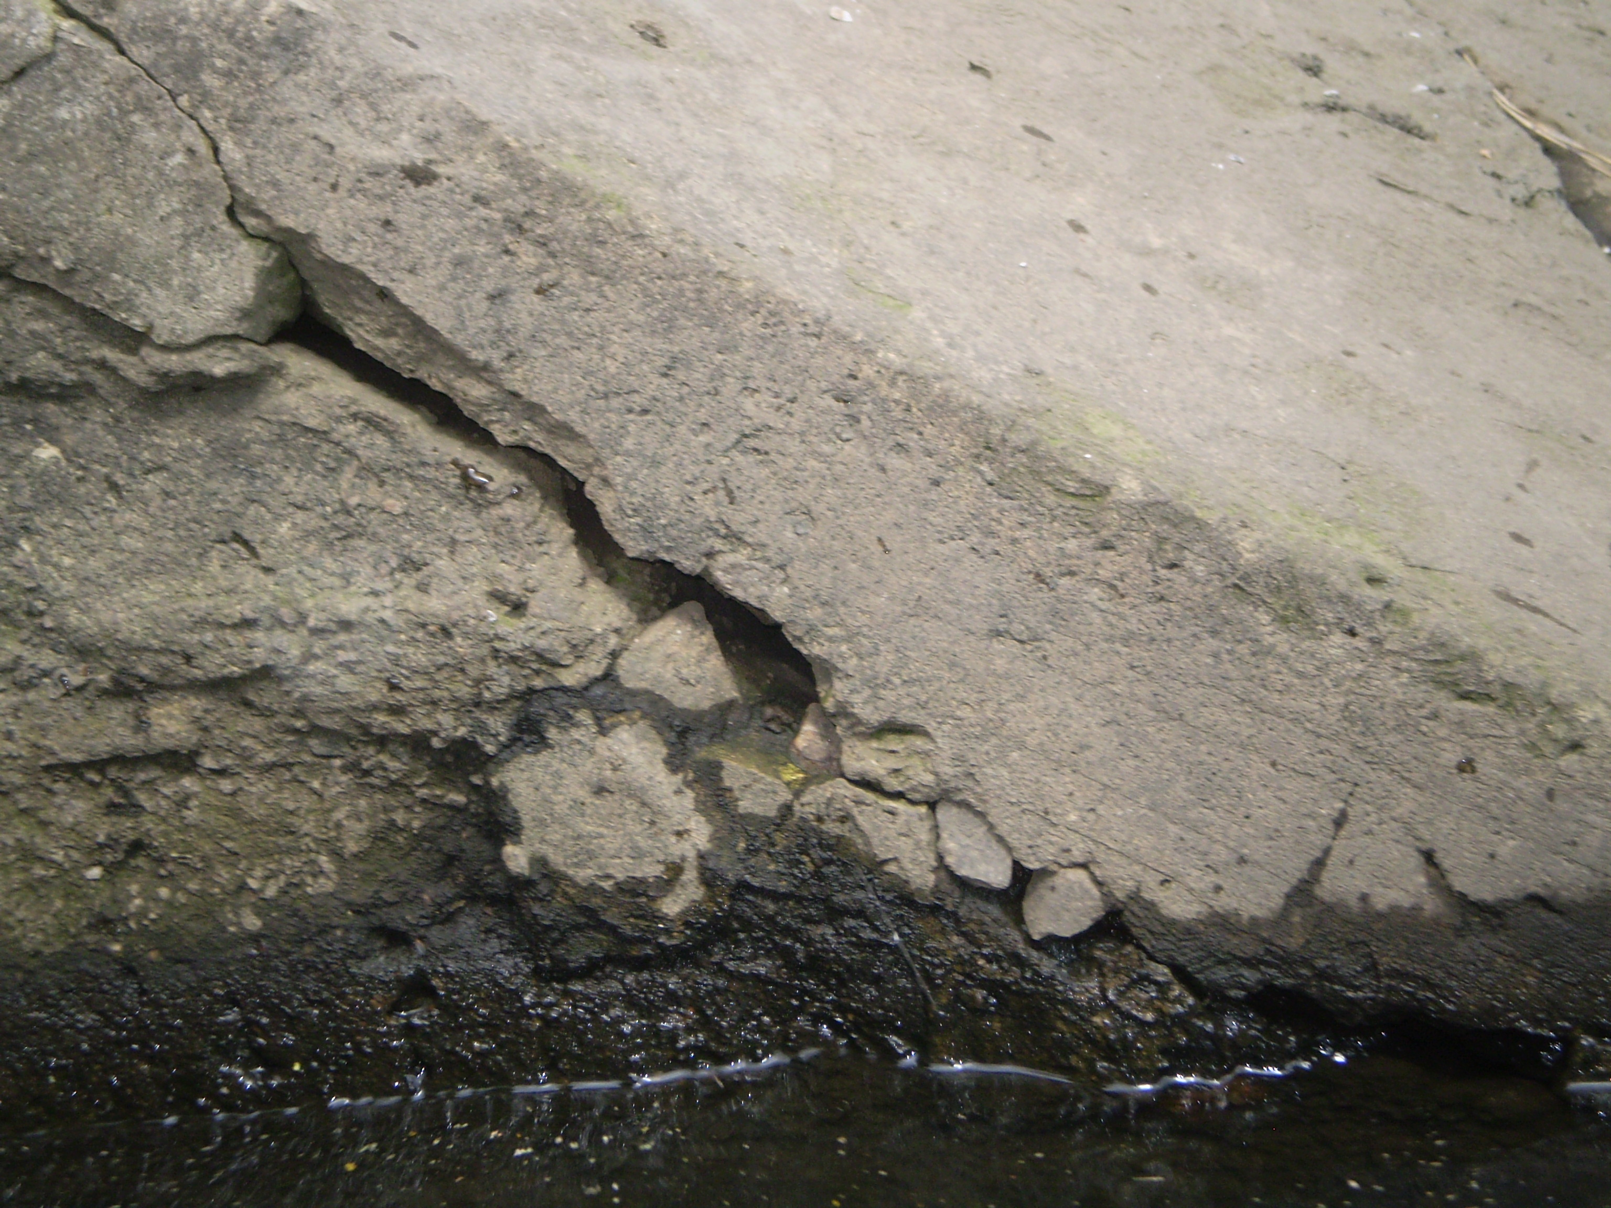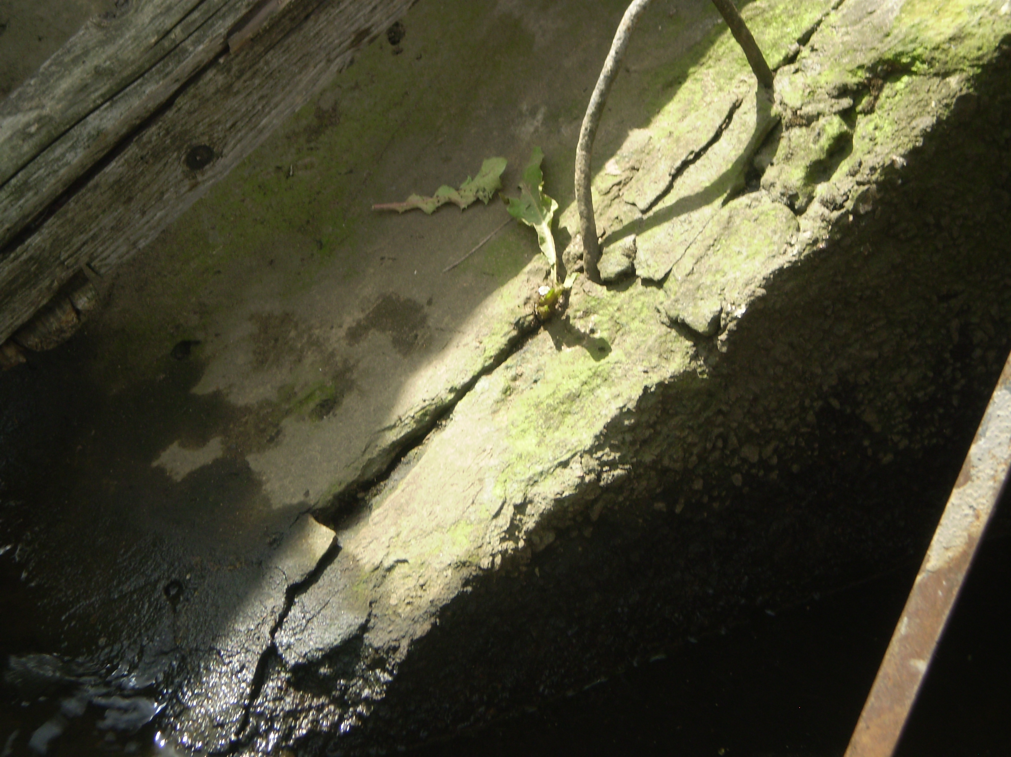
Fig.1. Head on the canal of Bortnytska irrigation system
Irpin IWMD. Inspection of the pre-chamber technical condition of Kochurska pumping station revealed the following damages to the fixing panels: cracks, chips, shells, destruction of the concrete protective layer, violation of the coating geometric shape, exposure of the reinforces (Fig. 2).

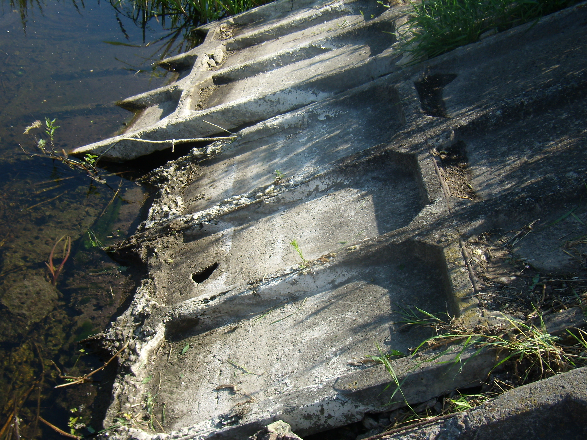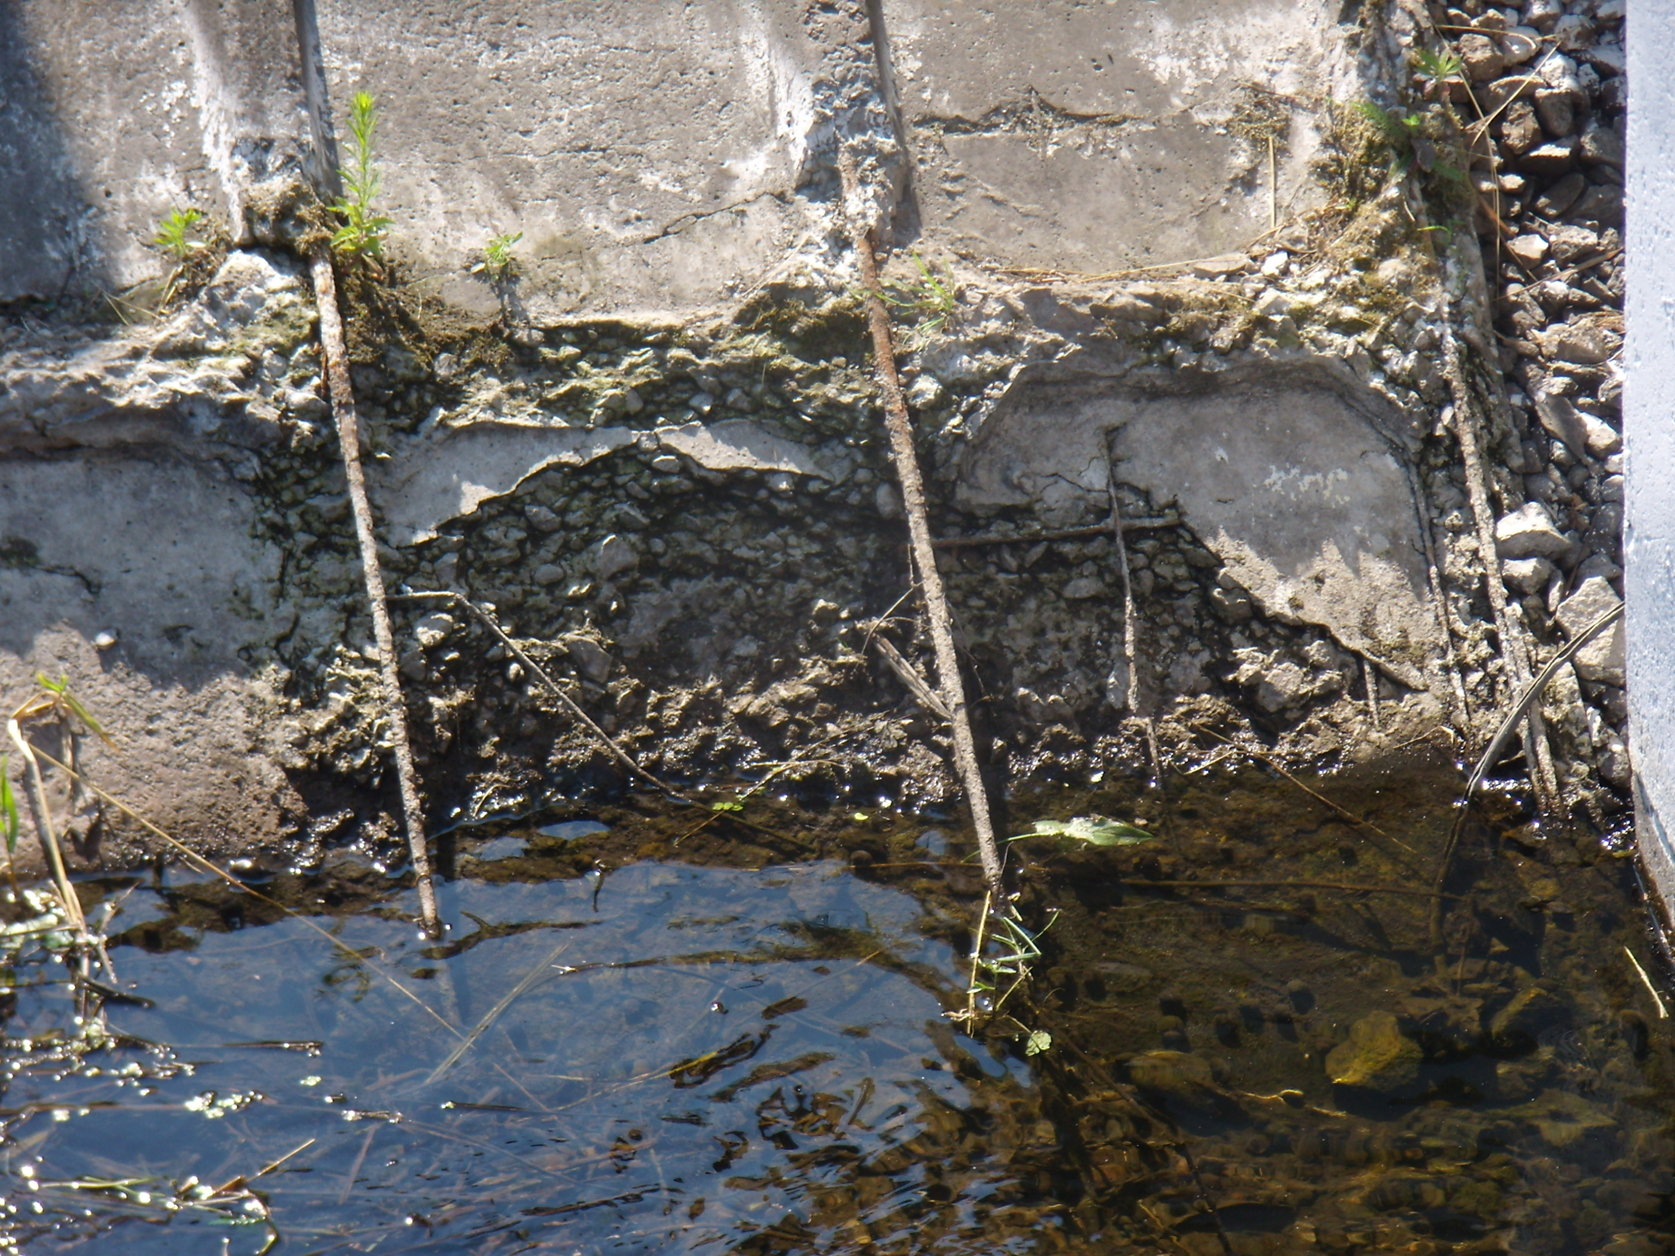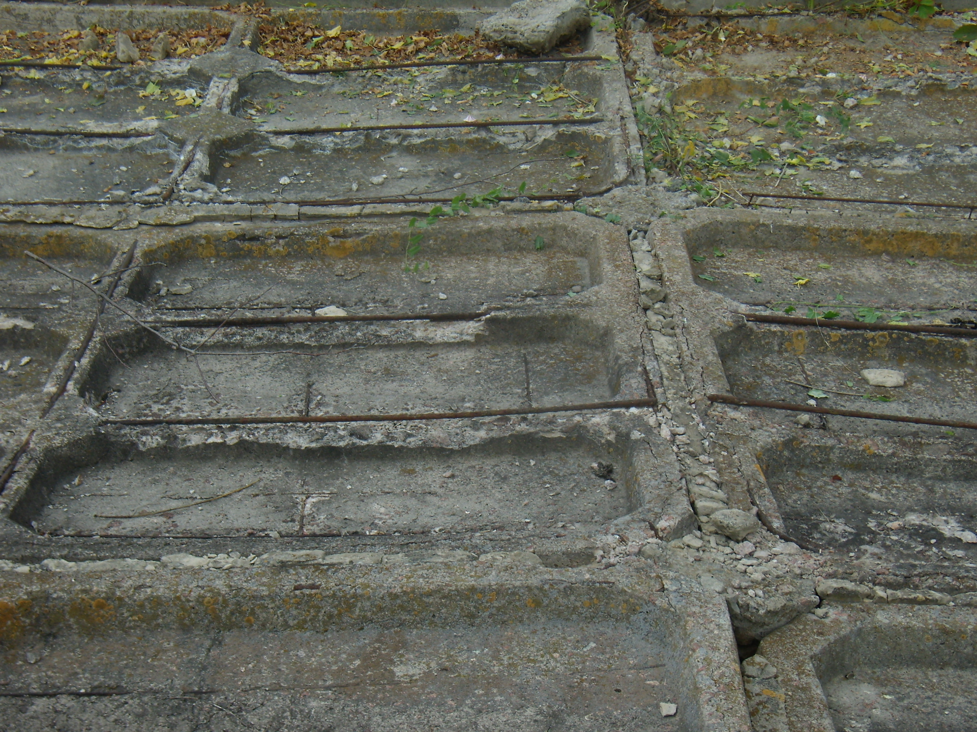
Fig. 2.Technical condition of the pre-chamber panels of the Kochurska pumping station of the Irpin IWMD
BWMD of Tysa river. Similar to the pre-chamber panels damages were discovered during the inspection of pumping station No. 3/3A of the Latoritza polder system. Performing repair and restoration works on these objects requires analysis and development of fundamentally new technological methods and materials for their implementation.
Accordingly, the requirements for the characteristics of cement-based repair materials, which are the most common and intended for the structural repair of reinforced concrete facilities, were analyzed (according to the European standard EN 1504 "Materials and systems for the protection and repair of concrete") (Table 1). [6 ˗ 8].

1. Requirements for the characteristics of cement-based repair materials intended for structural repair
Characteristics | Values
 | Class R4 (repair of main supporting structures) | Class R3 (repair of fencing structures)
Compressive strength, MPa | ≥45 | ≥25
Bond strength with old concrete, MPa | 2 | 1,5
Chloride content, % by mass | ≤0,05
Module of elasticity, GPa | ≥20 | ≥15
Compatibility in freeze-thaw cycles. Adhesion after 50 cycles | ≥2 | ≥1,5
Capillary sorption, kg/m² h | ≤0,5
Carbonation resistance, depth (dk) | ≤ dk control concrete

Additionally, taking into account the main operating characteristics according to EN 1504, actions and characteristics regarding the selection of repair material were determined. However, European regulations contain only functional requirements, there is no clear description of how to implement this or that technical solution. Thus, there is a need to work out technological solutions using the latest materials for structural repairs that would meet the functional requirements of European standards.
The literature analysis [9˗13] shows that various materials and technologies are used as modern composites for the repair of reinforced concrete waterworks, depending on the type and nature of damages. One of the main requirements for choosing a composite is the characteristics of the binder. Binders are divided into three main categories according to operational, physical, and mechanical characteristics:
1st category – repair materials based on organic (polymer) binder (polymer concretes, polymer solutions);
2nd category – polymer-modified materials on a cement binder (polymer-cement concrete, polymer-cement solutions);
3rd category – repair materials on a cement binder (cement-sand solutions, concretes).
Based on the analysis of binders and repair materials, recommendations were developed for the use of different categories of materials for the repair of waterworks made from reinforced concrete (Table 2).

2. Recommendations regarding the use of different categories of materials for the repair the waterworks made from reinforced concrete
Name of the material | Main properties | Recommendations for use
Cement mortars and concretes | Normal density and strength, normal concreting; low adhesion to old concrete. They require careful and long-term care during hardening, or the application of protective coatings. | Repair and strengthening of overall structures of waterworks elements; construction of reinforced concrete shirts, belts; construction of discharges; repair of the protective layer, which work only for constant load; repair of sinks, cavities, grouting of the cracks.
Polymer-cement mortars and concretes | Increased viscosity. Normal  (compared to cement) density and strength, increased adhesion to concrete and crack resistance. Does not require careful care during hardening | Repair of damaged structures in areas where prestressed reinforcement is exposed; grouting of cracks; for the production of injection solutions; restoration of the concrete protective layer.
Polymer solutions and concretes | High strength, density and impermeability, resistance in an aggressive environment. Increased adhesion to dry concrete. Reduced shelf life of the prepared mixture (30 ˗ 40 min) | Repair of concrete chips in areas where it is necessary to restore its calculated compressive and bending strength; achieving high chemical and mechanical resistance; for concreting prefabricated reinforcing structures; for the production of injection solutions; for the preparation of protective coatings.

To ensure high-quality repair, a necessary condition in the creation or selection of repair compositions is the compatibility of the composition with the characteristics of the repaired concrete. Compatibility is the relationship between the physical, chemical, and electrochemical characteristics of the repair compositions components and the characteristics of the concrete surface of the existing facility [14 ˗ 17]. These ratios of the characteristics of the repair layer (P) to the concrete base (C) and the general requirements for the properties of materials for repair work and the concrete base to ensure structural compatibility are shown in the table. 3.

3. General requirements for quality indicators of materials for repair work and concrete base for structural compatibility [14].
Quality indicators | The ratio of the characteristics of the repair layer (P) to concrete base (C)
Compressive strength, MPa | P ≥ C
Module of elasticity, Pa | P ~ C
Coefficient of thermal expansion, К⁻¹ | P ~ C
Adhesion, shear and tear strength, MPa | P ≥ C
Expansion upon wetting, % | P ≥ C
The ability to deform without breaking | P ≥ C

Compatibility implies the nature of the behavior of the repair material both in the hardened and in the hardening state. The efficiency of the repair is defined as the ratio of the stresses that the repaired structure can withstand to the stresses that the structure could withstand before the destruction and repair.
The main requirement in the selection of materials for the repair of concrete and reinforced concrete facilities is adhesive compatibility. Adhesion compatibility implies a sufficient amount of adhesion between the base concrete and the repair material. It was established that the insufficient adhesive property of the repair material to the restored concrete surface is observed when temperature deformations of the hardening repair composition and the base are detected. Adhesion also decreases with insufficient preparation of the damaged area of ​​the facility surface before applying the repair material.
According to the research results, it was found that adhesively compatible characteristics are provided under the condition of equality of shear strength, tensile index between the base concrete and the repair material, as well as the contact zone of destruction, which can characterize the recovery process within three zones. Achieving the greatest adhesion compatibility and strength for repair materials occurs under the condition of optimal state of the concrete preparation surface, as well as the use of primers.
Under the conditions of temperature changes, the amount of deformation of the structure should be proportional to the coefficient of thermal linear expansion of the material. The introduction of polymers into the solutions causes an increase in the coefficients of thermal linear expansion of the repair composition by 1,5...5 times, which can lead to the appearance of significant stress in the contact zone and cause cracking, distortion and peeling of the repair material. In this case, there is a need to use modifiers. The brand of frost resistance of repair compositions must also correspond to the frost resistance of the concrete base.
Deformation compatibility ensures the ability of the repaired area to withstand changes in volume without loss of adhesion and delamination. It was established that in the absence of deformation compatibility, delamination occurs as a result of the following reasons:
– shrinkage deformation of the repair material (plastic shrinkage, drying shrinkage, changes in volume caused by internal shrinkage processes during carbonization);
– expansion in repair materials with shrinkage compensation;
– thermal expansion followed by cooling;
- thermal expansion of repair materials due to daily or seasonal temperature changes.
According to the indicator of structural compatibility, repair materials are divided into two areas of use:
– non-structural or cosmetic repair, for which the perception of stresses is not the main condition for the repair area;
– structural repair, during which the material of the repaired area accepts the load on the damaged area of concrete.
To ensure structural compatibility during the repair of individual areas, special attention should be paid to the following requirements for materials:
– the compressive, bending and tensile strength of the repair material must exceed the corresponding characteristics of the base concrete;
- the elasticity module and the thermal expansion coefficient of the repair material and the base concrete must be equal.
Repair objects include the following components: "old" concrete, transition layer (zones of contact between concrete and repair composition) and repair solution. At the same time, the arrangement of the transition layer - the primer - helps to improve the adhesion of the repair solution to the base by increasing its strength.
Considering the above, in the development of a multi-component composition of repair compositions, it is necessary to take into account at least the following conditions to ensure compatibility (in technological and physico-chemical terms) at all levels of the system "repair composition - primer - damaged surface":
– rheological properties, which are determined by the instrumental research method;
– increase of adhesion to the concrete surface, in particular due to increase of penetrating capacity;
– reduction of shrinkage deformations, slowing of moisture migration and creation of normal hydration conditions.
For structural and non-structural repairs, mixtures are used, which, depending on the type of adhesive, can be divided into three groups: based on polymer resins; based on cements modified with active mineral additives; on the basis of cements modified with polymers (polymer cement).
According to research results, the following physical and mechanical properties of repair composites on different bases, which affect the operational reliability and durability of the "concrete - repair composite" system, were determined and are listed in table. 4.

4. Physical and mechanical properties of repair composites
Quality indicators | Composite based
 | polymer | cement | polymer-cement
Compressive strength, MPa | 60 – 120 | 20 – 70 | 10 – 80
Module of elasticity under compression, MPa | (2 – 10)10³ | (20 – 30)10³ | (15 – 40)10³
Bending tensile strength, MPa | 25 – 50 | 2 – 5 | 6 – 15
Axial tensile strength, MPa | 10 – -20 | 1,5 – 3,5 | 2 – 8
Relative elongation at break, % | 0 – 2 | 0 | 0 – 5
Coefficient of linear temperature expansion/compression, mm/mm/°C | (25-30)10 | (7-12)10 | (8-20)10
Water absorption in 7 days at 25°С, % | 0,1 – 0,5 | 5 – 15 | 0,1 – 2
Adhesion to concrete, MPa | 3,5 | 0,3 – 0,5 | 2,0 – 2,5

To increase the quality indicators of repair composites on a polymer or polymer-cement basis, modifying additives developed at the institute are recommended, which are able to influence technological, physical-mechanical and operational indicators and, in this way, increase the quality and efficiency of structural repair of concrete and reinforced concrete structures of reclamation systems’ waterworks [18]. Redispersed polymer powders (RPP) are one of the most effective modifiers of the properties of building materials.
We investigated the effect of RPPs, differing in chemical composition, on the adhesive properties of repair composites (Table 5).

5. Components of redispersed polymer powders
Name of RPP | YT-8012 | Еlotex FLOWKIT 74 | NEOLITH P 4400
Components  of RPP | vinyl acetate, ethylene | vinyl acetate, ethylene acetate, ethylene, acrylate | vinyl acetate,  versatile vinyl

Determination of the adhesive strength of the cement-sand solution with RPP additives was carried out in accordance with ASTM C 190 by determining the tensile strength on samples in the form of figures of eight with a collapsible contact area of ​​about 5,5 cm². For tests, cement-sand half-eights were made in special molds using a metal separation plate, to which half-eights were then formed from a modified solution with RPP additives. The redispersed polymer powder was introduced into a solution of 1 to 10% of the mass of cement with a water-cement ratio (W/C) of 0,4. After 28 days of aging in normal humid conditions, the manufactured samples were tested on the RM-05 tearing machine. The obtained results are shown in Fig. 4.
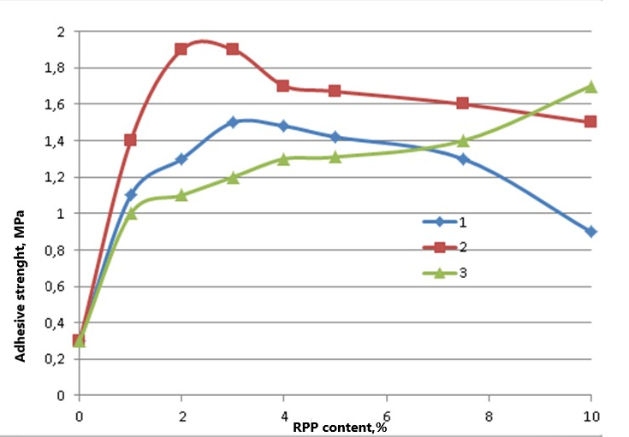
Fig. 4. Influence of RPP on adhesive strength: 1 - YT-8012; 2 - Еlotex FLOWKIT 74;
3 - NEOLITH P 4400.

As can be seen from the above data, the modification of cement-sand solutions of RPP causes a significant increase in adhesive strength. Concentration dependences of adhesive strength on the content of RPP have an extreme character. The most pronounced effect is achieved in the area of concentrations from 1 to 5% of the RPP content in relation to cement. When 3% YT-8012 is introduced into a cement-sand solution, the adhesive strength increases by 5 times, in the range of 2-3% Elotex FLOWKIT 74 - by 6, and in the range of 4-5% NEOLITH P 4400 by 4,3 times. The obtained results indicate the prospects of using RPP as part of repair composites.
Improving the physical and mechanical characteristics of cement-sand solutions by introducing modifiers of different chemical components into their composition makes it possible to create highly effective repair composites.
The properties of modified cement-sand solutions as heterogeneous multicomponent systems are the result of those changes in the physical properties and structure of the components, which are caused by the interaction at the phase interface. The change in the properties of the modified system compared to the original occurs as a result of the simultaneous action of many factors, but is not an additive value. Determination of the optimal ratio of components is carried out on the basis of the method of mathematical planning of the experiment. The obtained data are used for targeted regulation of the properties of modified cement-sand solutions.
Our research has found that with the complex use of superplasticizer (SP), microsilica (MC) and polypropylene fiber (F) in the composition of polymer cement dry construction mixtures in the area of concentrations of SP=0,23 — 0,5% (C), MK=5 - 25%(C), F=0 – 0,6%(C), the following quality indicators are achieved [12]:
– compressive strength R_{cs} > 60 MPa,
– bending strength R_{bs} > 10 MPa,
- water absorption W_{m} < 5%.
The results of research carried out at the institute indicate the possibility of increasing the strength indicators of cement-sand solutions modified with a powder superplasticizer of the polycarboxylate type Sika Viskocrete 225, amorphous microsilica (MK), polypropylene fiber (F) and redispersed polymer powder (RPP) [19].
The complex application enhances the effect of each individual modifying additive and makes it possible to obtain a composite material with high strength and performance indicators (R_{cs} = 12,5 MPa, R_{bs} = 65 MPa, Wm = 2,0%) and is a relevant direction in the modification of cement-sand solutions for repair of reinforced concrete structures of the reclamation systems waterworks.
The institute developed a polymer-cement dry construction mix for structural repair of concrete of the waterworks. This mix as modifiers contains microsilica, polypropylene fiber, redispersed polymer powder and SVK 225 superplasticizer in the following composition, %:
Cement M500................... 22,04;
River sand......................... 66,14;
SP SVK225.............................0,066;
Microsilica.....................3,307;
Fiber....................................0,066;
RPP...................................................0,88;
Water...................................7,49.
For practical use in the composition of the mix, a comparative analysis of the technical characteristics of the materials available on the market of Ukraine (according to the manufacturing companies materials) was carried out (Table 6).

6. Technological, physical, and mechanical indicators of repair mix
Quality indicator | Mix, developed at institute | Rem-stream-T | Bud-Master TINK-93 | Ceresit DM 25 | Master Emaso С488C | Sika REPER | Siltek  R-5
Ease of appication (blurring of the cone), sm | 16,0 | 18,0 | 13,0 | 14,0 | 20,0 | 18,0 | 16,0
Compressive strength, MPa | 65 | 60 | 45 | 25 | 60 | 45 | 35
Bending strength, MPa | 10,5 | 7 | 8,5 | 8,0 | 8,0 | 9,0 | 8,0
Adhesion to concrete, MPa | 2,2 | 2,0 | 2,0 | 1,5 | 2,5 | 2,0 | 2,0
Water resistance, W | 14-16 | 16 | 12 | 12 | 12 | 18 | 15
Frost resistance, cycles, F | 300 | 300 | 75 | 75 | 300 | 250 | 200
Viability, min | 30 | 45 | 40 | 30 | 50 | 45 | 30

The developed composite repair materials and technologies for their use have been successfully tested and implemented at the facilities of the State Water Agency of Ukraine: Bortnytska IWMD, Kochurska pumping station of the Irpin Interdistrict Water Management to restore waterproofing and monolithic reinforced concrete structures [20-22].
The repair of total concrete destruction, chips and shells was carried out by the method of monolithization based on the use of developed compositions of polymer cement mixes. Preliminary preparation of defective areas for repair consisted in cleaning the surface from debris, dust, removing destroyed concrete, overflows, treating cracks (creating a groove along the crack path for further sealing). To improve the adhesive properties of the repair compositions, preliminary surface impregnation of the site with epoxy isocyanate compositions was carried out. The structural repair of the head on the canel of the Bortnytska irrigation system is shown on Fig. 5.

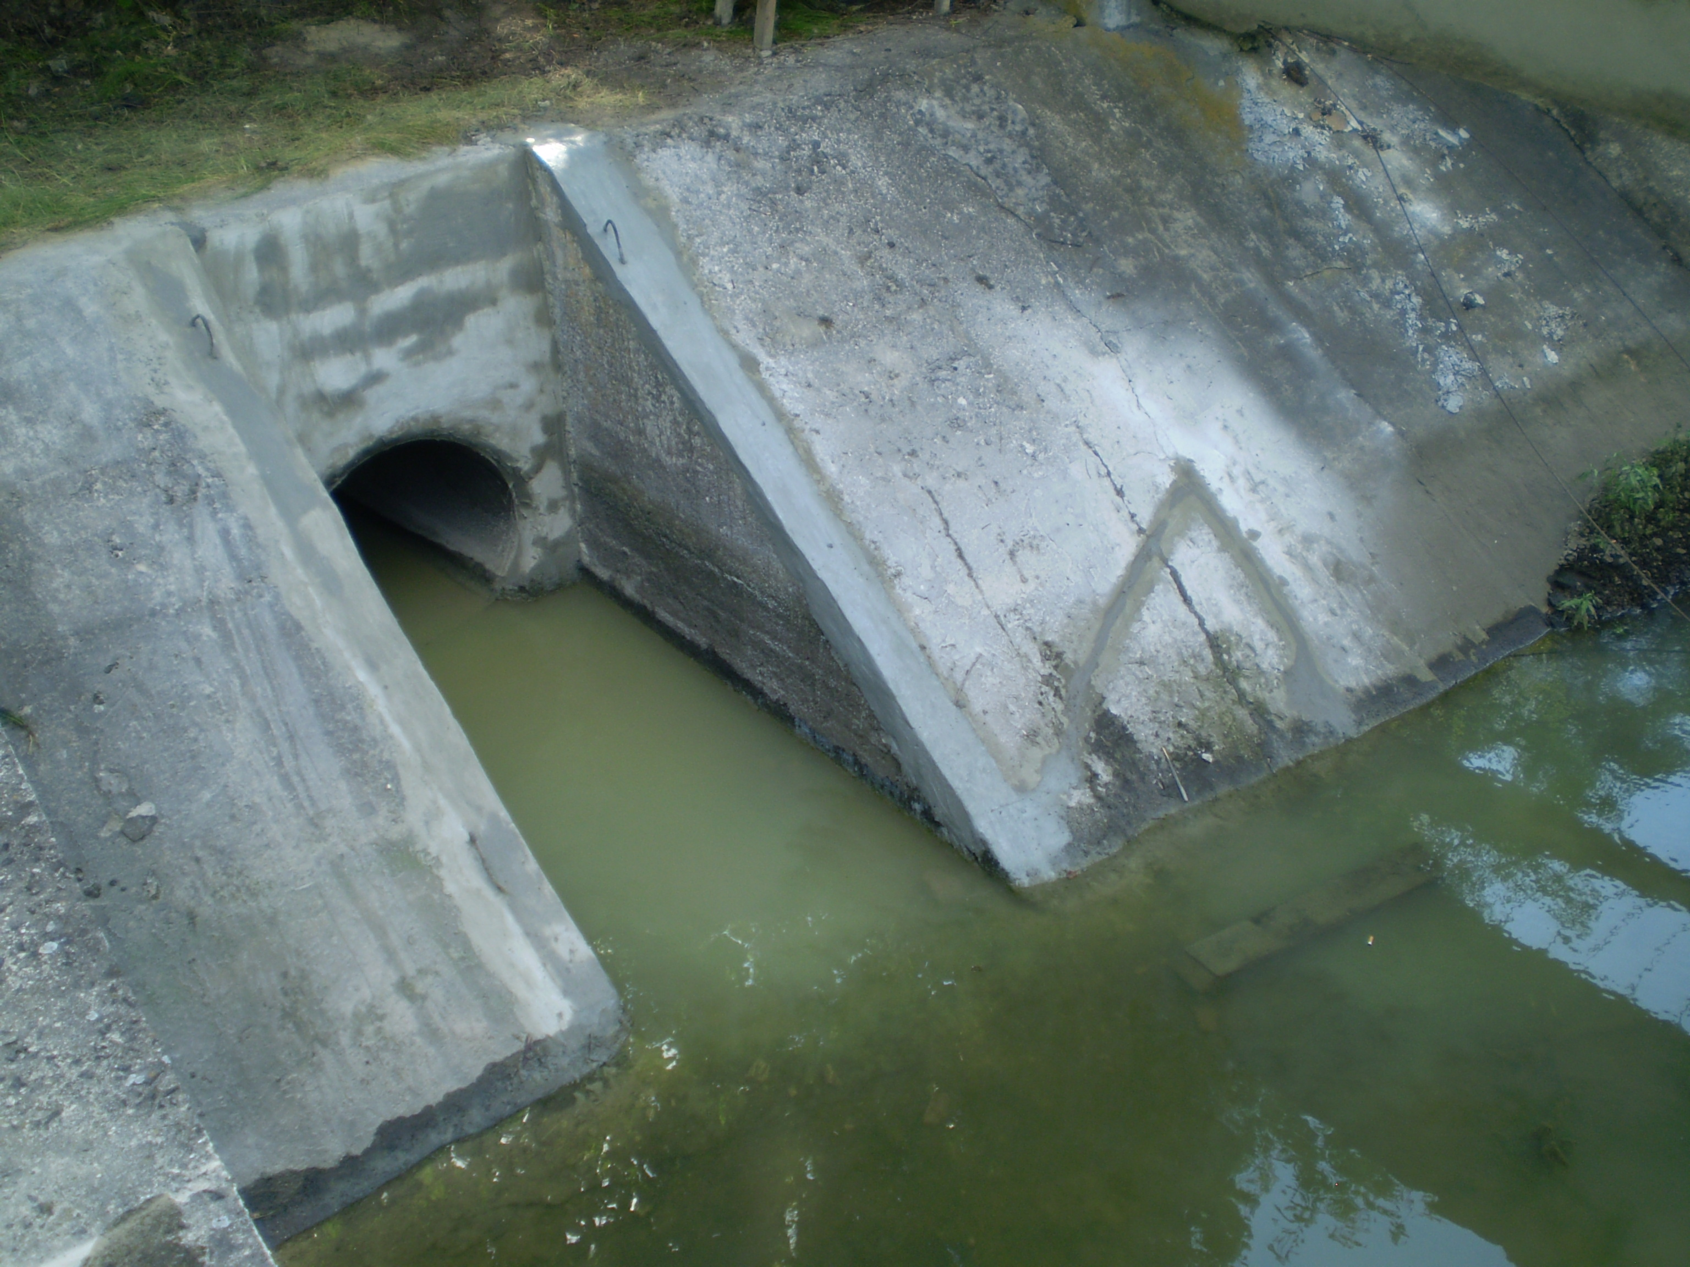
а б
Fig. 5. Head on the canel of the Bortnytska irrigation system after structural repair: a – after restoration; b - in 2 years
In order to eliminate the detected damages of pre-chamber panrls of the Kochurska pumping station, a structural repair was carried out using fiber-polymer cement compositions.
The technology of carrying out repair and restoration works included the following operations:
– preparation of the defective area for repair;
– primer treatment of the repaired concrete surface;
- preparing the working composition of the repair composite material and applying it to the defect area.
The developed dry fiber-polymer cement mixtures were produced in laboratory conditions, and the necessary amount of the water was added at the place of repair and restoration works.
The liquidation of shells, chips, volume and surface destruction of the concrete protective layer was carried out by the method of structural repair with the restoration of the geometric shape of the facilities using fiber-polymer cement compositions, which were applied after careful preparation of the surface in the repair areas: weak and brittle concrete was removed; the surface of the site was washed with a stream water under high pressure and blown with compressed air to prepare the concrete surface for repair work. The thickness of the layer of repair compositions was from 5 to 30 mm, depending on the degree of damage (Fig. 6).

Fig. 6. The pre-chamber panels after structural repair
A visual inspection after hardening of the repair composite materials showed that the repair layers are dense, there is no delamination of the compositions, and there is no filtration during the pilot test using a filterometer. The general condition of the repaired areas is good, the monolithic adhesion of the laid repair materials to the concrete is high. The results of laboratory studies of physical and mechanical indicators of fiber-polymer cement composition samples, which were formed from a batch of material produced for repair, are given in table. 7.

7. Results of research on the fiber-polymer cement composition used in the repair of panels
Indicator | Compressive strength, MPa | Bending strength, MPa | Adhesion to concrete, MPa
Value | 45,6 | 8,3 | 1,58

The obtained indicators correspond to the average values for repair mixes, given in the table 6 and correspond to class R3 of the European standard EN 1504 "Materials and systems for the concrete protection and repair" (Table 1).
Regular studies of the condition of restored sections of the waterworks after long-term operation have confirmed the absence of damages and the development of destruction and deformation of structures, which confirms the reliability and efficiency of the repair work.
Conclusions. The technology of structural repair of concrete and reinforced concrete structures of the waterworks with the use of modern composite materials has been developed, which ensures the restoration of the design geometric parameters and the load-bearing capacity of the facilities.
Repair composites on a polymer and polymer-cement basis have been developed, which are recommended and capable of influencing technological, physical-mechanical and operational indicators and, in this way, increasing the quality and efficiency of structural repair of concrete and reinforced concrete structures of reclamation systems’ waterworks.
It was established that the modification of cement-sand solutions of RPP leads to a significant increase in adhesive strength. Concentration dependences of adhesive strength on the content of RPP have an extreme character. The most pronounced effect is achieved in the range of concentrations from 1 to 5% of the RPP content in relation to cement. When 3% YT-8012 is introduced into a cement-sand solution, the adhesive strength increases by 5 times, in the range of 2-3% Elotex FLOWKIT 74 - by 6, and in the range of 4-5% NEOLITH P 4400 by 4,3 times.
Experimental and production testing, results of field studies and monitoring of the condition of repaired structures at the facilities of the Interregional Water Management Departments: Bortnytska, Irpinske Water Management Departments and BUVR of the Tysa region confirmed the high efficiency of the use of polymer-cement dry construction mixture in the repair and restoration of reinforced concrete water management facilities.

Reference
1. Krucheniuk, V.D., Kovalenko, O.V., Dekhtiar, O.O., & Briuzghina, N.D. (2013). Suchasnyi stan ta perspektyvy vidnovlennia HTS vodohospodarsko-melioratyvnoho kompleksu. [The current state and prospects for restoration of the GTS water management and land reclamation complex] Vodne hospodarstvo Ukrainy, 3, 34-37. [in Ukrainian].
2. Dekhtiar, O.O., Kovalenko, O.V., & Briuzghina, N.D. (2018). Otsinka tekhnichnoho stanu obiektiv inzhenernoi infrastruktury melioratyvnykh system. [Assessment of the technical condition of engineering infrastructure objects of reclamation systems]. Melioratsiia i vodne hospodarstvo, 1(107), 102-109. [in Ukrainian]. DOI: 10.31073/mivg201801-106. [in Ukrainian].
3. Nastanova shchodo obstezhennia budivel i sporud dlia vyznachennia ta otsinky yikh tekhnichnoho stanu [Guidelines for the inspection of buildings and structures to determine and assess their technical condition.]. (2016). DSTU-N B V.1.2-18:2016. Natsionalnyi standart Ukrainy. Kyiv: Derzhspozhyvstandart Ukrainy. [in Ukrainian].
4. Kovalenko, O.V. (2016). Osoblyvosti vidnovlennia ta zakhystu betonu hidrotekhnichnykh sporud vodohospodarsko-melioratyvnoho kompleksu [Peculiarities of restoration and protection of concrete of hydrotechnical structures of the water management and reclamation complex]. Melioratsiia i vodne hospodarstо, 104, 126-132. DOI: https://doi.org/10.31073/mivg201602. [in Ukrainian].
5. Dekhtiar, O.O., & Briuzghina, N.D. (2020). Innovatsiini tekhnolohii vidnovlennia protyfiltratsiinoi zdatnosti zroshuvalnykh kanaliv [Innovative technologies for restoring the anti-filtration capacity of irrigation canals]. II Mizhnarodna naukovo-praktychna konferentsiia: Suchasni tekhnolohii ta dosiahnennia inzhenernykh nauk v haluzi hidrotekhnichnoho budivnytstva ta vodnoi inzhenerii. [II International Scientific and Practical Conference: Such technological achievements and engineering sciences in the field of hydrotechnical construction and water engineering]. Kherson. 35-41. Retrieved from: https://www.ksau.kherson.ua/files/konferencii/20200611 [in Ukrainian].
6. NCC Concrete Repair Site. (2023). The European Standards EN 1504 Parts 1 to 10. Retrieved from: https://www.concreterepairsite.co.uk/PrinciplesNMethods.html.
7. Rukovodstvo po evropeiskym standartam remonta betona Seryia BS EN 1504. [Guide to European Concrete Repair Standards BS EN 1504 Series.]. (n.d.). https://waterproofing.com. Retrieved from: https://waterproofing.com.sg/a-guide-to-the-concrete-repair-european-standards-bs-en-1504-series/.
8. Products and systems for the protection and repair of concrete structures —Definitions, requirements, quality control and evaluation of conformity. Part 2: Surface protection systems for concrete. (n.d.). nobelcert.com. Retrieved from: https://nobelcert.com/DataFiles/FreeUpload/EN% 201504-2-2004.pdf.
9. Kovalenko, O.V. (2011). Rozvytok naukovykh ta praktychnykh osnov vedennia remontno-vidnovliuvalnykh robit na hidrotekhnichnykh sporudakh vodohospodarsko-melioratyvnykh system [Development of the scientific and practical foundations of repair and restoration works on hydrotechnical structures of water management and reclamation systems]. Budivelni materialy, vyroby i sanitarna tekhnika, 42, 18-25. Retrieved from:http://nbuv.gov.ua/UJRN/bmvs_2011_42_5. [in Ukrainian].
10. Krucheniuk, V.D., Dekhtiar, O.O., & Briuzghina, N.D. (2012). Perspektyvni tekhnolohii usunennia aktyvnykh protichok vody v betonnykh sporudakh. [Promising technologies for eliminating active water leaks in concrete structures]. Budivelni materialy, vyroby i sanitarna tekhnika, 45, 25-29. Retrieved from:http://nbuv.gov.ua/UJRN/bmvs_2012_45_6. [in Ukrainian].
11. Dekhtiar, O.O., & Briuzghina, N.D. (2015). Doslidzhennia adheziinykh vlastyvostei remontnykh kompozytiv [Studies of adhesive properties of repair composites]. Melioratsiia i vodne hospodarstvo, 102, 124-128. Retrieved from: http://nbuv.gov.ua/UJRN/Mivg_2015_102_27. [in Ukrainian].
12. Aheiev, А.A., Kovalenko, O.V., Dekhtiar, O.O., & Briuzghina, N.D. (2016). Optymizatsiia retsepturno-tekhnolohichnykh faktoriv kompozytsiinoho materialu dlia konstruktsiinoho remontu hidrotekhnichnykh sporud. [Optimization of receptor-technological factors of composite material for structural repair of hydraulic structures]. Melioratsiia i vodne hospodarstvo, 103, 107-111. Retrieved from: http://mivg.iwpim.com.ua/index.php/mivg/issue/view/4. [in Ukrainian].
13. Zakhezyn, A.E. Chernykh, T.N., Trofymov, B.Ya., & Kramar, L.Ya. (2004) Vlyianye redysperhyruemykh poroshkov na svoistva tsementnykh stroytelnykh rastvorov [The influence of redispersed powders on the properties of cement mortars]. Stroytelnye materyaly, 10, 6-7. [in russian].
14. Pshinko, O. M., Krasniuk, A. V., & Hromova, O. V. (2015). Vybir materialiv dlia remontu ta vidnovlennia betonnykh ta zalizobetonnykh konstruktsii transportnykh sporud z urakhuvanniam kryteriiu sumisnosti. [Selection of materials for repair and restoration of concrete and reinforced concrete structures of transport facilities, taking into account the compatibility criterion]. Dnipropetrovsk: DNUZT [in Ukrainian].
15. Pattnaik, R. (2006) Іnvestigation into compatibility between repair material and substrate concrete using experimental and finite element method. Doctor's thesis. Clemson University Retrieved from: https://tigerprints.clemson.edu/cgi/viewcontent.cgi?article=1007&context=all_dissertations
16. Pattnaik, R. R., & Rangaraju, P. R. (2007). Analysis of Compatibility between Repair Material and Substrate Concrete Using Simple Beam with Third Point Loading. Journal of materials and civil engineering, 19, 12. Retrieved from: https://ascelibrary.org/doi/abs/10.1061/(ASCE)0899-1561(2007)19:12(1060).
17. Morgan, D. R. (1996). Compatibility of concrete repair materials and systems. Construction and Building Materials, 10 (1) 57–67. Retrieved from: https://sci-hub.se/10.1016/0950-0618(95)00060-7.
18. Kovalenko, O.V. (2015). Modyfikuiuchi dobavky – holovnyi faktor formuvannia vlastyvostei remontno-zakhysnykh sukhykh budivelnykh sumishei. [Modifying additives are the main factor in the formation of the properties of repair and protective dry construction mixtures]. Melioratsiia i vodne hospodarstvo, 102, 131-133. Retrieved from: http://nbuv.gov.ua/UJRN/Mivg_2015_102_29. [in Ukrainian].
19. Kovalenko, O.V., Aheiev A.O. (2014). Vplyv poroshkovoho polikarboksylatnoho superplastyfikatora Sika ViskoKret 225 na vlastyvosti tsementno-pishchanoho rozchynu [The influence of the powdered polycarboxylate superplasticizer Sika Viskokret 225 on the properties of cement-sand mortar] Melioratsiia i vodne hospodarstvo, 101, 342-353. Retrieved from: http://www.irbis-nbuv.gov.ua/cgi-bin/irbis_nbuv/cgiirbis_64.exe?I21DBN=LINK&P21DBN=UJRN&Z21ID=&S21REF=10&S21CNR=20&S21STN=1&S21FMT=ASP_meta&C21COM=S&2_S21P03=FILA=&2_S21STR=Mivg_2015_102_29. [in Ukrainian].
20. Kovalenko, O.V. (2019). Pidvyshchennia ekspluatatsiinoi nadiinosti hidrotekhnichnykh sporud polimernymy ta polimertsementnymy kompozytsiinymy materialamy. (Improvements in operational reliability of hydraulic structures with polymer and polymer-cement composite materials). Melioratsiia i vodne hospodarstvo, 2, 217-230. DOI: https://doi.org/10.31073/mivg201902-184. [in Ukrainian].
21. Kovalenko, O.V., Aheiev, A.O., Briuzghina, N.D., & Dekhtiar O.O. (2016). Konstruktsiinyi remont zalizobetonnykh hidrotekhnichnykh sporud melioratyvnoho kompleksu iz vykorystanniam polimertsementnykh sukhykh budivelnykh sumishei. (Structural repair of reinforced concrete hydraulic structures of the reclamation complex with the use of polymer-cement dry building mixtures). Perspektyvny napravlennia razvytyia vodnoho khoziaistva, stroytelstva y zemleustroistva: Sbornyk materyalov Mezhdunarodnoi nauchno-praktycheskoi konferentsyy.-Kherson: Yzd-vo PP «LT - Ofys». 384 - 386. Retrieved from: http://www.eecca-water.net/content/view/8186/12. [in Ukrainian].
22. Romashchenko, M.I., Muzyka, O.P., Voitovych, I.V., & Usatyi, S.V. (2023). Naukovi zasady vidnovlennia tekhnichnoho stanu inzhenernoi infrastruktury zroshuvalnykh system v Ukraini u povoiennyi period (Scientific principles of restoring the technical condition of the engineering infrastructure of irrigation systems in Ukraine in the post-war period). Visnyk ahrarnoi nauky, 6, 61-70. DOI:https://doi.org/10.31073/agrovisnyk202306. [in Ukrainian].

УДК 691.175.699.8

ТЕХНОЛОГІЯ КОНСТРУКЦІЙНОГО РЕМОНТУ БЕТОННИХ ТА ЗАЛІЗОБЕТОННИХ КОНСТРУКЦІЙ ГТС

І.В. Войтович¹ канд. техн. наук, Н.Д. Брюзгіна² канд. техн. наук, О.П. Музика³ канд. техн. наук. Ю.В. Лімачов⁴, аспірант
¹ Інститут водних проблем і меліорації НААН, м.Київ, 03022, Україна;
https://orcid.org/0000-0002-1543-3955; e-mail: ivan.v.voytovich@gmail.com;
² Інститут водних проблем і меліорації НААН, Київ, 03022, Україна;
https://orcid.org/0000-0002-7659-2810; e-mail: natalya-51@i.ua;
³ Інститут водних проблем і меліорації НААН, Київ, 03022, Україна;
https://orcid.org/0000-0002-3388-3001; e-mail: muzyka_iwpim@ukr.net;
⁴ Інститут водних проблем і меліорації НААН, 03022, м. Київ, 03022, Україна;
https://orcid.org/0009-0008-5217-763X; e-mail: leman4767@gmail.com

Анотація. Оцінка сучасного стану об’єктів інженерної інфраструктури водогосподарсько-меліоративного комплексу, що проводилась на основі аналізу технічної документації, візуального та інструментального обстеження технічного стану конструкцій підтверджує, що внаслідок багаторічної експлуатації ГТС без належного проведення ремонтно-відновлювальних робіт технічний стан їх значно погіршився.
Найбільш перспективними для ремонту бетонних та залізобетонних конструкцій є матеріали на основі цементу, модифіковані полімерами (полімерцементні), які являють собою сухі суміші цементу, піску, редиспергуючого полімерного порошку (РПП) та інших модифікуючих добавок. Наведено результати досліджень впливу редиспергуючих полімерних порошків на адгезійні властивості ремонтних композитів. Показано, що модифікація цементно-піщаних розчинів РПП приводить до істотного зростання адгезійних властивостей ремонтних композитів. Встановлено оптимально ефективну концентрацію РПП у ремонтних композиціях.
У статті висвітлено технологію конструкційного ремонту бетонних та залізобетонних конструкцій ГТС із застосуванням сучасних композиційних матеріалів, що дає змогу відновити проєктні геометричні показники та несучу здатність конструкцій. Запропонована технологія та ефективні ремонтні композиції допомагають проводити ремонтно-відновлювальні роботи на гідротехнічних спорудах водогосподарсько-меліоративного комплексу, зокрема зруйнованих або пошкоджених внаслідок воєнної агресії російської федерації проти України. Розкрито основні принципи вибору оптимальної технології конструкційного ремонту бетонних та залізобетонних конструкцій ГТС залежно від характеру та ступеня пошкоджень, впливу технологічних та експлуатаційних умов на відновлення геометричних показників споруд під час модернізації та реконструкції меліоративних систем у повоєнний період.
Ключові слова: гідротехнічні споруди, композиційні матеріали, модифікатори, сумісність, адгезія, конструкційний ремонт

