DOI:
Available at (PDF):
UDC 631.811.982

Study of the Potential UsAGE OF Anolytes ANK to Remove Biological Fouling from Drip Irrigation Systems

M.I. Romashchenko¹, Doctor of Technical Sciences, B.I. Konakov², Ph.D. in Technical Sciences, V.V. Polishchuk³, Ph.D. in Agricultural Sciences, O.V. Tomashevskyi⁴, I.O. Kovalenko⁵, Ph.D.

- Institute of Water Problems and Land Reclamation of NAAS, Kyiv, Ukraine;
https://orcid.org/0000-0002-9997-1346; e-mail: mi.romashchenko@gmail.com;
- Kyiv Agrariana University of NAAS, Kyiv, Ukraine;
https://orcid.org/0000-0003-3065-4745; e-mail: crony@meta.ua;
- Institute of Water Problems and Land Reclamation of NAAS, Kyiv, Ukraine;
https://orcid.org/0000-0003-0429-7406; e-mail: vitaliypolishchuk@ukr.net;
- LLC «Irrigator Ukraine», Odesa, Ukraine;
https://orcid.org/0009-0004-3214-4217, e-mail: aleksandr.timoshevskyi@gmail.com;
- Institute of Water Problems and Land Reclamation of NAAS, Kyiv, Ukraine;
https://orcid.org/0000-0003-1548-3992, e-mail: igor13081995@gmail.com

Abstract. The prospects for using neutral anolytes ANK of Ukrainian producers for cleaning emitters and pipelines of drip irrigation systems from contaminants of biological origin have been studied. The relaxation characteristics of the neutral anolytes ANK were determined, changes in their main characteristics (TDS, ppm, pH; ORP, mV) were established depending on the degree of dilution with water, and an assessment of the market and production capacities of anolytes ANK in Ukraine was performed. The laboratory, laboratory-analytical, field, and mathematical-statistical comparative research methods were applied to determine the effectiveness of flushing the emitters and drip irrigation pipelines with environmentally safe neutral anolytes ANK of Ukrainian manufacturers ("AQUA SALIS", "Krystal", and "Secobren") and environmentally hazardous 15% sodium hypochlorite produced in the People’s Republic of China (PRC). The presence of a biological component of contaminants was determined using the Biuret reaction. It has been found that obtaining effective solutions for flushing emitters and pipelines of drip irrigation systems from contamination of biological origin, with an ORP of not less than +750 mV, is possible by diluting the anolytes ANK produced by "Aquasalis", "Krystal", and "Secobren" with irrigation water in a 1:40 ratio; produced by "Sterilox", "Vitalmix" and "Allsteril" - in a 1:20 ratio.
Visual and quantitative indicators of the quality of flushing the emitters and drip irrigation pipelines from contaminants of biological origin were obtained. In laboratory, it was determined that the flow rate of drip pipelines with 20 emitters clogged with biological contaminants after washing with hypochlorite "AquaDoctor", depending on the pressure, increased by 17,6...52,3%, with anolyte "Krystal" - by 23,7...92,0%. Field flushing of 136 m long drip irrigation pipelines with 340 emitters with anolytes ANK resulted in an increase in the flow rate of one pipeline by 8 l/h, and the other - by 13 l/h.
It has been found that neutral anolytes ANK produced in Ukraine are an effective and environmentally safe alternative to chemicals (chlorine, 15% sodium hypochlorite, chlorine dioxide, and hydrogen peroxide), which are currently used to flush emitters and drip irrigation pipelines from contaminants of biological origin. It was determined that Ukrainian production capacities for anolytes ANK are capable of meeting the needs of Ukrainian farmers for flushing emitters and drip irrigation pipelines.
Keywords: drip irrigation systems, drip water emitters, biological pollution, flushing, electrochemically activated low-concentration salt solutions, anolyte, sodium hypochlorite.

Relevance of the research. The problem of biological contamination of pipelines that transport water for various purposes is not the new, but the need to solve it is becoming increasingly urgent in different countries [1,2]. For the drip irrigation systems, this issue has become one of the main reasons for the decrease in the reliability of their operation in recent years [3, 4]. It is associated, on the one hand, with the use of emitters (drip water outlets), the diameters of water supply pipelines (labyrinths) and holes of which are from 0,5 to 1,4 mm (to ensure flows from 0.5 to 8 l/h), and, on the other hand, with the increasing intensity of reproduction and growth of various microbiota in water supply sources due to the increase in solar radiation and average daily air and soil temperatures during the irrigation period as a result of climate change. It should be noted that emitters of drip irrigation systems, due to the very small diameters of their labyrinths, are vulnerable to contamination of mechanical and chemical origin in addition to biological contamination [5]. To prevent mechanical contamination, filter stations with coarse and fine filters are placed at the beginning of drip irrigation systems, which prevents mechanical particles that are larger in size than the diameters of the emitter labyrinths (50…150 microns) from entering the system. As a result, and while maintaining a turbulent water flow regime in the emitters, the risk of mechanical contamination is significantly minimized, but the threat of chemical and biological contamination remains high.
Chemical contamination of emitters occurs as a result of the formation of solid deposits in the labyrinths or at the emitter outlet due to the deposition of salts, metals, or mineral compounds under the influence of changes in pH, pressure, temperature, or mixing of fertilizers with water. The main mechanisms of chemical pollution are the contamination from carbonates CaCO₃, MgCO when using «hard» water, as well as phosphates and sulfates Ca₃(PO₄)₂ or CaSO₄ when fertilizers are improperly mixed during their application with irrigation water [6]. Another source of chemical (partially biological) pollution is the presence of Fe²⁺ or Mn²⁺ ions in water, which, upon contact with oxygen, are oxidized to insoluble forms of Fe(OH)₃ or MnO₂. These compounds form rusty-brown or black deposits that settle in pipelines and emitters and are often combined with biological deposits (iron bacteria). The main methods for combating chemical pollution are regular acid washing of systems with nitric, phosphoric, sulfuric, or citric acids [7]. Despite the fact that research is constantly being conducted to improve the means and methods of cleaning emitters of drip irrigation systems from contamination of mechanical and chemical origin, it can be considered that the problem of combating them has been generally solved today. But this cannot be said about the issue of combating biological contamination of emitters of drip irrigation systems.
Biological contamination of emitters of drip irrigation systems is a complex biochemical process, in which microorganisms create a biofilm, and within it, redox and sedimentary reactions occur, which lead to a decrease in the permeability of the emitter labyrinths and, as a result, a decrease in their flow rates and the reliability of the systems. The main groups of organisms involved in bio-fouling are bacteria (Pseudomonas, Bacillus, Flavobacterium, Leptothrix, Sphaerotilus - the most active initiators of biofilm); micro-algae Chlorella, Oscillatoria, and Anabaena that photosynthesize and produce mucus enriching the system with organic substances; fungi Aspergillus, Penicillium, and Fusarium, whose mycelium intertwines particles and enhances the mechanical strength of the biofilm; iron and sulfur bacteria (Gallionella, Thiobacillus), which oxidize Fe²⁺ or S²⁻ creating additional solid deposits (hydroxides, sulfates) [6]. The mentioned groups of microorganisms in the form of embryos, spores, and larvae practically freely pass through all filters, only partially slowing down on their working surfaces, penetrate with irrigation water into the distribution and irrigation pipelines of drip irrigation systems and emitter labyrinths, and, attaching to the walls, develop to sizes that subsequently significantly exceed the diameters of the labyrinths. In addition, growing in the housings and filter elements of the filters, they completely disable them. In coarse sand and gravel filters, algae and other microbiota form various colonies weighing up to several kilograms. E.g., during our audit on October 8, 2025, sand and gravel filters on the drip irrigation system of the FG "GRASS AVENUE" of the Zhytomyr district of the Zhytomyr region (near the village of Zabilochchya) of Ukraine, a significant amount of algae similar in appearance and consistency to river’s Badyaga (Ephydatia fluviatilis) was discovered (Fig. 1).

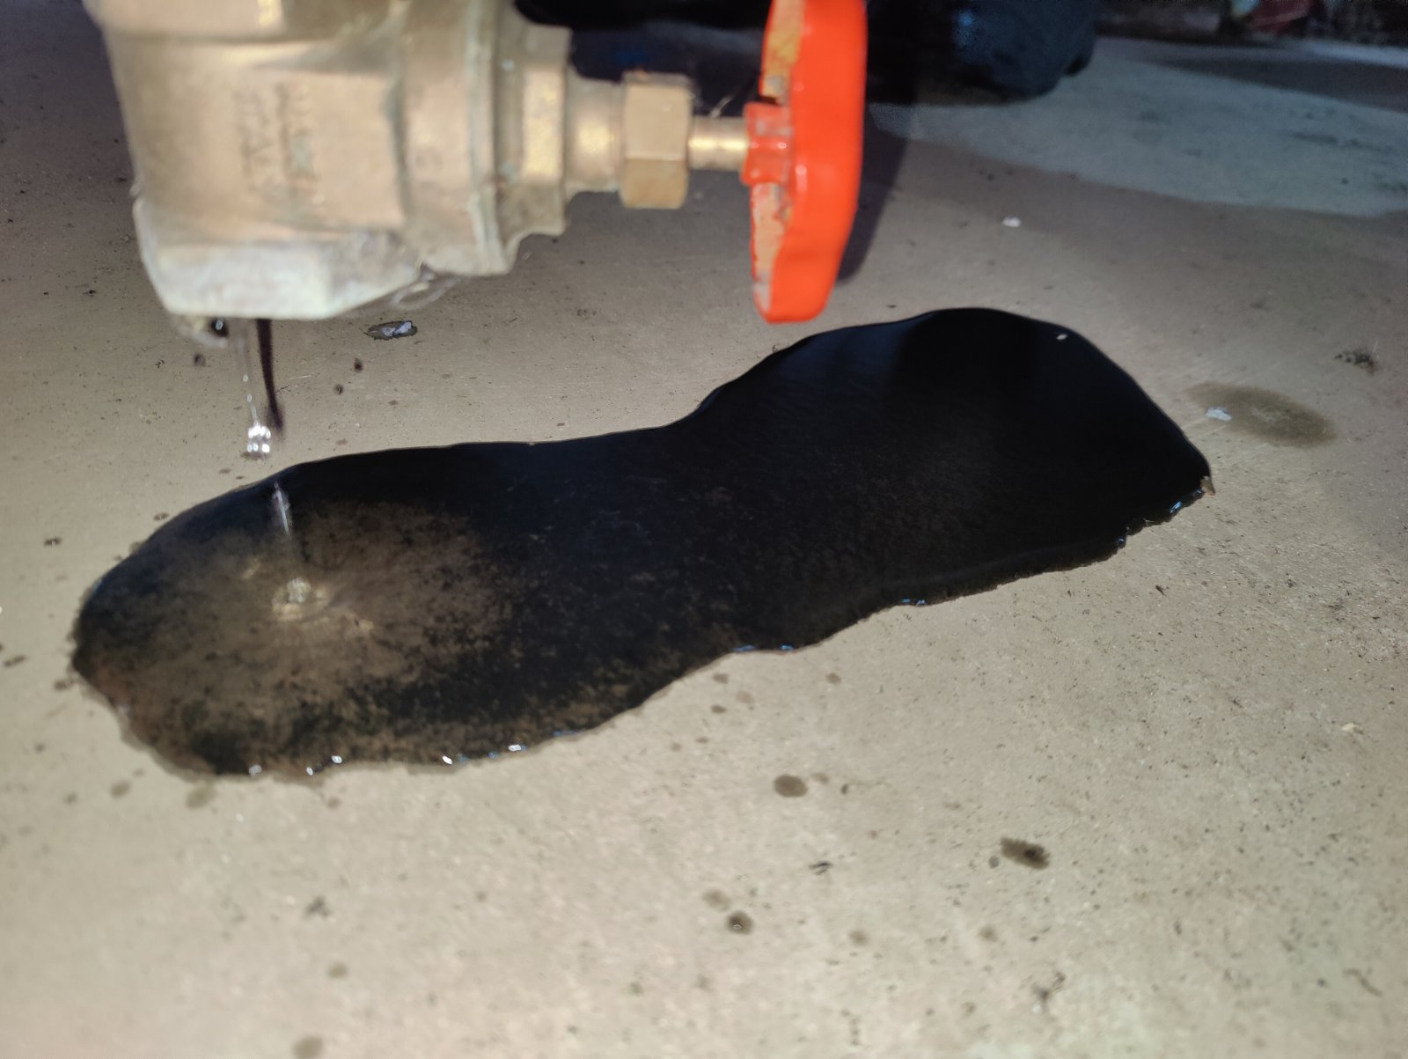 | 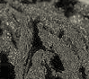
а | b
Figure 1. Biological contamination of sand and gravel filters: a – small particles of algae in water drained from the filter; b – large conglomerates of algae.

Analysis of recent research and publications. Since the emergence of the problem of biological fouling of drip irrigation systems (late 1990s - early 2000s) and to this day, methods for cleaning drip irrigation pipelines and emitters from such contamination have followed similar methods for cleaning drinking water supply pipelines. The main method for a long time was chlorination [8]. Chlorination is quite effective in terms of destroying microbiota, but extremely dangerous from an ecological point of view. The disadvantages of chlorination of drip irrigation systems are the formation of toxic by-products: trihalomethanes, haloacetic acids, and chloramines. These compounds are toxic to plants, soil microbiota, and can pollute the environment [9]. In addition, chlorine causes corrosion of metal elements of the system (fittings, valves, pumps; elements of pressure control systems, etc.), and also leads to degradation of polymers, gradually destroying polyethylene and rubber parts (emitters, seals, tubes). Further searches for an effective cleaner for drip irrigation systems follow similar ways to overcome this problem in water supply: the use of sodium hypochlorite (NaOCl), chlorine dioxide (ClO₂), and hydrogen peroxide (H₂O₂) [10, 11, 12]. All of these substances are quite successful in destroying biological contamination (biofilms, bacteria, algae, fungi, etc.) also in drip irrigation systems. However, sodium hypochlorite can cause corrosion of system elements (which reduces their service life) and form harmful by-products, such as trichloromethanes. The use of chlorine dioxide, compared to chlorination and the use of sodium hypochlorite, reduces the risks of the formation of some organochlorine by-products, but does not guarantee their complete elimination, and, in addition, it has higher cost and more complex application technology. Hydrogen peroxide does not leave a chlorine residue, but it is quite corrosive and has a short life period, which makes it practically impossible to flush drip irrigation pipelines longer than 20...30 m.
The shortcomings of the existing methods for cleaning drip irrigation systems from biological contaminants necessitate the search for new, more effective and environmentally friendly methods for their cleaning. In the process of such a search, the authors drew attention to anolytes - electrochemically activated (ECA) low-concentrated salt solutions with high oxidation-reduction potential (ORP).
The history of the invention and development of electrolyzed water is associated with the Japanese company FUJIIRYOKI, which in 1931-1950 initiated scientific research into the production of such water and the study of its impact on the development of agricultural plants [13]. In the territory of the former USSR, work on the study of ECA water began in the 1970s in Uzbekistan by a group of scientists led by PHD in Technical Sciences V. Bahir. The influence of the components of ECA water (catholyte and anolyte) on the properties of drilling fluids was studied, and high bactericidal properties of one of these components – anolyte – were discovered by chance. That was when the names "living water" appeared - for the catholyte - the alkaline component, and "dead water" - for the anolyte - the acidic component of ECA water. Catholytes, in addition to high alkalinity (pH 10 and above), are characterized by a negative ORP: -400 mV. The effect of catholytes on biological organisms, both of plant and animal origin, is manifested in their regenerative (antioxidant) and stimulating effects: seed germination improves along with plant growth and development; for humans and animals, catholyte promotes cell regeneration, but excessive or prolonged use can disrupt the acid-base balance. At the same time, the effect of catholytes on living organisms is less predictable than the effect of anolytes.
Anolytes, unlike catholytes, have high acidity (pH 5 and below) and high ORP values (+500 and above). The acceptor properties of anolytes determine their high bactericidal activity against almost all types of microorganisms. Anolytes destroy bacteria, viruses, fungi, and spores by destroying cell walls and membranes, oxidizing enzymes and DNA, and in plants at low concentrations they can stimulate germination, growth, and disease resistance. Anolytes are safe for animals and humans when properly diluted, but highly concentrated solutions can irritate mucous membranes. In general, catholyte and anolyte are paradoxical liquids, since their properties cannot be explained in terms of the normal physics and chemistry of water solutions. Being highly active substances, they are environmentally safe, and the ultra-low salt content in them (from 0.01 to 0.5%) cannot explain their high activity. With the time that has passed since the discovery of the phenomenon of ECA water, many studies have been conducted on the influence of ECA water components on the processes of development and vital activity of plants and animals. Summarizing the research results, including the results of the authors of the paper [14], on the assessing the influence of ECA water components on plant development, we can state that irrigation with water solutions of catholytes (or their mixtures with anolytes) accelerates the germination and the development of vegetable crops and increases their yield. At the same time, it should be noted that this effect is quite differentiated and significantly depends on both the parameters of irrigation solutions (pH, ORP), and on the type of plants and stages of their development. In addition, one of the properties of catholytes is their rapid relaxation - the loss of biologically stimulating properties within a short time (several hours), which requires their production directly in the field - near the pumping stations of irrigation systems. All this significantly complicates and reduces the potential effectiveness of the use of catholytes in irrigated agriculture.
Unlike catholytes, the results of using anolytes are much more predictable and can be achieved much more easily technologically. Acting as universal, environmentally friendly and powerful antiseptics, anolytes have been used in the agricultural sector as environmentally safe disinfectants in the food industry and livestock farming since the middle of the first decade of this century [15, 16]. An important advantage of anolytes over catholytes is also their sufficiently long life period. These properties were acquired by neutral anolytes ANK, which began to be produced on advanced installations for the generation of ECA water starting from the end of the last - beginning of this century. Anolytes ANK are characterized by pH 6.5…7.2 and ORP +800…+900 mV with a guaranteed life period of at least 1 year.
Aim of the research is to determine the main characteristics of Ukrainian neutral anolytes ANK and to substantiate the possibility of their use for cleaning emitters and pipelines of drip irrigation systems from contaminants of biological origin, as well as the ability of Ukrainian manufacturers of anolytes ANK to meet the needs of the users of drip irrigation systems.
Research methods and materials. Analytical, laboratory, field, mathematical-statistical, and comparative research methods were used. Analytical methods were used in planning and summarizing laboratory and field research, assessing the market for Ukrainian anolytes ANK, etc. Laboratory, field, and comparative studies were conducted to determine the effectiveness of flushing emitters and drip irrigation pipelines with environmentally safe neutral ANK anolytes of Ukrainian manufacturers ("AQUA SALIS", "Krystal", and "Secobren") and environmentally hazardous 15% sodium hypochlorite produced in the PRC. Mathematical and statistical research methods were used in processing the results of laboratory and field studies. The presence of a biological component of pollution was determined using the Biuret reaction. Laboratory studies of the action of anolytes ANK on the cleaning of drip water emitters of a drip tape manufactured by «Metzer» (Ultra Lin W.T. - 0.15 - 5F mil, with a diameter of 16 mm and a number of emitters of 20 pcs. with a distance between emitters equal to 20 cm) from contamination by organic compounds were carried out on a stand for testing drip irrigation pipelines (Fig. 2) in the Laboratory for Testing Irrigation and Drainage Means of the Institute of Water Problems and Land Reclamation of the National Academy of Agrarian Sciences of Ukraine (IWP&LR of NAAS) (Certificate of Measurement Capabilities No. PT-8/24 dated 01/11/2024). The flow rates of the emitters were determined by the volumetric method using 25 ml measuring cups and a stopwatch. The determination time at each pressure was 60 s. The pressure was created by the test bench pump, controlled by a manometer, and the pressure was regulated by a valve. The studies were conducted according to the microirrigation technical equipment testing methodology developed at the IWP&LR of NAAS [17].

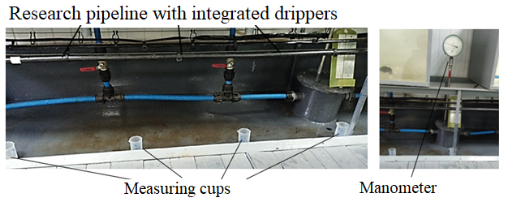
Figure 2. Laboratory stand for testing water emitters and irrigation pipelines

Field research (tests) were conducted on drip irrigation systems of POA "UKRAINE" of Boryspil district, Kyiv region, Ukraine, and FG "GRASS AVENUE" of Zhytomyr district, Zhytomyr region (village Zabilochchya), Ukraine. The research was conducted on drip irrigation pipelines manufactured by the Spanish company AZUD, 136 m long and with a nominal passage diameter of 16 mm, equipped with adjustable (compensated) emitters with a nominal flow rate of 1 l/h and a distance between emitters equal to 40 cm.
The testing procedure included:
• emptying the irrigation pipelines (in turn) through the end taps followed by rinsing them with irrigation water for 5 minutes;
• measurement of pipeline flow rates with irrigation water supply at a nominal pressure of 0.17 MPa;
• filling pipelines with anolyte ANK flushing solution diluted with irrigation water in a ratio of 1:30;
• keeping the flushing solution in the pipelines for 48 hours;
• draining the flushing solution through the end taps and flushing the pipelines with irrigation water during 5 minutes;
• measurement of pipeline flow rates after flushing with irrigation water at a nominal pressure of 0.17 MPa.
The supply of irrigation water to the pipelines, as well as the preparation of flushing solutions, was carried out withdrawing water from the distribution pipeline of the pumping station. The preparation of the flushing solution was carried out in a mixing tank with a volume of 100 dm³ (Fig. 3a), from which it was then pumped into the pipelines. Pressure was maintained using taps and controlled by a manometer with a measurement range of 0…0.6 MPa and a division value of 0.01 MPa of a portable measuring stand (Fig. 3b). The flow rates were determined using a volumetric water meter with a division value of 0,1 dm³ as part of the stand (Fig. 3c) and a stopwatch.

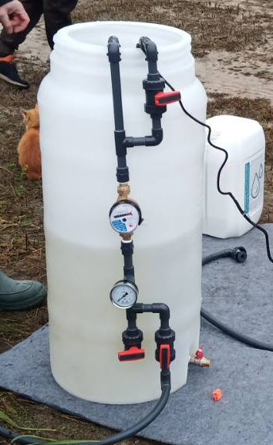 | 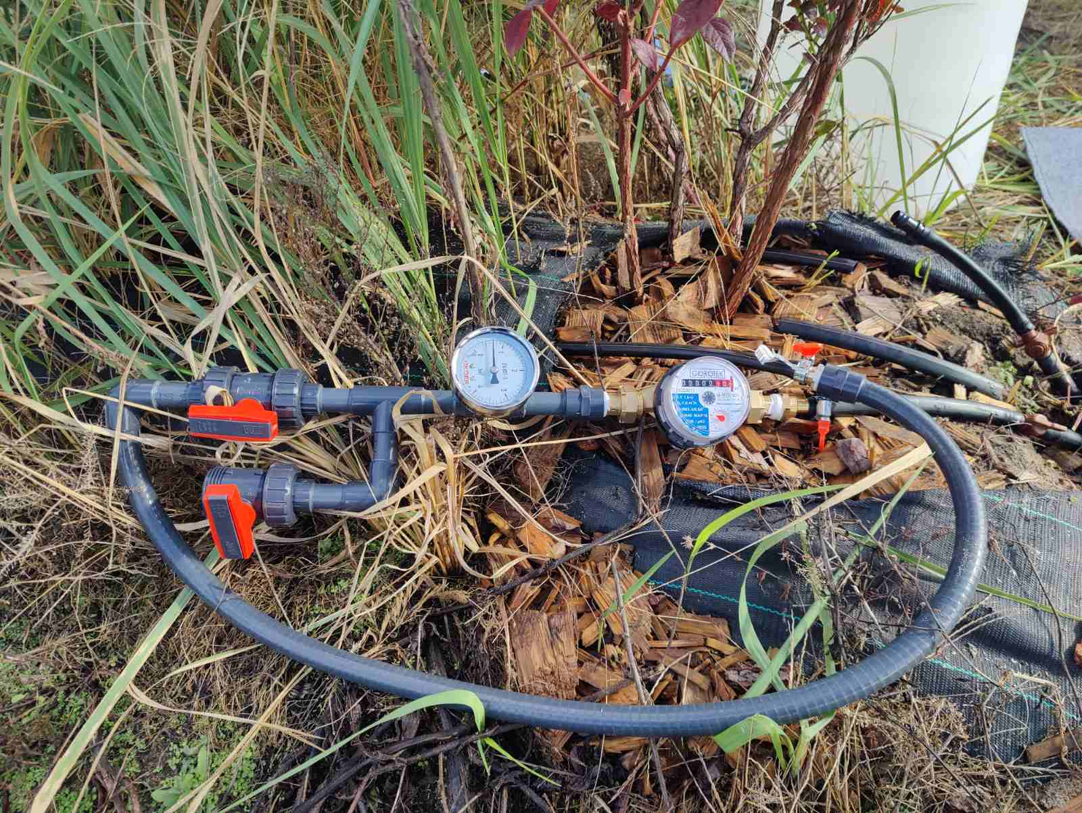 | 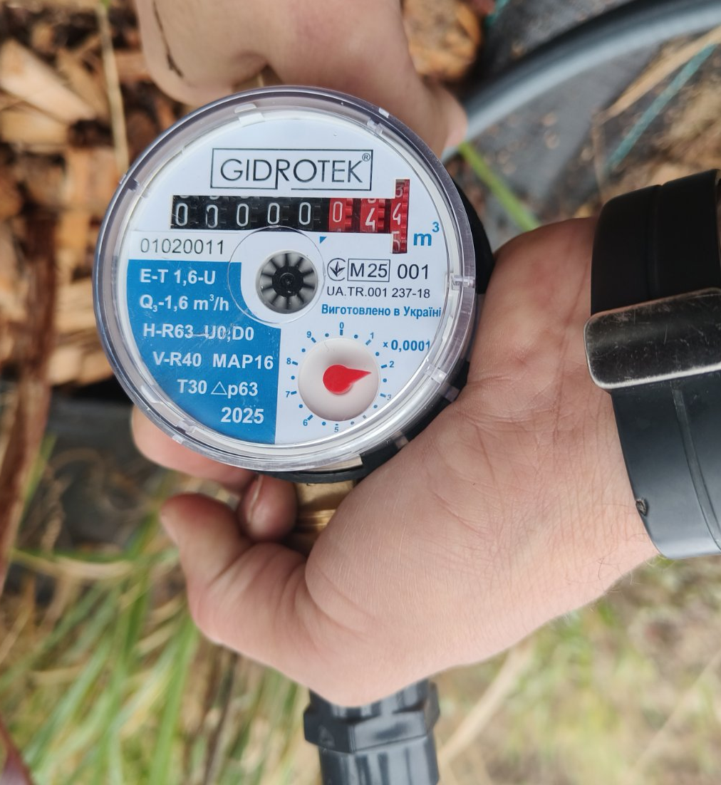
а | b | c
Figure 3: Technical means of research (a – container with a pump inside for preparing the flushing solution and a line for pumping the solution into the pipeline; b – portable test stand with taps, a pressure gauge, and a water meter (also serves as a line for pumping the working solution into the pipeline); c – volumetric water meter).

Research results. Analysis of the Ukrainian market of anolytes ANK revealed the presence of 6 varieties: “Aquasalis”, “Krystal”, “Secobren”, “Sterilox”, “Vitalmix”, and “Allsteril” (Fig. 4). The production capacity of these anolytes ranges from 0.3 to 0.8 m³/h.

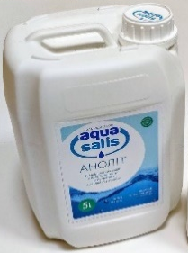 | 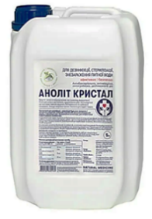 | 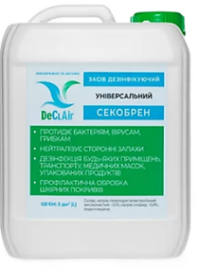 | 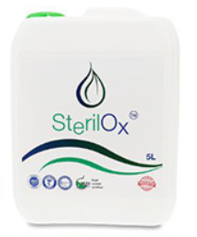 | 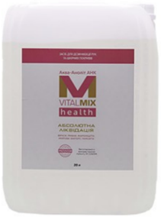 | 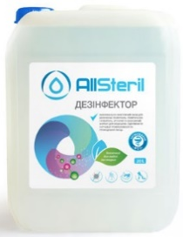
а | б | в | г | д | е
Figure 4: Neutral anolytes ANK of Ukrainian production: a - "Aquasalis"; b - "Krystal"; c - "Secobren"; d - "Sterilox"; e - "Vitalmix"; e - "Allsteril".

Studies of the changes in the physicochemical properties of anolytes produced in Ukraine at different degrees of dilution with water allowed us to conditionally divide them into two groups according to the similarity of the main parameters (TDS, ppm, pH and ORP, mV) both in the initial state and after dilution with water in ratios from 1:5 to 1:50.

Table 1 shows changes in TDS, ppm, pH and ORP, mV of anolytes “Aquasalis”, “Krystal”, and “Secobren” (first group), Table 2 shows changes in anolytes “Sterilox”, “Vitalmix”, and “Allsteril” (second group).

1. Change in TDS, pH and ORP parameters of anolytes "Aquasalis", "Krystal", and "Secobren" depending on the degree of their dilution with water (water characteristics: TDS, ppm = 211 pH = 7.5; ORP, mV = 256 mV; T. deg. С⁰ = 23.4).
Name | “Aqua Salis” |  |  | «Krystal» |  |  | «Secobren»
Dilu- tion | TDS, ppm | рН | ORP, mV | TDS,  ppm | рН | ORP, mV | TDS, ppm | рН | ORP, mV
0 | 236 | 6,5 | 890 | 512 | 6,3 | 914 | 311 | 8,1 | 822
1:5 | 568 | 7,0 | 835 | 378 | 6,6 | 862 | 524 | 7,9 | 803
1:10 | 403 | 7,1 | 819 | 283 | 6,8 | 823 | 440 | 7,7 | 802
1:20 | 317 | 7,3 | 805 | 251 | 7,1 | 805 | 340 | 7,7 | 792
1:40 | 268 | 7,5 | 763 | 242 | 7,2 | 763 | 283 | 7,7 | 774
1:50 | 258 | 7,5 | 767 | 239 | 7,3 | 651 | 271 | 7,7 | 748

As can be seen from the data presented in Table 1, despite the significant difference in the initial TDS values, the anolytes of this group have a pH close to neutral and an ORP exceeding +800 mV. It is especially important that even at high dilution rates with water (1:40), their ORP exceeds +750 mV, which will positively affect the bactericidal activity of their solutions.

2. Change in TDS, pH and ORP parameters of anolytes "Sterilox", "Vitalmix", and "Allsteril" depending on the degree of their dilution with water (water characteristics: TDS, ppm = 226 pH = 7.4; ORP, mV = 251 mV; T. deg. С⁰ = 24.5).
Name | «Sterilox» |  |  | «VITAMIX» |  |  | “Allsteril”
Dilu- tion | TDS,  ppm | рН | ORP, mV | TDS, ppm | рН | ORP, mV | TDS, ppm | рН | ORP, mV
0 | 446 | 6,2 | 892 | 492 | 6,3 | 850 | 211 | 6,0 | 845
1:5 | 270 | 6,6 | 856 | 969 | 7,2 | 772 | 512 | 6,4 | 763
1:10 | 239 | 7,0 | 801 | 632 | 7,4 | 732 | 365 | 7,3 | 679
1:20 | 228 | 7,2 | 770 | 443 | 7,5 | 618 | 296 | 7,4 | 553
1:40 | 225 | 7,2 | 691 | 342 | 7,6 | 520 | 260 | 7,5 | 472
1:50 | 223 | 7,2 | 482 | 312 | 7,6 | 480 | 231 | 7,5 | 428

From the analysis of the data given in Table 2 it is clear that, despite the similar initial TDS, pH and ORP indicators when compared to the anolytes of the first group, in the anolytes of the second group, when diluted with water in proportions higher than 1:20, the ORP decreases to +770 mV in (“Sterilox”) and lower - to + 618 mV in “VITAMIX”, and to + 553 mV in “Allsteril”, which will negatively influence the bactericidal properties of their solutions. Therefore, the dilution of anolytes of the second group when used for washing emitters and irrigation pipelines of drip irrigation systems should not be more than 1:20, while for the anolytes of the first group, the dilution can be carried out in a ratio of 1:40.
The study of changes in the main characteristics (TDS, ppm, pH and ORP, mV) of the anolytes ANK "Krystal", "Sterilox", and "Allsteril" over time showed that they retain their properties for a fairly long time (20 days) (Fig. 5). Fig. 5a shows that with a significant difference in the total salt content of the studied anolytes (from 200 to 1000 ppm), the nature of changes in this indicator over time is almost unchanged. Changes in the pH and ORP values for the anolytes (Fig. 5b, 5c) are more significant compared to the salt content, but these changes not only do not worsen, but on the contrary, due to the increase in ORP, improve the bactericidal effect of the anolytes. This gives reason to believe that it is possible to store anolytes for a relatively long time and deliver them to drip irrigation systems directly from manufacturers, which significantly improves the possibilities of using anolytes ANK to clean emitters and pipelines of drip irrigation systems from contaminants of biological origin.

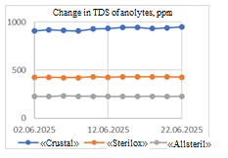 | 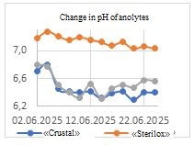 | 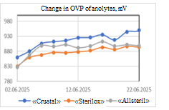
а | b | c
Figure 5. Time-dependent changes in TDS, ppm (a); pH (b) and ORP, mV, of the anolytes ANK "Krystal", "Sterilox", and "Allsteril".

The feasibility of using anolytes ANK to clean emitters and pipelines of drip irrigation systems from contaminants of biological origin was substantiated based on the results of laboratory and field studies conducted in 2024-2025.
Laboratory studies in 2024 included a comparison of the effectiveness of flushing drip tape emitters with sodium hypochlorite "Akvador" (PRC) with an active chlorine content of 15%, and anolytes "Krystal" and "Secobren". Flushing was carried out in two stages: in the first stage, the concentration of the solutions was 1% at pressures from 0,025 to 0,1 MPa, in the second stage, the concentration was 5% at pressures from 0,15 to 0,3 MPa. Before flushing, one of the samples was filled with "Akvador", the second one - with "Krystal", and the third one - with "Secobren". All samples filled with these substances were kept for 48 hours, after which they were flushed with water at pressures from 0,025 to 0,3 MPa. The results of laboratory studies confirmed high flushing ability of environmentally safe anolytes “Krystal” and “Secobren”, which is not inferior to the washing effect of environmentally dangerous hypochlorite “Akvador” (Table 3) [19].

3. Assessment of changes in the flow characteristics of drip water emitters depending under the influence of different types of detergents
Active ingredient | %, drip water emitters | Pressure, MPa
Active ingredient | %, drip water emitters | 0,15 |  |  | 0,2 |  |  | 0,25 |  |  |  | 0,3
Active ingredient | %, drip water emitters | Flow rate depending on pressure, ml/60s
Active ingredient | %, drip water emitters | before | after | %, changes from nominal | before | after | %, changes from nominal | before | after | %, changes from nominal | before |  | after | %, changes from nominal
Aqua  Doctor | 33 | 0 | 7 | 50 | 0 | 11 | 79 | 0 | 14 | 100 | 12 |  | 14 | 100
Aqua  Doctor | 33 | 0 | 0 | 0 | 0 | 0 | 0 | 0 | 0 | 0 | 0 |  | 0 | 0
Aqua  Doctor | 34 | 1 | 0 | 0 | 2 | 0 | 0 | 4 | 0 | 0 | 3 |  | 0 | 0
Secobren | 25 | 8 | 10 | 71 | 13 | 13 | 93 | 12 | 13 | 93 | 12 |  | 13 | 93
Secobren | 25 | 7 | 8 | 57 | 10 | 10 | 71 | 10 | 11 | 79 | 10 |  | 12 | 86
Secobren | 25 | 6 | 8 | 57 | 9 | 9 | 64 | 10 | 10 | 71 | 11 |  | 10 | 71
Secobren | 25 | 5 | 1 | 7 | 4 | 4 | 29 | 12 | 12 | 86 | 13 |  | 13 | 93
Krystal | 20 | 7 | 7 | 50 | 9 | 10 | 71 | 11 | 11 | 79 | 12 |  | 12 | 86
Krystal | 20 | 7 | 8 | 57 | 6 | 10 | 71 | 9 | 10 | 71 | 7 |  | 8 | 57
Krystal | 20 | 6 | 7 | 50 | 8 | 10 | 71 | 11 | 11 | 79 | 11 |  | 12 | 86
Krystal | 20 | 7 | 7 | 50 | 8 | 10 | 71 | 11 | 12 | 86 | 12 |  | 13 | 93
Krystal | 20 | 0 | 0 | 0 | 0 | 0 | 0 | 0 | 0 | 0 | 0 |  | 0 | 0

These results were confirmed by laboratory studies conducted in 2025 on the pressure-flow characteristics of pipelines with 20 emitters "before" and "after" flushing with 15% sodium hypochlorite "AquaDoctor" (Fig. 6a) and anolyte "Krystal" (Fig. 6b). The flow rate of the pipeline after flushing with hypochlorite "AquaDoctor", depending on the pressure, increased by 17,6-52,3%, and with anolyte "Krystal" - by 23,7-92,0%. In this case, the pressure-flow characteristics of pipelines with 20 emitters before and after flushing in the pressure range of 0,075 – 0,2 MPa are approximated by the dependencies shown in Fig. 6.
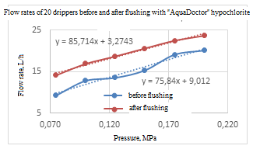 | 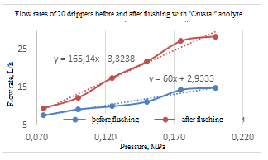
а | b
Figure 6. Pressure-flow characteristics of pipelines with 20 emitters before and after flushing with sodium hypochlorite "AquaDoctor" (a) and anolyte ANK "Krystal" (b).

The results of field research conducted in 2024 in the POA "UKRAINE", Boryspil district, Kyiv region, Ukraine, on the quality of flushing the pipelines of the subsurface drip irrigation system with anolytes ANK "Krystal" and "Secobren" and 15% hypochlorite "AquaDoctor" showed comparable results of the quality of flushing with all three tested substances. Visual analysis of the condition of the inlet filters of the emitters of the drip irrigation pipelines "before" and "after" flushing showed a high degree of cleaning of the emitters with anolytes (Fig. 7) [19].
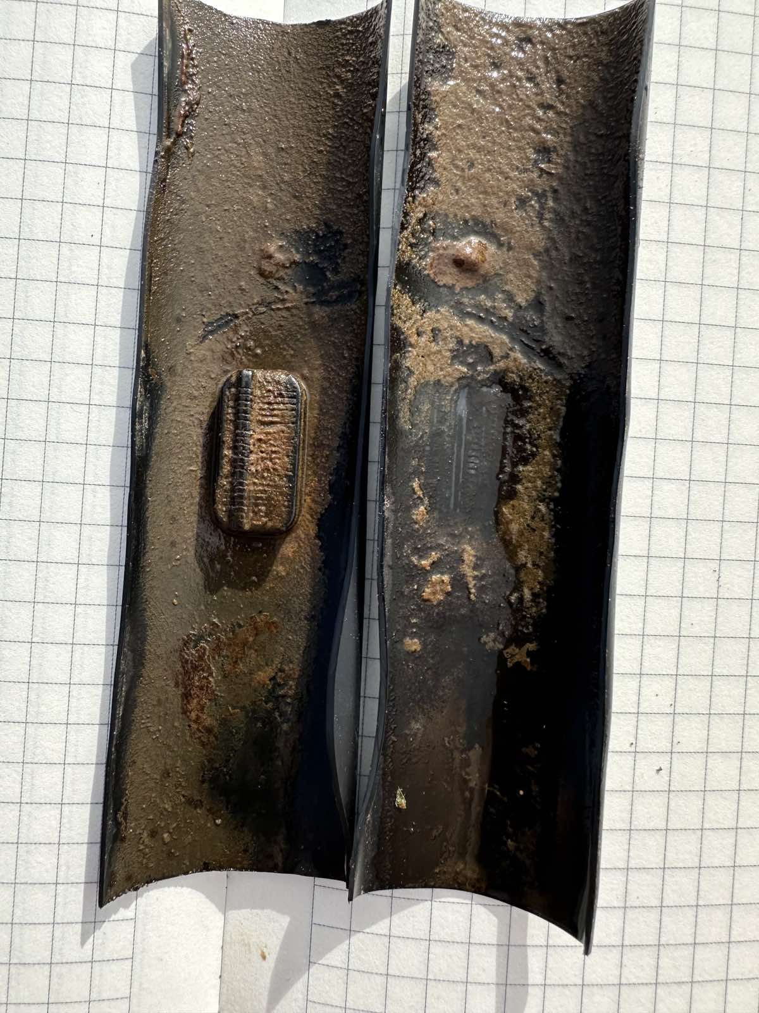а |   b | 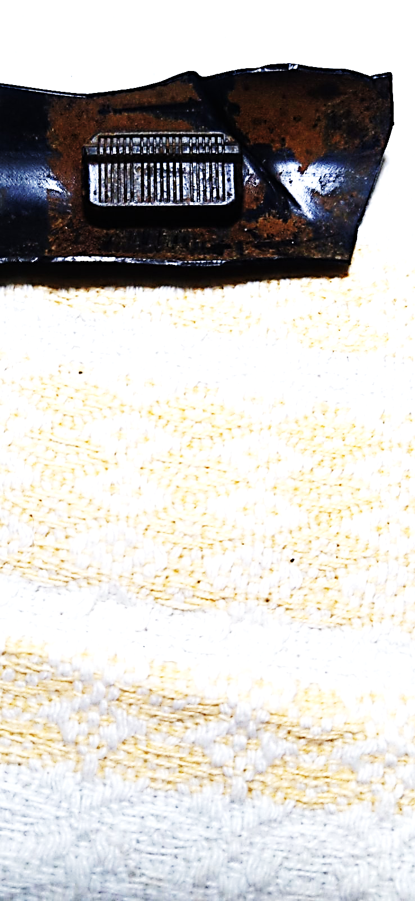  c
Figure 7. The emitters from the side of the inlet filter: a - before washing; b, c - after washing.

During field research in 2025 on the subsurface drip irrigation system of the "GRASS AVENUE" FG, Zhytomyr district, Zhytomyr region, Ukraine, the flushing effect of anolyte ANK diluted with irrigation water in a ratio of 1:30 was determined by the changes in the flow rate of two pipelines at a nominal pressure of 0,017 MPa "before" and "after" flushing. The flow rate of both pipelines before flushing was 382 l/h. After flushing the pipelines with anolyte, the flow rate of one of the pipelines increased to 390 l/h (an increase by 2%), of the other one - to 395 l/h (by 3,5%). At the same time, as in 2024, a high degree of cleaning of the inlet filters of the drip water emitters was visually observed (Fig. 8a), as well as a significant increase in the contamination of the drained water “before” and “after” flushing with anolyte (Fig. 8b, 8c).

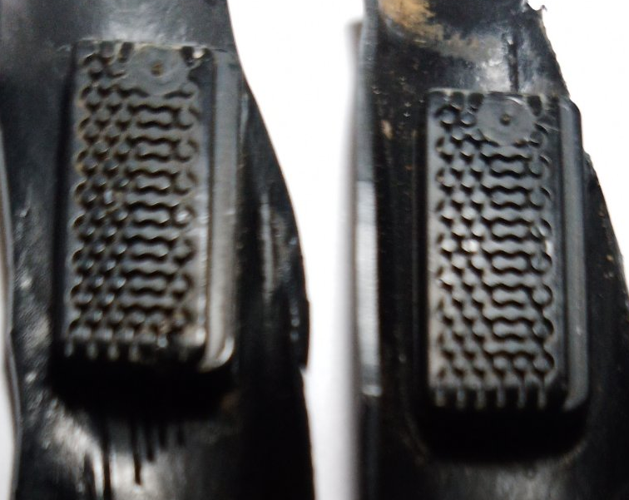 | 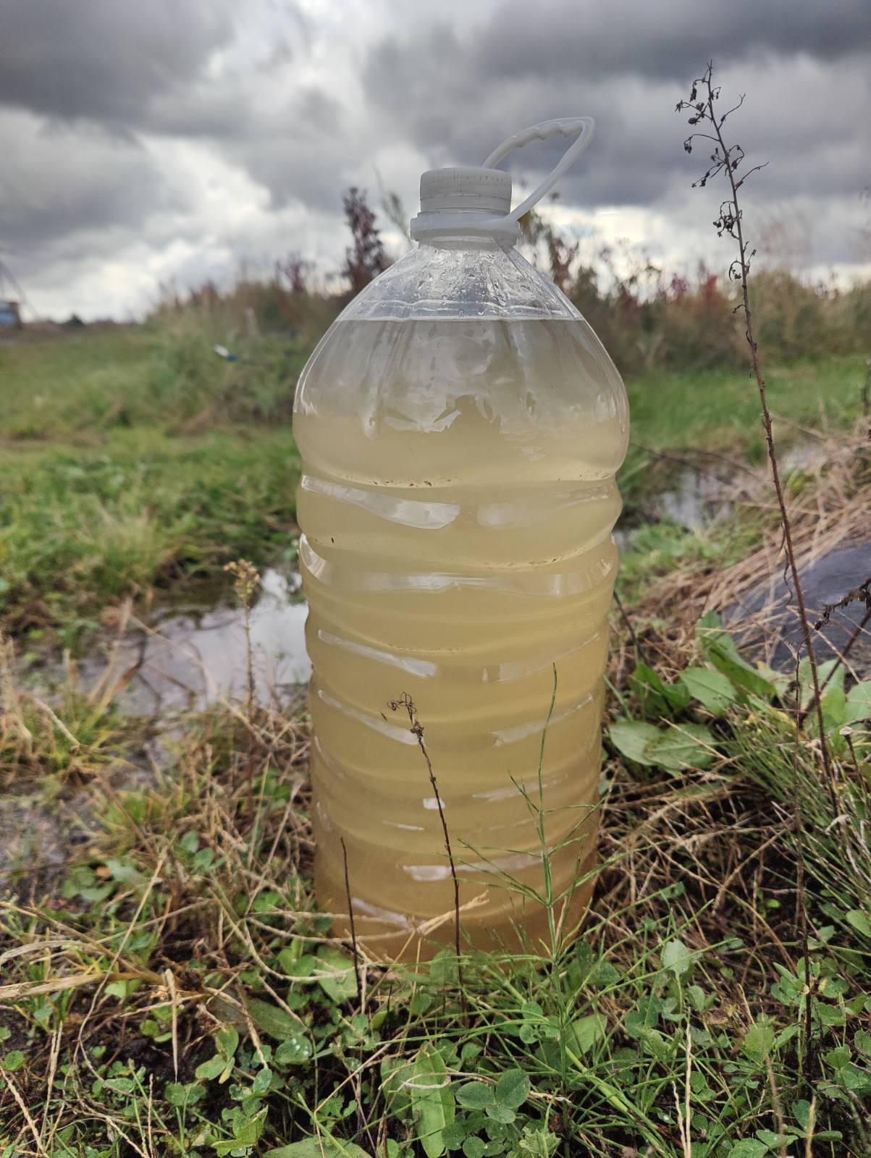 | 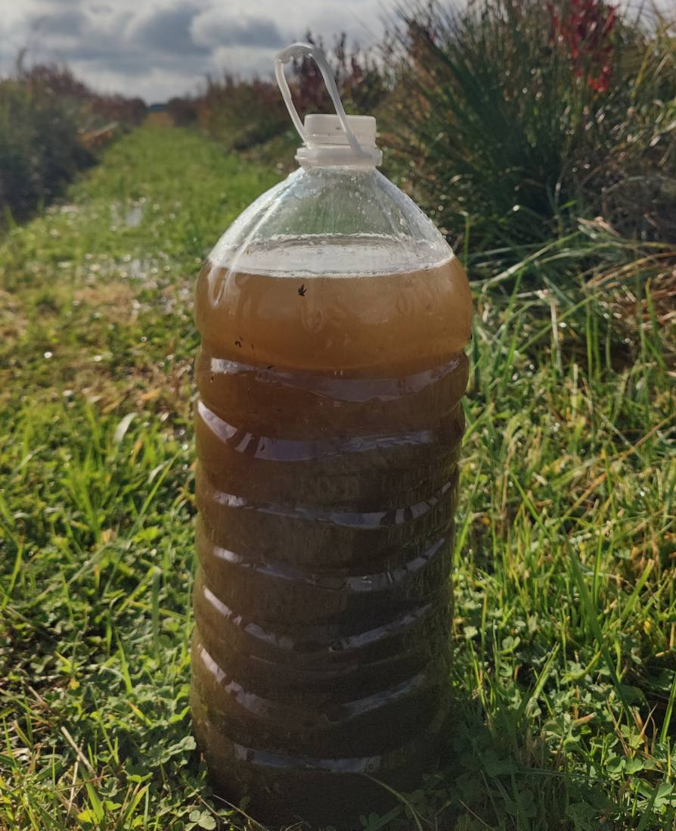
а | b | c
Figure. 8: a – view of the emitters at the heads of both pipelines; b – drained water before flushing with anolyte; c – drained water after flushing with anolyte.

As a result of the research, an assessment was made on the ability of Ukrainian producers of anolytes ANK to meet the needs for cleaning emitters and pipelines of drip irrigation systems in Ukraine from pollution of biological origin. The following initial data were adopted in the calculations: the total area of drip irrigation systems in the country is 50 thousand hectares; the required volume of anolyte to fill irrigation pipelines on an area of 1 hectare, depending on their diameters and provided that the anolyte is diluted with irrigation water in a ratio of 1:30 – 0,45...0,7 m³. Accordingly, for a single flush (provided that 50% of drip irrigation systems need to be flushed) about 11,250...17,500 m³ of anolyte ANK is required per year. The existing total capacity of Ukrainian production of anolytes ANK per day can reach 60 m³, which significantly exceeds the annual need for them for the purposes of cleaning drip irrigation systems from contaminants of biological origin.
Conclusions. It has been proven that neutral anolytes ANK of Ukrainian production are an environmentally safe and effective alternative to the chemicals - chlorine, 15% sodium hypochlorite, chlorine dioxide, and hydrogen peroxide, which are currently used to flush emitters and drip irrigation pipelines from contamination of biological origin. It has been established that from the point of view of maintaining bactericidal activity and economic efficiency, the rational proportion of dilution with irrigation water of anolytes "Aquasalis", "Krystal", and "Secobren" is 1:40, of anolytes "Sterilox", "Vitalmix" and "Allsteril" - 1:20. It has been determined that the capacities of Ukrainian producers of anolytes ANK are able to satisfy the needs of farmers in the country for carrying out measures to flush emitters and drip irrigation pipelines from contamination of biological origin.

References
1. Flemming, H. C. (2002). Biofouling in water systems: Cases, causes and countermeasures. Applied Microbiology and Biotechnology, 59(6), 629–640. https://doi.org/10.1007/s00253-002-1066-9
2. Pick, F. C., Fish, K. E., Husband, S., & Boxall, J. B. (2021). Non-invasive biofouling monitoring to assess drinking water distribution system performance. Frontiers in Microbiology, 12. https://doi.org/10.3389/fmicb.2021.730344
3. Usatyi S. V., & Usataа, L G. (2016). Biolohichne zabrudnennia vody v systemakh kraplynnoho zroshennia. [Biological water contamination in drip irrigation systems]. Land Reclamation and Water Management. 104, 57-66 [in Ukrainian].
4. Changjian, M., Li, M., Hou, P., Wang, X., Sun, Z., Li, Y., Xiao, Y., & Li, Y. (2024). Biofilm dynamic changes in drip irrigation emitter flow channels using reclaimed water. Agricultural Water Management, 291, Article 108624. https://doi.org/10.1016/j.agwat.2023.108624
5. Ramachandrula, V. R., & Kasa R. R. (2022). .Prevention and treatment of drip emitter clogging: a review of various innovative methods. Water Practice and Technology, 17 (10), 2059–2070. doi: https://doi.org/10.2166/wpt.2022.11
6. Shi K., Lu T., Zheng W., Zhang X., & Zhangzhong L. (2022). A review of the category, mechanism, and controlling methods of chemical clogging in drip irrigation system. Agriculture, 12(2), 202. https://doi.org/10.3390/agriculture12020202
7. Dehghanisanij, H., Mirlatifi, S. M., Emami, S., & Rajabzadeh, T. (2025). Reducing the clogging of emitters in drip irrigation systems using acid washing and ultrasonic technology. Scientific Reports, 15(1). https://doi.org/10.1038/s41598-025-95915-w
8. Li J., Chen, L., Li, Y., Yin, J., & Zhang H. (2010). Effects of chlorination schemes on clogging in drip emitters during application of sewage effluent. Applied Engineering in Agriculture, 26(4), 565–578. https://doi.org/10.13031/2013.32067
9. Hao, F., Wang, Z. & Zhen, Z. (2024). Influence of lateral length and residual chlorine concentration on soil nitrogen and soil enzyme activities under drip irrigation with secondary sewage effluent. Agronomy, 14(7), 153. https://doi.org/10.3390/agronomy14071538
10. University of California, Agriculture and Natural Resources. (2025). Maintenance of microirrigation systems. https://ucanr.edu/site/maintenance-microirrigation-systems/chlorination
11. EAI Water. (2025). Chlorine dioxide biofilm control in cannabis dripper systems. https://eaiwater.com/chlorine-dioxide-biofilm/
12. Verhoeven, J. (2023). Cleaning the drip system during cultivation with hydrogen peroxide. Royal Brinkman. https://royalbrinkman.com/knowledge-center/technical-projects/cleaning-drip-system-during-cultivation
13. Fujiiryoki. (2025). History of alkaline ionized water (electrolyzed reduced water) in Japan. https://www.fujiiryoki.in/history-of-alkaline-ionized-water-electrolyzed-reduced-water-in-japan/
14. Romashchenko, M., Konakov, B., Nikytiuk, O., & Yarosh, A. (2023). Evaluation of possibilities for using electrochemically activated water for irrigation. Land Reclamation and Water Management, (2), 50 - 58. https://doi.org/10.31073/mivg202302-365
15. Orejel, R.J, & Cano-Buendía, J. A. (2020). Applications of electrolyzed water as a sanitizer in the food and animal by-products industry. Processes, 8(5), 534. https://doi.org/10.3390/pr8050534
16. Mandyhra, M. S., Lysytsia, A. V., Hnatiuk, D. M., Hryshchuk, V. P., & Mandyhra, Yu. M. (2020) Vykorystannia elektrokhimichno aktyvovanykh (EKhA) rozchyniv u veterynarnii medytsyni i orhanichnomu vyrobnytstvi: (naukovo-praktychni rekomendatsii). [The use of electrochemically activated (ECA) solutions in veterinary medicine and organic production: (scientific and practical recommendations)]. Lutsk: PP Ivaniuk V.P. 84 [in Ukrainian].
17. Romashchenko, M. I., Usaty, S. V., Usata, L. G., Kalenikov, A. T., Prysiazhniuk, V. V., & Kupiedinova, R. A. (2014). Metodyka vyprobuvan tekhnichnykh zasobiv mikrozroshennia [Testing technique of microirrigation equipment]. Romashchenko, M. I. (Ed.). Kyiv. [in Ukrainian].
18. Zroshennya. Yakistʹ vody dlya system kraplynnoho zroshennya. Ahronomichni, ekolohichni ta tekhnichni kryteriyi [Water quality for drip irrigation systems. Agronomic, environmental and technical criteria]. (2014). DSTU 7591:2014. Natsionalnyi standart Ukrainy. Kyiv: Ministry of Economic Development of Ukraine.[in Ukrainian].
19. Romashchenko, M., Konakov, B., Timoshevskyi, A., Polishchuk, V., & Kovalenko, I. (2024). Evaluation of the possibility of flushing of drip irrigation systems with electrochemically activated low-concentration salt solutions. Land Reclamation and Water Management, (2), 45 - 54. https://doi.org/10.31073/mivg202402-390

УДК 631.811.982

Дослідження можливості застосування анолітів АНК для очищення систем краплинного зрошення від забруднень біологічного походження

М.І. Ромащенко¹, докт. техн. наук, Б.І. Конаков², канд. техн. наук, В.В.Поліщук³, канд. с.-г. наук, О.В. Томашевський⁴, І.О. Коваленко⁵, доктор філософії

- Інститут водних проблем і меліорації НААН, Київ, Україна;
https://orcid.org/0000-0002-9997-1346; e-mail: mi.romashchenko@gmail.com;
- Київський аграрний університет НААН, Київ, Україна;
https://orcid.org/0000-0003-3065-4745; e-mail: crony@meta.ua;
- Інститут водних проблем і меліорації НААН, Київ, Україна;
https://orcid.org/0000-0003-0429-7406; e-mail: vitaliypolishchuk@ukr.net;
- ТОВ «Ірігатор Україна», Одеса, Україна;
https://orcid.org/0009-0004-3214-4217, e-mail: aleksandr.timoshevskyi@gmail.com;
- Інститут водних проблем і меліорації НААН, Київ, Україна;
https://orcid.org/0000-0003-1548-3992, e-mail: igor13081995@gmail.com

Анотація. Досліджено перспективи використання вітчизняних нейтральних анолітів АНК для очищення емітерів і трубопроводів систем краплинного зрошення від забруднень біологічного походження. Визначено релаксаційні характеристики вітчизняних нейтральних анолітів АНК, встановлено зміни їх основних характеристик (TDS, ppm; pH; ORP, mV) залежно від ступеню розведення водою, виконано оцінку ринку та потужностей вітчизняного виробництва анолітів АНК. Застосовано лабораторні, лабораторно-аналітичні, польові та математико-статистичні порівняльні методи досліджень з визначення ефективності промивки емітерів і трубопроводів краплинного зрошення екологічно безпечними нейтральними анолітами АНК вітчизняних виробників ("AQUA SALIS", «Кристал» та «Секобрен») і екологічно небезпечним 15% гіпохлоритом натрію виробництва КНР. Наявність біологічної компоненти забруднень з’ясовувалась за допомогою Біуретової реакції. Встановлено, що отримання ефективних розчинів для промивки емітерів і трубопроводів систем краплинного зрошення від забруднень біологічного походження, з ОВП не меншим, ніж +750 мВ , можливо за розведення поливною водою вітчизняних анолітів АНК «Aquasalis», «Кристал» і «Секобрен» в пропорції 1:40; «Sterilox», «Vitalmix» та «Аllsteril» - в пропорції 1:20.
Отримано візуальні і кількісні показники якості промивки емітерів і трубопроводів краплинного зрошення від забруднень біологічного походження. В лабораторних умовах визначено, що витрата краплинних трубопроводів з 20-ма емітерами, засмічених біологічними забрудненнями, після промивки гіпохлоритом «AquaDoctor», залежно від тиску, зросла на 17,6…52,3%, анолітом «Кристал» - на 23,7…92,0%. Промивка в польових умовах трубопроводів краплинного зрошення довжиною 136 м з 340 емітерами анолітами АНК призвела до збільшення витрат одного трубопроводу на 8 л/год, іншого – на 13 л/год.
Встановлено, що нейтральні аноліти АНК вітчизняного виробництва є ефективною і екологічно безпечною альтернативою хімічним речовинам (хлору, 15% гіпохлориту натрію, діоксиду хлору і пероксиду водню), які сьогодні використовуються для промивки емітерів і трубопроводів краплинного зрошення від забруднень біологічного походження. Визначено, що вітчизняні потужності виробництва анолітів АНК спроможні забезпечити потреби українських аграріїв для промивки емітерів і трубопроводів краплинного зрошення.
Ключові слова: системи краплинного зрошення, краплинні водовипуски, забруднення біологічного походження, промивки, електрохімічно активовані низькоконцентровані сольові розчини, аноліт, гіпохлорит натрію

