DOI:
Available at (PDF):
UDС 631.67:004

CALCULATION AND VISUALIZATION OF WATER CONSUMPTION RATES OF CROPS WHEN USING INFORMATION TECHNOLOGIES

T.V. Matiash¹, Ph.D. in Technical Sciences, Y.O. Butenko², Ph.D. in Agricultural Sciences, V.M. Popov³, Doctor of Technical Sciences, N.V. Soroka⁴, A.F. Saliuk⁵, A.M. Smirnov⁶
- Institute of Water Problems and Land Reclamation of the National Academy of Agricultural Sciences, Kyiv, Ukraine; https://orcid.org/0000-0003-1225-086X; e-mail: t.v.matiash@gmail.com;
- Institute of Water Problems and Land Reclamation of the National Academy of Agricultural Sciences, Kyiv, Ukraine; https://orcid.org/0000-0002-1743-7175; e-mail: iarynabulba@gmail.com;
- Institute of Water Problems and Land Reclamation of the National Academy of Agricultural Sciences, Kyiv, Ukraine; https://orcid.org/0000-0003-2024-0290; e-mail: v_popov15@ukr.net;
- Institute of Water Problems and Land Reclamation of the National Academy of Agricultural Sciences, Kyiv, Ukraine; https://orcid.org/0000-0003-2868-1832; e-mail: soroka1975@ ukr.net;
- Institute of Water Problems and Land Reclamation of the National Academy of Agricultural Sciences, Kyiv, Ukraine; https://orcid.org/0000-0003-3968-1125; e-mail: allasaluk@ukr.net;
- Institute of Water Problems and Land Reclamation of the National Academy of Agricultural Sciences, Kyiv, Ukraine; https://orcid.org/0009-0006-5865-9141; e-mail: justtosha@gmail.com

Abstract. The article analyzes existing approaches to determining water consumption rates of crops for irrigation in Ukraine. They were estimated at the level of weather stations and regions, in view of climate change and the need for their constant updating using the developed automated system and information technologies. It was found that water need for growing crops has increased significantly, especially in the southern regions of Ukraine. This work is a continuation of the study of evapotranspiration, its components and dynamics based on remote sensing data and calculations when using the Penman-Monteith-Leuning method. The obtained results are presented in an interactive database and as visualized cartographic information. The rate calculation was carried out based on the potential evapotranspiration for the period 2005–2024, when using the biophysical Shtoiko method, which allows determining water consumption rates taking into account a natural moisture deficit. Meteorological data from regional weather stations operating in automatic mod as well as the information systems developed at the Institute of Water Problems and Land Reclamation were used for calculations. Water consumption was estimated based on water balance equations and multi-year series of agricultural and meteorological observations.
The average annual sowing dates and development phases of the main crops in the regions of Ukraine were also specified, with reference to weather stations, and the maps of water consumption spatial distribution were built. A database of crop water consumption rates was created with integrating geospatial parameters. Python software was developed using the Folium, Shapely, and Django libraries for data analysis and visualization. For geospatial presentation of the results, the zones of weather stations influence were calculated using the Thyssen-Voronyi polygon method. The study revealed a significant increase in water consumption rates for crops in Ukraine over the past two decades compared to the control climatic period of 1960-2000. In the Steppe zone, water consumption increased by 40%, in the Forest-Steppe and Polissya zones - by 15%. Data analysis for 2005-2024.
Analysis of data for 2005-2024 confirmed a further increase in water consumption in all climatic zones by an average of 18-25%. Combining these data with web tools increases the availability of information and promotes its practical use in agriculture. Maps of water consumption deficits for the warm period of the year, water consumption rates for corn and wheat for the years of 50%, 75% and 95% water supply deficit, which reflect regional variability in their distribution, were built. The study confirmed the need for constant updating of water consumption rates and their consideration in planning agricultural policy and water management.
Keywords: evapotranspiration, water consumption rate, the Shtoiko method, information system, BBCH, development phases, Thyssen-Voronyi polygons, irrigation.

Relevance of the study. Recent decades are characterized by a steady trend towards increasing aridity of the climate and maximum temperatures in the summer period [1, 2]. This has influenced the duration of crop vegetation period. Under these conditions, irrigation becomes key as one of the main measures for adapting agricultural production to climate change [3].
Effective adaptation involves the implementation of modern methods of water use planning and optimization of irrigation regimes taking into account the biological characteristics of crops, soil properties, irrigation technologies, as well as economic and environmental factors. Water consumption rates are a somewhat generalized criterion for assessing the suitability of the climate for crop growing under irrigation, since the same year, according to the assessment of water consumption deficits in the warm period, may be favorable for some crops and not favorable for others.
Water consumption rates are classified by various criteria: annual level of water supply by water consumption deficit, water losses, period, irrigation technologies, territorial relevance and optimality criteria.
Such rates are applied annually and in the long-term in water management planning, are used by project organizations to determine water supply volumes, calculate the capacity of irrigation networks and justify the water supply of systems being built or reconstructed. Management organizations use them to draw up annual water use plans and justify tariffs for water supply for irrigation, issue permits for special water use, etc. These indicators are necessary for agricultural producers for planning water intake volumes, calculating energy consumption and irrigation costs and assessing the economic efficiency of irrigation under various strategies of its use [4, 5].
Currently, studies of the mechanism of changing crop water consumption are very important for developing adaptation strategies and finding alternative solutions for water supply in agroecosystems. Determining the dependencies between climatic factors (temperature, precipitation, evaporation) and plant growth phases is the basis for optimizing water management, modernizing irrigation systems, and adapting agricultural technologies to new conditions. The study uses well-known methods for modeling crop water balance given regional climatic features of Ukraine.
Analysis of recent research and publications. Climate change is already having an impact and in the future, if current trends continue, it will cause an increase in demand for crop irrigation, and will affect the selection of sources and methods of irrigation in agriculture. This is evidenced by the studies conducted in Ukraine [6], the USA [7,8], etc. Recent assessments conducted with the participation of the scientists from the Institute of Water Problems and Land Reclamation of NAAS [9] have shown that the restoration of irrigation will have significant potential for post-war reconstruction in war-affected regions, and play a significant role in supporting production, increasing productivity and ensuring the sustainability of agricultural crop cultivation.
Climate change will have a significant impact on all agricultural producers, but this impact will vary across countries and within individual territories due to different water requirements for irrigation, which are also changing.
The increase in the amount of moisture required during the season is already forcing agricultural producers to reconsider crop rotations in favor of more drought-resistant crops and technologies for their cultivation with minimizing unproductive moisture losses. Quantitative estimates of changes in seasonal water requirements have previously been obtained using agrometeorological yearbooks based on seasonal calculations.
The water consumption rates developed in the IWPLR [2] were based on the observations data from weather stations in the South of Ukraine, but progressive climate change caused the necessity to develop water consumption rates for the entire territory of Ukraine. In modern conditions, the assessment of water consumption deficits is also carried out using remote sensing and GIS [10-12], however, official data from ground-based weather stations are basic for comparison and development of regulatory documentation. This study focuses on the analysis of climate data and spatial visualization of water consumption rates based on weather station data, as well as clarification of the onset timing of the phenological phases of crop development based on the analysis of agro-forecast information and data from leading agricultural producers.
Effective water management requires irrigation planning, which in turn requires accurate measurement of crop water needs, namely accuracy in determining plant evapotranspiration.
In world practice, there are various approaches to calculating evapotranspiration, which have pros and cons [13-16]. Monitoring evapotranspiration by remote sensing when using satellites is becoming increasingly popular [17]. Ready-made solutions for measuring evapotranspiration are modern software products that automate all calculations necessary for its determination. [18-20]. In addition to numerical models based on using meteorological and remote sensing data as well as energy balance calculation algorithms, modern approaches involve the use of machine learning (ML) modeling methods [21].
There are a number of methods for calculating actual evaporation. According to the recommendations of the FAO, the Penman-Monteith method is used; however, in the case of limited climatic data, as in this work, the Shtoiko biophysical method was used, which is based on the correlative dependencies between air temperature, relative humidity, and total moisture evaporation from the soil. This method is called biophysical in the literature, since it enables us to calculate the total moisture evaporation from a field under a certain crop for any time period of the growing season.
The biophysical method is based on the fact that at optimal soil moisture, the evaporation process is practically not regulated by the plant and soil, since the supply of moisture to the plant or to the evaporation surface depends only on the state of the atmospheric surface layer.
The purpose of the research was to calculate and spatially visualize seasonal water consumption rates of crops, necessary for medium- and long-term irrigation planning.

The materials and research methods
The research was conducted from 2005 to 2024. To calculate evapotranspiration, when using the Shtoiko method, meteorological data from regional weather stations of Ukraine operating in automatic mode were used, as well as information systems developed by the IWPLR. The calculations were made in the warm period of the year [28] using daily data. They enabled us to determine the water consumption deficit of various crops when using standard calculation procedures.
The research algorithm can be presented in the form of the following stages:
- accumulation of daily climate data in the database;
- calculation of soil moisture consumption by the Shtoiko method;
- formation of data sets on phenological phases of crop development with reference to weather stations using the ВВСН scale (an international system (scale) for describing the phenological phases of plant development in two-digit codes [29];
- ranking of data by weather stations in a multi-year series;
- development of software using the Folium, Shapely, Django, Voronoi package libraries [32];
- determination of the influence zone of weather stations by the Thyssen-Voronoi polygon method;
- visualization of calculated water consumption rates for a given level of annual water supply by the water consumption deficit of a certain crop.
The rationing of crop water consumption under irrigation is made based on zoning of the territory by a natural moisture coefficient and water balance calculations of the water consumption deficit. The water consumption rate is the estimated amount of water required during the growing season (irrigation season) per 1 ha of area to achieve the planned yield in specific natural, technical and economic conditions [22, 23].
Modern methods for determining water consumption rates include the use of the latest technologies, mathematical models and monitoring systems that allow for accurate calculation of the required water supply volumes. They take into account climatic conditions, crop development phases, soil type and irrigation methods [1, 2, 19].
The calculation of water consumption rates is based on determining the water consumption deficit when using a following water balance equation in the active soil layer:
$D_{i}=E_{i}-(P_{i}-∆P_{i})$, m³/ha, (1)
where D_{i} is crop water consumption deficit the i-th decade of the growing season;
E_{i} is total evaporation;
P_{i} is precipitation;
ΔP_{i} is the part of precipitation that account for surface runoff and filtration.
Long-term series of meteorological observations (20–30 years) from representative weather stations, which allows obtaining reliable results for a specific territory [24, 2] are used.
To calculate the soil moisture losses, the biophysical method of Shtoiko was used in this work. The coefficient of soil moisture losses at different depths of groundwater was not used. Under these conditions, from sowing or germination to complete shading of the soil surface and during the ripening period, the total evaporation is determined by the formula [25]:
$E_{1}=\sum_{i=1}^{n}{t_{c}^{i}}*(0,1*t_{c}^{i}-\frac{a}{100})$, (2)
And in other periods, when there is a complete soil shading by plants and more intense evaporation the total evaporation is determined by the formula:
$E_{2}=\sum_{i=1}^{n}{t_{c}^{i}}*(0,1*t_{c}^{i}+1-\frac{a}{100})$, (3)
where - $\sum_{i=1}^{n}{t_{c}^{i}}$ is the sum of average daily air temperatures for n days, $t_{c}^{i}$- average daily air temperature for the period, a - average daily relative air humidity for the period, %.
To calculate crop water consumption rates, the sum of water consumption deficits D_{i} for all decades of the irrigation period is reduced by the amount of readily available moisture in the active soil layer at the beginning of the growing season (W_{o}).
$M_{j_{n}}=\sum_{i=1}^{i=J}{D_{i}^{к}}-W_{0_{j}}$ , m³/ha (4)
$M_{j_{n}}$- crop water consumption rate;
$D_{i}^{к}$ - water consumption deficit in the i^{th} decade of the growing season;
$W_{0_{j}}$- starting moisture reserves in the active soil layer in the j^{th} period.
Based on crop water consumption deficits, net-field water consumption rates are determined. When calculating the water consumption of winter crops, autumn moisture-charging watering is also taken into in case it is performed.
Conversion into gross-field rates is made by dividing the net-field water consumption rates by efficiency coefficients of the irrigation network and sprinkling equipment. In this research, the net-field water consumption rate was determined.
The annual water consumption deficit is the probability in the estimated multi-year series of the number of years in which this deficit cannot be exceeded. When calculating crop water consumption deficit of agricultural crops based on a multi-year series of meteorological observations on air temperature, air humidity and precipitation, it is assumed that the patterns of D_{i} distribution observed in the past will be repeated in the future. To determine water consumption rates in irrigation of a given statistical water probability, the multi-year series of water consumption deficits D_{i} is ranked, and the water probability is determined by the Chegodaev formula [30, 31]:
$p=\frac{n-0,3}{N+0,4}⋅100,\%$, (5)
where n is the serial number of the required rate by the deficit of the water balance, and
N is the number of years in the series.
In the practice of irrigated agriculture, when designing, the most common calculation rates are 75% of probability by water consumption deficit, which correspond to the average dry year and meet crop need in irrigation in approximately 3 out of 4 years. Therefore, the obtained probability p is reliable providing plants with water along many years of irrigation system operation, while 1-p characterizes unreliability, and is a risk characteristic.
The software developed in the Python programming language uses the Folium, Shapely, and Voronoi libraries for data analysis and visualization, and Django - for data storage [32].
To estimate the influence zone of weather stations, Thyssen-Voronoi polygons are used in calculations and visualization. They are built around a network of weather stations in such a way that the distance from any point to a weather station inside the polygon is always less than to any other point object within the existing weather station network. The data calculated for different degree of water consumption deficit probability (50%, 75%, 95%) will be considered representative for the corresponding polygon. When visualizing crop water consumption deficits that are not typical for cultivation in a given region, the calculation results are not displayed, ensuring the correctness of the analytics.
Research results and their discussion. Based on the analysis of existing approaches to determining seasonal water consumption rates, assessments were made at the level of meteorological stations and regions. Water consumption rates, calculated based on estimates of potential evapotranspiration, are necessary for the development and implementation of state policies in the agricultural sector of Ukraine. They serve as an important source of information when forming integrated water resources management plans, agricultural sector development forecasts, setting restrictions on water use for irrigation, designing and reconstructing irrigation systems. Due to climate change, water consumption rates have to be constantly updated, and their trends have to be determined to assess the sustainability of current agricultural practices.
According to the research being conducted at the Institute of Water Problems and Land Reclamation, changes in modern climatic conditions and increasing aridity in almost all regions of the country have proven the need for developing water consumption rates not only for the southern, but also for the central and northern regions of Ukraine [12, 29].
Since 2005, climatic weather stations have been operating in automatic mode. The process of accumulating and analyzing climatic data, ranking years in series by the deficit of precipitation and water consumption, determining development phases and forming a ranked series with determined water consumption deficits has been automated. The results are collected in an interactive database on the website of the Institute of Water Problems and Land Reclamation [26].
Based on the assessment of potential evapotranspiration by the Shtoiko method when using modern climate data, updated crop water consumption rates were obtained and their trends were assessed. Water consumption rates were obtained for different levels of detail: agro-climatic zone (Steppe, Forest-Steppe, Polissya), region, district, individual weather station, for crops under sprinkler irrigation, for dry (P = 95%), medium-dry (P = 75%) and medium (P = 50%) years by water deficit.
Data on water consumption rates obtained in previous climatic periods are arranged in recommendations and reports [2, 24]. However, comparison of the water consumption rates obtained when processing the data for 2005-2024 has shown an increase in the impact of climate change. Table 1 shows the results of a selective comparison of normative values with data calculated when using the developed software [27]. As an example, a comparison of water consumption rates for winter wheat in different years of moisture supply when using normative data and meteorological data from the Kherson weather station is given. Data on the current water consumption rate are updated and arranged into series, automatically forming an annual current series and a list of observations for individual crops and meteorological stations, accumulating and replenishing the knowledge database.
- Example of comparison of water consumption rates for winter wheat and mid-season corn in different years of water consumption deficit probability by weather station data
Kherson weather station,  crop – winter wheat | Probability the year by water consumption deficit,%
Kherson weather station,  crop – winter wheat | 95% | 75% | 50%
Standard value, m³/ha | 2100 | 1500 | 1300
Calculated value (2005-2024), m³/ha | 2871 | 2553 | 2216
Deviation, % | 36% | 70% | 70%
Odesa weather station,
crop – mid-season corn
Standard value, m³/ha | 3900 | 3700 | 3500
Calculated value (2005-2024), m³/ha | 4890 | 4440 | 4145
Deviation, % | 25% | 18% | 18%
The assessment of the results showed that with the onset of acute drought years (when natural moisture supply deficit is of 95% probability and higher), water consumption rates in the Steppe zone of Ukraine increase on average by 15–40%, in the Forest-Steppe zone by 9–67%, and in Polissya by 2–58%, depending on the crop grown.
Figure 1 shows the spatial distribution of water consumption deficits for years with different water probability, calculated when using the Shtoiko formula (3) based on the analysis of a series of data from May 1 to September 30 for 2005 - 2023. Using the formula (3) allows us to estimate the maximum values of water consumption deficits for years with different water probability.
50% water probability | 75% water probability | 95% water probability
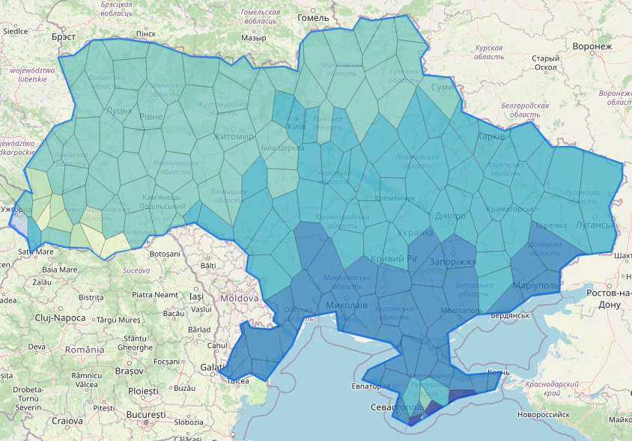 | 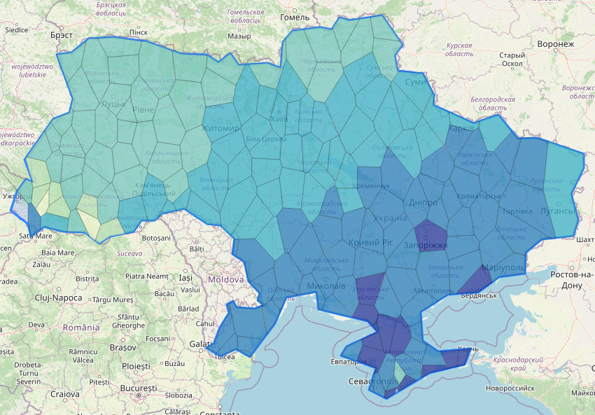 | 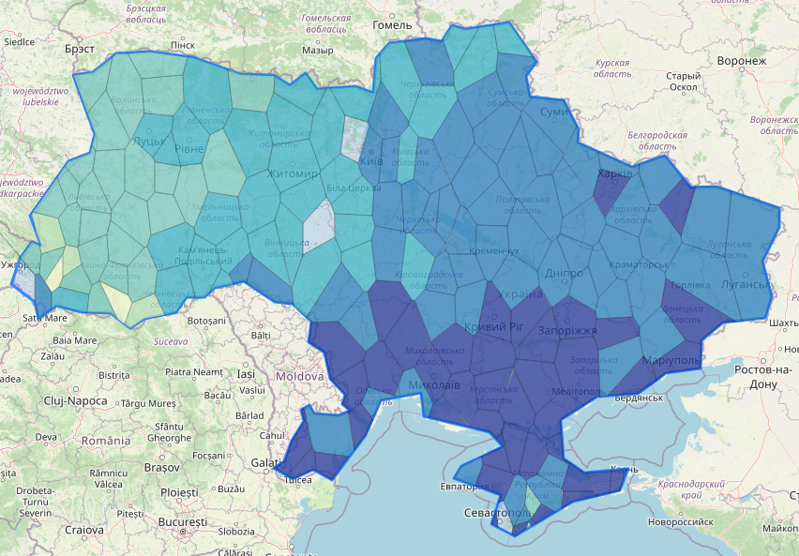
2500 3800 5100 6400 7700 9000 10300
Fig.1. Spatial distribution of water consumption deficits for years with different water probability by the Shtoiko E2 formula based on the analysis of a series of data from 01.05 to 30.09 for 2005 - 2023, m³/ha
Fig. 1 shows the degree of moisture deficit that occurs in years of different water probability. Thus, in medium-dry years (75% water probability), that is, under conditions when natural moisture is insufficient, but not yet critical, there are regions where the natural moisture deficit is stably high, so there is a need to adjust water supply rates to obtain high yields. The greatest deficit is observed in the Steppe zone, especially in Odessa, Mykolaiv, Kherson and Zaporizhzhia regions. At the same time, in the Forest-Steppe and Polissya zones the moisture deficit is moderate.
In the driest years (95% water probability), when natural moisture supply is extremely low, the need for additional irrigation becomes critical. Fig. 1 clearly shows that the most arid regions are the south of Ukraine - Odesa, Kherson, Zaporizhzhia regions, where soil moisture is insufficient even for drought-resistant crops. However, a high deficit of water supply is also observed in the Forest-Steppe zone, while based on spatial zoning this territory did not need additional moisture until 2005 [28].
Figure 2 shows the results of the statistical analysis of the water consumption rate for a separate cell of the Thyssen-Voronyi polygon by the data of the Kherson weather station for the period 2005-2023 when growing winter wheat. According to this analysis, the average water consumption rate is 2216 m³/ha - in the year of 50% water probability, 2553 m³/ha - in the year of 75% water probability, 2871 m³/ha – in the year of 95% water probability and 1958 m³/ha in the year of 25% water probability by the deficit of natural moisture supply.

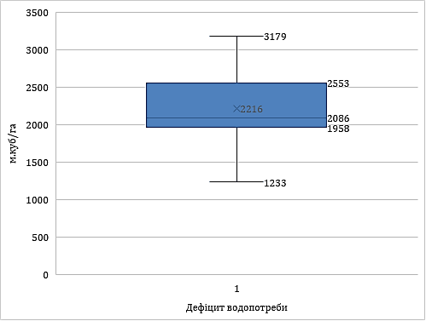
m³/ha
water consumption deficit
Fig. 2. Average ranked values of water consumption rates as a result of statistical analysis calculated by the Shtoiko method when using the data from the Kherson weather station, 2005-2024, m³/ha
Climate change analysis shows that growing crops using the usual practices is already risky for Ukrainian agricultural producers. The high deficit of natural moisture supply shows that in the next 20-30 years, irrigation will be increasingly necessary to support crop production.
To calculate and specify natural moisture deficits, it is necessary to improve and replenish a database of agrometeorological parameters, data on crops given current trends in climate change: development phases, sums of active temperatures for the onset of phenological phases, lower limits of optimal moisture content in the root-containing soil layer and its depth, crop water consumption coefficients and their drought resistance depending on the development phases, etc.
In the course of conducted research, the phenological phases of crop development were assessed given the current trends in climate change, and crop databases were formalized and specified by the macrophases of the BBCH scale, both by regions and with reference to weather stations.
The analysis of phenological phases of plant development and their binding to weather stations in Ukraine was carried in the course of scientific research [29]. Based on the research results a database of the onset of crop development phases was formed. The study of crop development phases was carried given the data from agrometeorological yearbooks and the observation data obtained from leading producers of agricultural products. The database was digitized by the generally accepted BBCH scale for using in the information system. The calculation of water consumption deficits was made directly on vegetation days of each crop.
50% water probability | 75% water probability | 95% water probability
wheat
636 1076 1486 1857 2247 2637 3028 | 764 1197 1631 2085 2499 2933 3386 | 1011 1444 1312 1375 2307 3171 3603
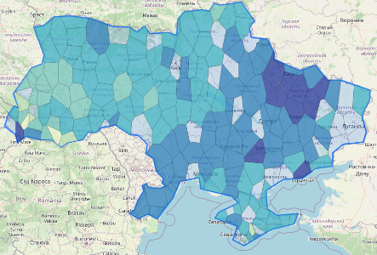 | 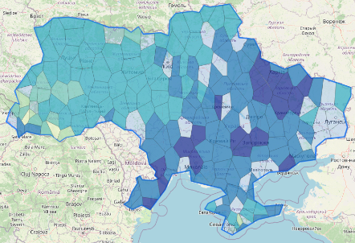 | 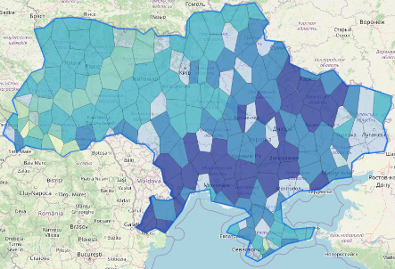
corn
1449 2287 3125 3983 4801 5638 6476 | 1616 2471 3326 4182 5037 5392 6747 | 2091 2916 3742 4567 5392 6218 7043
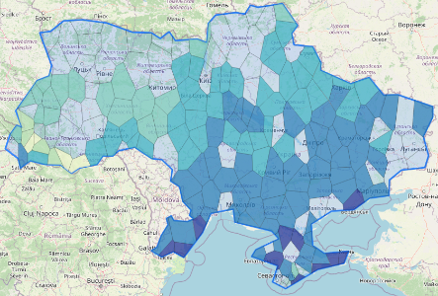 | 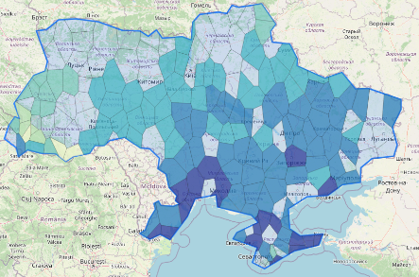 | 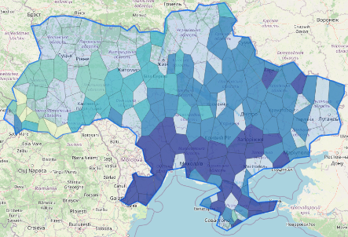
Fig. 3. Water consumption rates (m³/ha) for growing crops in Ukraine in the years of different water probability with reference to weather stations
The calculation of water consumption rates for the main crops available in the database (early and mid-season soybean, spring and summer potato, mid-season corn, buckwheat, winter wheat, sugar beet, spring barley, oat, sunflower) for all natural-climatic zones of Ukraine was made given the phenological phases of their development, when using the available data from weather stations (Fig. 3).
The calculation of water consumption rates can be provided to the user both in paper form where there is information on water probability of the years (starting from 2005) and visualized information.
Further research will focus on comparing quantitative estimates of actual water consumption rates with similar estimates obtained from remote sensing data.
Conclusions
- Comparison of the results obtained over the past two decades with the water consumption rates for 1960-2000, defined by the World Meteorological Organization as a reference climatic period, showed that the increase in water consumption in medium-dry years in the Steppe zone of Ukraine reaches 40%, in the Forest-Steppe and Polissya zones - 15%.
- Comparison of accumulated data for 2005-2024 showed a continued increase in water consumption rates in all climatic zones (on average by 18-25%) compared to the normative values and research data in the climatic period 1960-2000.
3. The practical use of updated water consumption rates will minimize environmental and economic risks when applying them due to their maximum compliance with the current climatic conditions.
4. Taking into account the specified phenological phases of crop development by the BBCH scale when determining water consumption rates allows us to specify the process of formation and accumulation of water consumption deficit during the growing season, depending on the phase of crop development.
- Development of a database and visualization of water consumption rates, based on geospatial water deficits, creates a basis for medium- and long-term planning of agricultural activities. Combining this data with modern web tools will make the information accessible and practical for farmers and agronomists.

References
- Shtakovskyi, A. V., et al. (1984). Ukrupnennye normy vodopotrebnosti dlia orosheniia po pryrodno-klimaticheskim zonam SSSR [Generalized water demand norms for irrigation by natural-climatic zones of USSR]. Ministry of Water Resources. [in Russian].
- Tymchasovi raionovani normy vodopotreb sіlskohospodarskykh kultur dlia zroshennia doshchuvanniam [Temporary zonal water demand norms for irrigated crops using sprinklers] (2015). Agrarna Nauka. [in Ukrainian].
- Metodychni rekomendatsii z operatyvnoho planuvannia rezhymiv zroshennia [Methodical recommendations for operational planning of irrigation regimes] (2004). IGiM UAAN, IZPR UAAN. [in Ukrainian].
- Open Data Portal. (n.d.). Register of issued permits for special water use. Retrieved: October 20, 2025, from: https://data.gov.ua/dataset/water-use-permits
- State Environmental Inspection of Ukraine. (n.d.). Retrieved from: https://www.dei.gov.ua/post/2225
- Romashchenko, M. I., Husyev, Y. V., Shatkovskyi, A. P., Saydak, R. V., Yatsyuk, M. V., Shevchenko, A. M. & Matyash, T. V. (2020). Impact of climate change on water resources and agricultural production. Melioratsiya i vodne hospodarstvo, (1), 5-22. https://doi.org/10.31073/mivg202001-235
- Haile, G. G., Tang, Q., Reda, K. W., Baniya, B., He, L., Wang, Y., & Gebrechorkos, S. H. (2024). Projected impacts of climate change on global irrigation water withdrawals. Agricultural Water Management, 305, 109144. https://doi.org/10.1016/j.agwat.2024.109144
- El-Fakharany, Z. M., & Salem, M. G. (2021). Mitigating climate change impacts on irrigation water shortage using brackish groundwater and solar energy. Energy Reports, 7, 608-621. DOI:10.1016/j.egyr.2021.07.091
- Rosa, L., Ragettli, S., Sinha, R., Zhovtonog, O., Yu, W., & Karimi, P. (2024). Regional irrigation expansion can support climate-resilient crop production in post-invasion Ukraine. Nature Food, 5(8), 684-692. DOI:10.1038/s43016-024-01017-7
- Casa, R., Rossi, M., Sappa, G., & Trotta, A. (2009). Assessing crop water demand by remote sensing and GIS for the Pontina Plain, Central Italy. Water Resources Management, 23, 1685-1712. DOI:10.1007/s11269-008-9347-4
- Parmar, S. H., Patel, G. R., & Tiwari, M. K. (2023). Assessment of crop water requirement of maize using remote sensing and GIS. Smart Agricultural Technology, 4, 100186. https://doi.org/10.1016/j.atech.2023.100186
- Matiash, T. V., Butenko, Y. O., Smirnov, A. M., & Matiash, E. I. (2024). Assessment of the evapotranspiration components dynamics in different agro-climatic zones of Ukraine using the Penman-Monteith-Leuning model. Land Reclamation and Water Management, (2), 34-44. https://doi.org/10.31073/mivg202402-398
- Beeson, R. C. Jr. (2011). Weighing lysimeter systems for quantifying water use and studies of controlled water stress for crops grown in low bulk density substrates. Agricultural Water Management, 98(6), 967-976. https://doi.org/10.1016/j.agwat.2011.01.005
- Denager, T., et al. (2020). Comparison of evapotranspiration estimates using the water balance and the eddy covariance methods. Vadose Zone Journal, 19(1). https://doi.org/10.1002/vzj2.20032
- Ragab, R., Evans, J. G., Battilani, A., & Solimando, D. (2017). Towards accurate estimation of crop water requirement without the crop coefficient Kc: New approach using modern technologies. Irrigation and Drainage, 66, 469-477. https://doi.org/10.1002/ird.2153
- Ragab, R., Evans, J. G., Battilani, A., & Solimando, D. (2017). The Cosmic-ray Soil Moisture Observation System (Cosmos) for estimating the crop water requirement: New approach. Irrigation and Drainage, 66, 456-468. https://doi.org/10.1002/ird.2152
- Roja, M. (2020). Estimation of crop water requirement of maize crop using FAO CROPWAT 8.0 Model. Indian Journal of Pure & Applied Biosciences, 8(6), 222-228. https://doi.org/10.18782/2582-2845.8148
- Roja, M. (2020). Estimation of crop water requirement of maize crop using FAO CROPWAT 8.0 Model. Indian Journal of Pure & Applied Biosciences, 8(6), 222-228. https://doi.org/10.18782/2582-2845.8148
- Food & Agriculture Organization of the United Nations (FAO). (1992). Cropwat (126 p.).
- FAO. (2021). The AquaCrop model – Enhancing crop water productivity. https://doi.org/10.4060/cb7392en
- Adnan, M., et al. (2017). Estimating Evapotranspiration using Machine Learning Techniques. International Journal of Advanced Computer Science and Applications, 8(9). https://doi.org/10.14569/ijacsa.2017.080915
- Baliuk, S. A., Romashchenko, M. I., & Stashuk, V. A. (2009). Naukovi osnovy okhorony ta ratsionalnoho vykorystannia zroshuvanykh zemel Ukrainy [Scientific foundations of the protection and rational use of irrigated lands in Ukraine]. Agrarna Nauka. [in Ukrainian].
- Kovalenko, P. I. (Ed.). (2016). Intehrovane upravlinnia vodnymy i zemelnymy resursamy na meliorovanykh terytoriiakh [Integrated management of water and land resources in reclaimed areas]. Agrarna Nauka. [in Ukrainian].
- Metodychni rekomendatsii z operatyvnoho planuvannia rezhymiv zroshennia [Methodical recommendations for operational planning of irrigation regimes] (2004). IGiM UAAN, IZPR UAAN. [in Ukrainian].
- Shtoiko, D. A., & Pysarenko, V. A. (1967). Rekomendatsii po rezhimu zroshennia silskohospodarskykh kultur [Recommendations on the irrigation regime of agricultural crops]. Urozhai. [in Ukrainian].
- Rozrakhunok norm vodopotreby [Calculation of water demand norms]. (n.d.). Retrieved from http://185.168.130.174:90/m/
- iwpim. (n.d.). Retrieved from http://185.168.130.174:90/
- Klimat Ukrainy [Climat of Ukraine] (2003). Scientific edition. ed. V.M. Lipinsky, V.A. Dyachuk, V.M. Babichenko/Ukr. nauk.-dosl. hydrometeorological. inst. – K.: Publishing of Raevsky.[in Ukrainian]
- Matiash, T. V., et al. (2024). Instytut vodnykh problem i melioratsii NAAN. Zvit pro naukovo-doslidnu robotu “Rozroblennia teoretychnykh osnov system pidtrymky pryiniattia rishen u zroshenni na osnovi poiednannia danykh riznoi pryrody” (Zavdannia 04.02.00.12.F). “Doslidzhennia zakonomirnostei zmin sezonnoi vodopotreby kultur v umovakh zmin klimatu” [Institute of Water Problems and Land Reclamation. Report on the research project “Development of theoretical foundations of decision support systems in irrigation based on the integration of heterogeneous data”]. [in Ukrainian].
- Kovalchuk, P. Ι., Matiash, T. V., Kovalchuk, V. P., Demchuk, O. S., Balykhina, H. A., Gerus, A. V., & Pendak, N. V. (2019). Systemne modeliuvannia i upravlinnia vodo-i zemlekorystuvanniam [System modeling and management of water and land use]. Kyiv: Ahrarna nauka. [in Ukrainian].
- Mezentsev, V. S. (Ed.). (1974). Rezhimy vlagoobespechennosti i usloviia gidromelioratsii stepnogo kraia [Moisture regimes and hydromelioration conditions of the steppe region]. Moscow: Kolos. [in Russian].
- Virtanen, P., Gommers, R., Oliphant, T. E., Haberland, M., Reddy, T., Cournapeau, D., ... & van Mulbregt, P. (2020). SciPy 1.0: Fundamental Algorithms for Scientific Computing in Python. Nature Methods, 17, 261–272. https://doi.org/10.1038/s41592-019-0686-2

УДК 631.67:004

МЕТОДОЛОГІЯ РОЗРАХУНКУ ТА ВІЗУАЛІЗАЦІЇ НОРМ ВОДОПОТРЕБИ СІЛЬСЬКОГОСПОДАРСЬКИХ КУЛЬТУР З ВИКОРИСТАННЯМ ІНФОРМАЦІЙНИХ ТЕХНОЛОГІЙ

Т.В. Матяш¹, канд. техн. наук, Я.О. Бутенко², канд. с.-г. наук, В.М. Попов³, докт. техн. наук, Н.В. Сорока⁴, наук. співр., А.Ф. Салюк⁵, наук. співр., А.М. Смірнов⁶, аспірант

- Інститут водних проблем і меліорації НААН, Київ, Україна;
https://orcid.org/0000-0003-1225-086X; e-mail: t.v.matiash@gmail.com
- Інститут водних проблем і меліорації НААН, Київ, Україна;
https://orcid.org/ 0000-0002-1743-7175; e-mail: iarynabulba@gmail.com
- Інститут водних проблем і меліорації НААН, Київ, Україна;
https://orcid.org/0000-0003-2024-0290; e-mail: v_popov15@ukr.net
- Інститут водних проблем і меліорації НААН, Київ, Україна;
https://orcid.org/0000-0003-2868-183; e-mail: soroka1975@ ukr.net
- Інститут водних проблем і меліорації НААН, Київ, Україна;
https://orcid.org/0000-0003-3968-1125; e-mail: allasaluk@ukr.net
- Інститут водних проблем і меліорації НААН, Київ, Україна;
https://orcid.org/0009-0006-5865-9141; e-mail: justtosha@gmail.com

Анотація. У дослідженні проаналізовано існуючі підходи до визначення та коригування норм водопотреби сільськогосподарських культур для зрошення в Україні. Коригування норм водопотреби здійснено по всім метеостанціям, для кожної з яких визначені дати настання фенологічних фаз сільськогосподарських культур. Виконано оцінку їх величини на рівні метеостанцій та областей, враховуючи сучасні кліматичні зміни та необхідність їх постійного оновлення з використанням розробленої автоматизованої системи та інформаційних технологій. Встановлено, що потреба у воді для вирощування культур значно зросла, особливо в південних регіонах України. Ця робота є продовженням дослідження евапотранспірації, її компонентів та динаміки за даними ДЗЗ за методом Penmann-Monteith-Leuning. Інтеграція до оцінювання евапотранспірації, розрахованої за різними методами залежно від наявних даних, дозволяє точніше враховувати зміни водопотреби сільськогосподарських культур, кліматичні зміни та регіональні особливості вирощування сільськогосподарських культур. Отримані результати впроваджено у вигляді інтерактивної бази даних та візуалізованої картографічної інформації. Розрахунок норм здійснено на основі потенційної евапотранспірації за період 2005–2024 рр. із використанням біофізичного методу Штойка, що дозволяє визначити оптимальні норми водопотреби з урахуванням дефіциту природного зволоження. Для розрахунків обирали метеорологічні дані регіональних метеостанцій, що працюють в автоматичному режимі та інформаційні системи розроблені в ІВПіМ. Оцінку водопотреби здійснювали на основі водно-балансових рівнянь та багаторічних рядів агро- та метеоспостережень. Проведена адаптація настання середньорічних дат сівби по основних сільськогосподарських культурах, здійснено уточнення настання фаз розвитку сільськогосподарських культур по регіонах України, з прив'язкою до метеостанцій, побудовано карти просторового розподілу норм водопотреби. Створена база даних норм водопотреби сільськогосподарських культур з інтеграцією геопросторових параметрів. Розроблено програмне забезпечення на Python із застосуванням бібліотек Folium, Shapely, Django для аналізу та візуалізації даних. Для просторового розподілу і аналізу поширення результатів розраховані зони впливу метеостанцій за методом полігонів Тиссена-Вороного. Дослідження встановило значне зростання норм водопотреби сільськогосподарських культур в Україні за останні два десятиліття порівняно з контрольним кліматичним періодом 1960-2000 років. У степовій зоні водопотреба збільшилася до 40%, у лісостеповій та поліській – на 15%. Аналіз даних 2005-2024 рр. підтвердив подальше зростання водопотреби у всіх кліматичних зонах в середньому на 18-25%. Удосконалення методів розрахунку норм водопотреби з урахуванням фенологічних фаз розвитку культур за шкалою BBCH, дозволяє точніше оцінювати накопичення дефіцитів вологи протягом вегетаційного сезону. Поєднання цих даних із веб-інструментами підвищує доступність інформації та сприяє практичному використанню її у сільському господарстві. Побудовано карти розповсюдження дефіцитів водопотреби для теплого періоду року, норм водопотреби для кукурудзи та пшениці для років 50%, 75% та 95% за дефіцитом водозабезпеченості, що враховують регіональні мінливості їх розподілу. Дослідження підтвердило необхідність постійного оновлення норм водопотреби та їх врахування при плануванні аграрної політики та управлінні водними ресурсами.
Ключові слова: евапотранспірація, норма водопотреби, метод Штойка, зміни клімату, інформаційна система, BBCH, фази розвитку, полігони Тиссена-Вороного, зрошення

