DOI:
Available at (PDF):
UDC 628.1

MODELING OF THE OPERATING MODES OF THE EJECTOR-CAVITATOR TO DETERMINE ITS OPTIMAL DESIGN AND TECHNOLOGICAL PARAMETERS.

R.D. Odynchenko¹, Ph.D. Student, S.V. Marysyk², Ph.D., D.V. Charny³, Doctor of Technical Sciences, E.M. Matselyuk⁴, Ph.D. in Technical Sciences, V.D. Levytska⁵, Ph.D.,
M.E. Matselyuk⁶, O.V. Boyko⁷, A.V. Tovmachenko⁸

- Institute of Water Problems and Land Reclamation of NAAS of Ukraine, Kyiv, Ukraine;
https://orcid.org/0009-0005-0221-8243, 888888ruslan@gmail.com;
- Institute of Water Problems and Land Reclamation of NAAS of Ukraine, Kyiv, Ukraine;
https://orcid.org/0000-0002-0100-7787, sergsi.marisik@ukr.net;
- Institute of Water Problems and Land Reclamation of NAAS of Ukraine, Kyiv, Ukraine;
https://orcid.org/0000-0001-6150-6433, dmitriych10@gmail.com;
- Institute of Water Problems and Land Reclamation of NAAS of Ukraine, Kyiv, Ukraine;
https://orcid.org/0000-0001-9960-6333, evgen1523@ukr.net;
- Institute of Water Problems and Land Reclamation of NAAS, Kyiv, Ukraine, https://orcid.org/0000-0003-2213-1696;
- State University of Information and Communication Technologies, Kyiv, Ukraine;
https://orcid.org/0009-0008-2859-1435
- Institute of Environmental Geochemistry of NAS of Ukraine, Kyiv, Ukraine, https://orcid.org/0009-0007-5423-7037;
- Institute of Environmental Geochemistry of NAS of Ukraine, Kyiv, Ukraine, https://orcid.org/0000-0002-0674-8410

Abstract. The article presents the results of the development and scientific substantiation of the technology of cavitation activation of natural zeolites of the Sokyrnytske deposit (Transcarpathian region) and the Nyzhnohrabovetske deposit (Slovakia) to significantly increase their sorption capacity for heavy metal ions (Pb, Cd, Zn, Cu, etc.), radionuclides (¹³⁷Cs, ⁹⁰Sr) and nitrogen compounds (nitrates, ammonium). The use of hydrodynamic cavitation in a Venturi tube and a modified ejector-cavitator is proposed as an environmentally safe, energy-efficient and reagent-free method of modifying sorbents, which fully complies with the principles of green chemistry and the objectives of the Water Strategy of Ukraine until 2030.
A comprehensive CFD modeling (Ansys Fluent 2023 R2) with a multiphase VOF+URANS approach, a Schnerr-Sauer cavitation model, and a discrete-phase model for estimating trajectories and collapse of cavitation cavities was performed. The independence of the solution from the computational grid was verified with more than 100 thousand elements. Single-phase and multiphase modelingswere compared. The multiphase approach provides physically realistic values of pressure (up to 215 atm) and temperature (~800 K) of cavity collapse, while the single-phase approach significantly overestimates these parameters, but is suitable for quick qualitative assessment and preliminary optimization of geometry and operating modes.
The optimal inlet pressure of 7 bar was established, having which the maximum intensity of the cavitation effect is achieved with minimal energy costs. A hybrid optimization strategy was developed, which consists of the initial rapid screening of promising designs by single-phase modeling with subsequent detailed multi-phase analysis of the best options.
Based on the results of modeling the operating modes of the ejector-cavitator, its optimal design and technological parameters were obtained. Using the obtained data, a laboratory recirculation unit (volume 20 l, pump 1,1 kW, pressure regulation up to 10 bar) and an ejector-cavitator design for manufacturing by 3D printing from cavitation-resistant Spectrum PP polypropylene will be created. The obtained results are a scientific and technical basis for making highly efficient sorption materials and water purification technologies with high potential for industrial scaling.
Keywords: Cavitation, zeolites, sorption, heavy metals, radionuclides, nitrogen compounds, Venturi tube, adsorption isotherms, Langmuir model, CFD modeling, particle size analysis

Relevance of the research. Pollution of natural and wastewater with heavy metals (Pb, Cd, Zn, Cu, etc.), radionuclides (137Cs, 90Sr) and nitrogen compounds (nitrates, ammonium) remains one of the most acute environmental problems of Ukraine, especially in regions of intensive agriculture, industry and prone to the consequences of the Chernobyl disaster. Natural zeolites of Ukraine have significant potential as affordable and environmentally safe sorbents. However, their sorption capacity in the natural state is often insufficient. Modification of zeolites by cavitation allows to significantly increase the surface activity, porosity and selectivity without the use of expensive chemical reagents, which corresponds to the principles of green chemistry and the objectives of the Water Strategy of Ukraine until 2030.
Analysis of recent research and publications. The issue of sorption water purification with zeolites is actively studied both in Ukraine and all over the world [1-4, 13]. High efficiency of zeolites for Cesium-137, Strontium-90, heavy metal ions and ammonium has been established. At the same time, chemical (acid, alkaline), thermal and mechanical activation are used to increase the capacity [5, 6, 15]. Cavitation technologies for water purification are being developed separately [7, 14], however, the use of hydrodynamic cavitation specifically for the modification of natural zeolites has been almost not studied yet. CFD modeling of cavitation flows in Venturi tubes and ejectors is presented in the works [8-12], but without connection to sorbent modification.
Research objective. To develop a scientifically based technology for cavitation activation of natural Ukrainian zeolites using a Venturi tube and a modified ejector-cavitator to increase their sorption capacity for heavy metals, radionuclides and nitrogen compounds, as well as to create a laboratory unit and CFD models for further optimization of the process.
Research objective. To develop a scientifically based technology for cavitation activation of natural Ukrainian zeolites using a Venturi tube and a modified ejector-cavitator to increase their sorption capacity for heavy metals, radionuclides and nitrogen compounds, as well as to create a laboratory unit and CFD models for further optimization of the process.
Materials and methods of research. The object of research is natural zeolites of the Sokyrnytske deposit (Transcarpathian region) and the Nyzhniy Grabovets deposit. The Ansys Fluent 2023 R2 software was used for modeling (k-ω SST turbulence models, Schnerr-Sauer cavitation model, VOF+URANS multiphase approach, discrete-phase model for cavity trajectories). Venturi tube geometryis the following: neck diameter is 2 mm, tube diameter is 20 mm, narrowing/expansion angles are 22б61°/6б4°. A laboratory recirculation unit has been developed (tank volume 20 l, three-cylinder pump 1.1 kW, pressure regulation up to 10 bar, cavitation Venturi tube in the main line). An ejector-cavitator for 3D printing made of Spectrum PP polypropylene has been designed.
Research results and discussion. For the study of modification methods, the flow through a cavitation Venturi tube was considered the most promising. The chosen geometry is shown in Fig. 1. Several experiments were conducted using this Venturi tube to verify the CFD model.
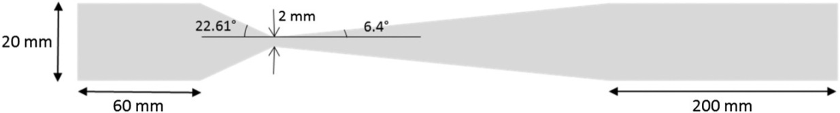

Fig. 1. Schematic diagram of a venturi tube.
The diameter of the venturi tube orifice is 2 mm and the diameter of the tube is 20 mm. The convergence angle of the venturi tube is 22,61° and the divergence angle is 6б4°. The walls of the converging and diverging sections are straight. An additional length of 60 mm before the inlet and 200 mm after the outlet was added to the CFD model to obtain a fully developed flow and to avoid any inlet or outlet effects.
When determining mesh dependencies the modeling was performed when using different mesh sizes to provide an independent solution. The geometry was divided into meshes with 14 k, 40 k, 60 k, 70 k, 100 k and 200 k elements. A representative mesh is shown in Fig. 6 (a) below.

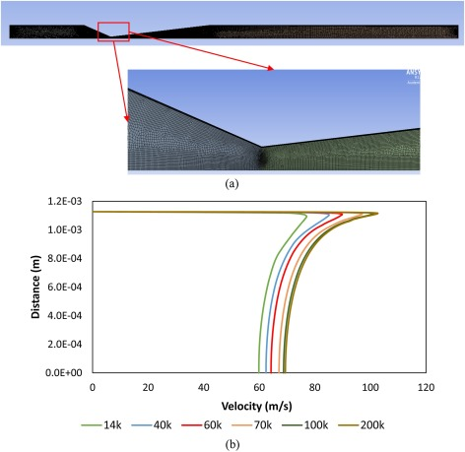
(а) | (б)
Fig. 2. Typical mesh for a Venturi tube (a), Comparison of velocity profiles in the orifice for different mesh sizes (b).

For a mesh with 70 k-elements and higher, the average value was below 1, which is sufficient for the resolution of the viscous sublayer. A comparison of the velocity profiles in the Venturi orifice is shown in Fig. 2(b). It was found that the solution was not mesh dependent beyond 100 k-elements, hence this mesh is a discrete-phase model. After the turbulence model was completed, steady-state modeling was performed for a range of venturi inlet pressures considering single-phase flow. The cavitation model was not included in the modeling. It was noted that the single-phase model significantly overestimated the flow rate for the corresponding inlet pressure.
The maximum velocity and turbulent kinetic energy in the flow area were high. Fig. 2(a) and (b) show the velocity and turbulent kinetic energy plots for an inlet pressure of 7 bar. Since the cavitation model is not included, the predicted pressure in the orifice is lower than the vapor pressure and even reaches negative values, which is unrealistic. In the single-phase model, the phase transition is not considered, and since there is no energy loss during the phase transition, the pressure energy is completely converted into kinetic energy, which leads to high velocities and therefore high flow rates. Thus, it is necessary that the cavitation model matches the mass flow rate and pressure drop relationship.
The multiphase CFD modeling was performed using the URANS (finite difference method for convergence) approach. The time step size was 10⁻⁶ s. It was observed that the flow in Venturi tube initially fluctuated and stabilized after some time, as shown in Fig. 3. (d) The Y-axis indicates the normalized average flow rate through the orifice of Venturi tube as a function of time. The modeling was considered complete when the inlet and outlet flows were stabilized and no fluctuations in flow rate were observed with respect to flow time. This damping of flow fluctuations could be a result of the URANS modeling approach, and what is obtained as a stable result is the average flow through the orifice of Venturi tube. There may be some changes in the cavity dynamics at the lowest and highest flow through the orifice due to flow fluctuations, which are not considered in this study. However, the average behavior of the cavity dynamics is expected to be similar to that predicted one by the current model. Typically, the flow was found to stabilize after 0,5–0,7 s. The fluctuation frequency ranged from 30 to 100 Hz, depending on the inlet pressure. The fluctuation frequency gradually decreased and the fluctuation amplitude increased as the inlet pressure increased.
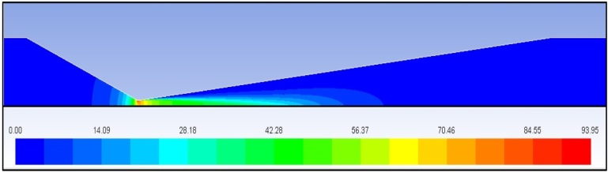 | 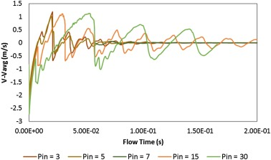
(а)
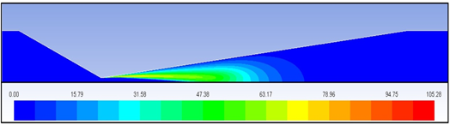
(b) | (c)
Fig. 3. Plots of (a) velocity, m/s and (b) turbulent kinetic energy, m²/s² for single-phase CFD modeling when having P_{in} = 7 bar, (c) oscillatory flow in the orifice.

The modeling data were also validated using measured pressure drop and flow rates. The flow velocity in the multiphase model is much lower compared to the single-phase model, so the velocity and kinetic energy in the flow area are also lower. Cavitation is observed in the diverging section of Venturi tube, just downstream of the orifice, with maximum vapor fractions observed near the orifice wall. The velocity plot contours, turbulent kinetic energy, and vapor volume fraction are shown in Fig. 4.
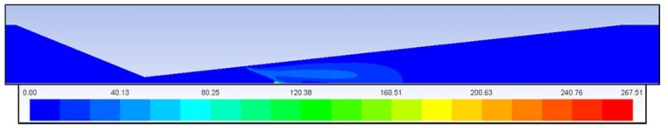 | 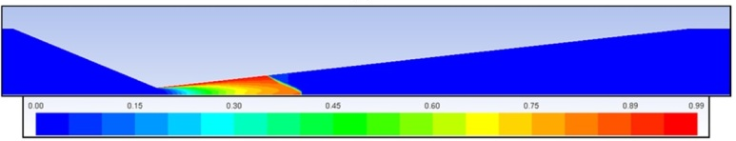
(а) | (b)
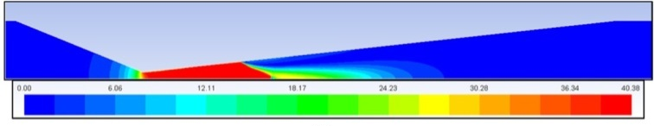
(c)
Fig. 4. (a) turbulent kinetic energy, m²/s², and (b) vapor volume fraction for multiphase CFD modeling when having P_{in} = 7 bar, and (c) velocity contours, m/s.

After obtaining convergent results in the CFD modeling, about 75 particles was introduced onto the isosurface, at the distance of 2 mm before Venturi orifice. The trajectory plot is shown in Fig. 5. The pressure data depending on the particle flow time were plotted along these trajectories. These data were used as the volume pressure (p^{t}) surrounding the cavity at time t. The initial cavity radius (R₀) when t = 0 was previously assumed to be 1 μm.
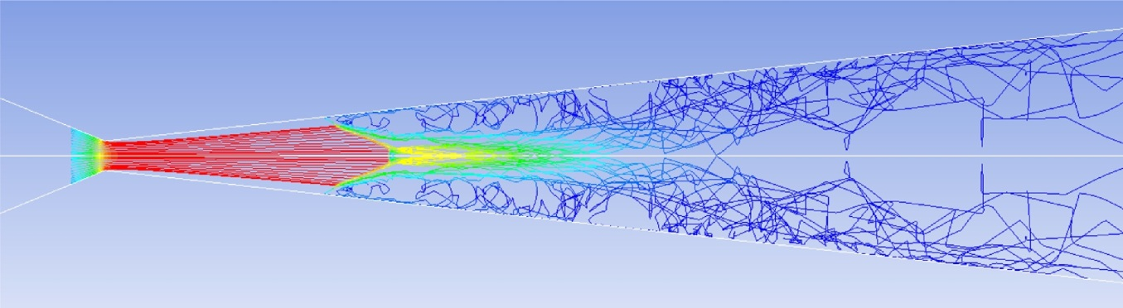
Fig. 5. DPM trajectories in the flow area, representing the paths of cavities.

Fig. 6 (a)–(c) shows the results of the cavity dynamics model for the case when P_{in} = 10 bar. The cavity gradually contracts through multiple volume fluctations as it passes through the flow area, and the maximum collapse pressure was about 215 atm. The corresponding maximum collapse temperature was about 800K.
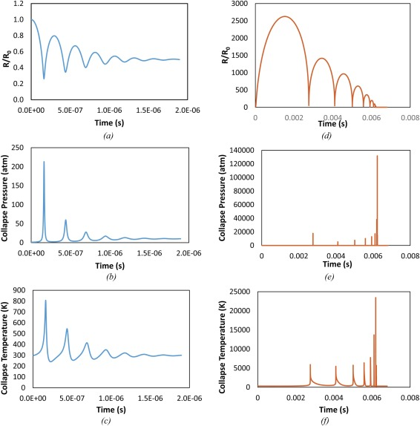
Fig. 6. (a)–(c) The results of the cavity dynamics model showing the change in relative cavity size, cavity collapse pressure, and cavity collapse temperature for multiphase simulation, (d)–(f) – the results of the cavity dynamics model for single-phase modeling

Similar studies were also conducted for DHM introducing under single-phase flow modeling conditions. In this case, the predicted collapse pressure and temperature траwere very high compared to the multiphase case. The results are shown in the form of plots in Fig. 6 (d)–(f). These values are unrealistic and should be considered for qualitative comparison only. Such high values of collapse pressure and temperature can be explained by the very high pressure difference at the inlet and in the orifice of the Venturi tube. This means that the bubble in such a flow will have a higher velocityin the orifice compared to the multiphase modeling, and therefore higher turbulence levels, which further contributes to the unrealistic growth of a parameter (R/R0) and more intense bubble collapse temperature and pressure.
The collapse pressure values for all trajectories were averaged. The average collapse pressure was used to estimate the cavitation efficiency coefficient (CEC). Since CEC is directly proportional to the collapse pressure value of the cavity, the CEC values for the single-phase modeling are unrealistically higher than those observed in the multiphase simulation. CEC is a parameter for comparing the theoretical efficiency of a cavitation device. In this case, the effect of the operating condition, i.e., the inlet pressure, on CEC is shown in Fig. 7. A comparison of the trends of CEC as a function of inlet pressure for the single-phase and multiphase cases was made. Due to the difference in the scale of the values, the CEC values are normalized using the volumetric flow rate (Q). Although the CEC values for the single-phase modeling are unrealistically high, the trend for the normalized CEC for both the single-phase and multiphase cases is qualitatively similar, indicating a correct representation of the physics of cavitation flow.
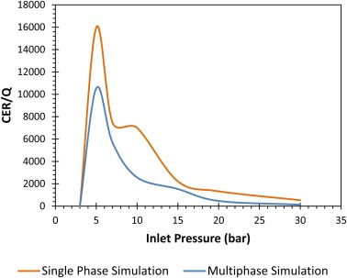
Fig. 7. Comparison of flow-normalized CEC values depending on inlet pressure (P_{in}) for single-phase and multiphase cases.
Considering the multiphase case, it can be concluded that an inlet pressure of 7 bar is the optimal operating condition. The fact that the results of the single-phase and multiphase models are qualitatively similar, single-phase modeling is much faster and numerically less expensive compared to multiphase one. However, it is necessary to properly account for the damping and the lower value observed in multiphase flow. Single-phase modeling can be used to qualitatively determine the optimal design or optimal operating conditions, and the multiphase model can be run only for these optimal conditions to obtain more accurate quantitative results.
Conclusions
1. Cavitation activation when using a Venturi tube and a modified ejector-cavitator is a promising, environmentally safe and energy-efficient method of increasing the sorption activity of natural zeolites of the Sokyrnytske and Nyzhnohrabovetske deposits in Ukraine, which allows to significantly increase the porosity, surface activity and selectivity of sorbents without the use of chemical reagents, contributing to the implementation of green chemistry principles and compliance with the Water Strategy of Ukraine until 2030. It also opens up opportunities for industrial scaling in wastewater and natural water purification systems from heavy metals, radionuclides and nitrogen compounds.
2. The optimal inlet pressure to achieve the maximum intensity of the collapse of cavitation cavities is 7 bar, when the cavitation efficiency coefficient (CEC) reaches its peak value, ensuring a balance between high pressure and collapse temperature (up to 215 atm and ~800 K in multiphase modeling) and minimal energy consumption, which was confirmed by a comparison of single-phase and multiphase CFD modeling, as well as flow stabilization without significant flow fluctuations.
3. Multiphase CFD modeling in view of the phase transition (VOF+URANS, Schnerr-Sauer model) is mandatory for accurate quantitative estimation of cavitation flow parameters, such as pressure and cavity collapse temperature, while simplified single-phase modeling, despite overestimation of velocity and turbulent kinetic energy values, can be effectively used for initial qualitative optimization of the geometry and operating modes of cavitation devices, allowing to reduce computational costs before conducting detailed multiphase calculations.
Prospects for further research. Based on the results of the modeling, it was decided to use single-phase modeling of the modified ejector-cavitator for the activation and modification of zeolite. To select the cavitation modes, a virtual model of the modified ejector-cavitator was created, and hydrodynamic modeling is currently being conducted using Autodesk CFD Simulation software.
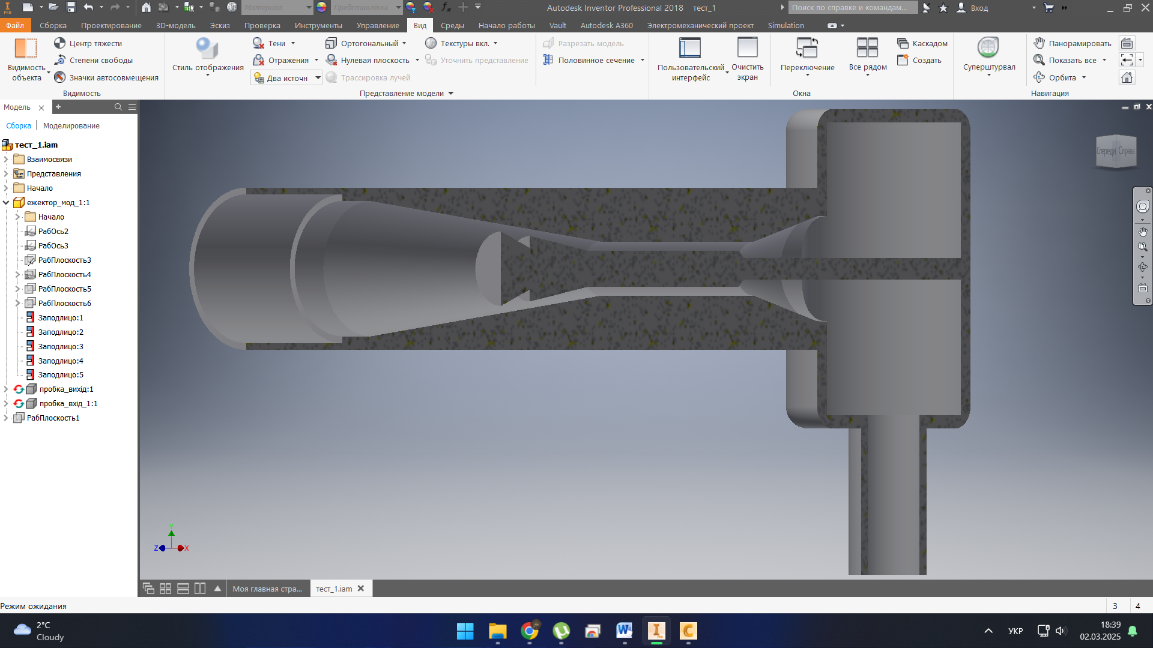 | 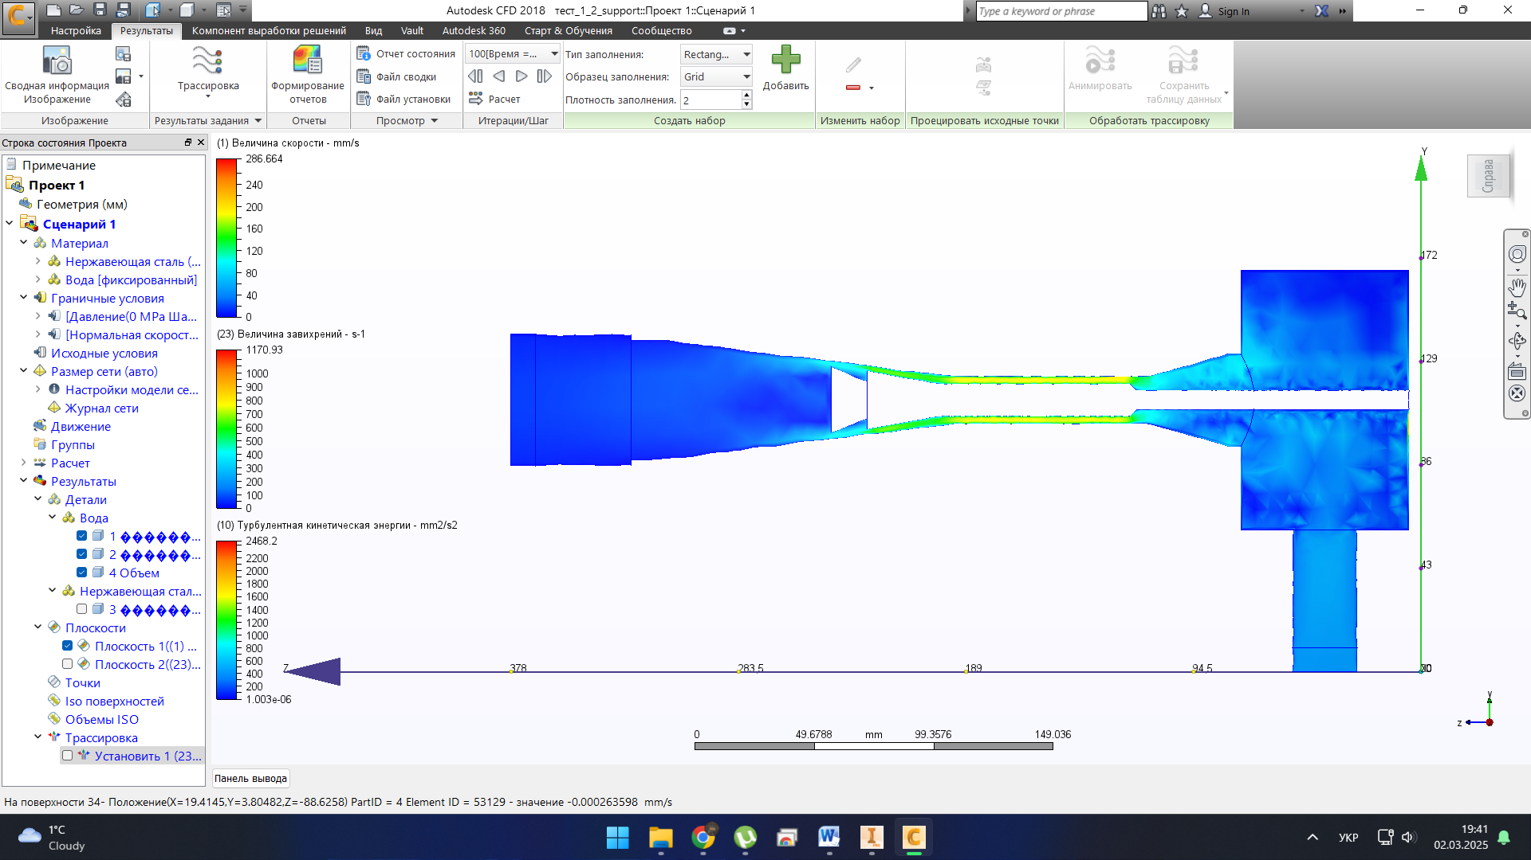
а | b
Fig. 8. a - Simplified model of the ejector-covitator for hydrodynamic modeling; b – Flow velocity distribution diagram of the hydrodynamic calculation of the ejector-covitator; number of calculation cells is 913; inlet velocity of 7 atm and turbulent kinetic energy of 160,000 mm²/s².

For laboratory studies on improving zeolite, a schematic diagram of a laboratory unit was developed, shown in Fig. 9. The unit has a 20-liter tank attached to the suction line of a three-cylinder positive displacement pump (to reduce flow pulsations). There are baffles inside the tank to avoid the formation of vortices and to entrain air bubbles into the flow. The pump power is 1.1 kW. The pump discharge line is divided into a main line and a bypass line, which after a while merge and are connected back to the tank, which is under atmospheric pressure, forming a recirculation circuit. The bypass line in the unit is mainly used as a safety device to avoid excessive back pressure on the pump. A cavitation Venturi tube is placed in the main line. The flow rate through the main and bypass lines is controlled by three control valves. Pressure gauges are provided before and after the cavitation device to measure the pressure drop. The pump is equipped with a flow controller in the VFD system. Water was passed through Venturi tube at different inlet pressures and the corresponding flow rates were measured.
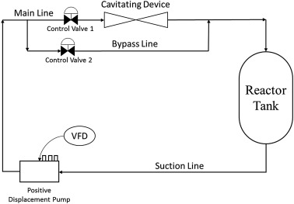
Fig. 9. Schematic representation of the experimental unit
It is planned to make a modified ejector-covitator when using 3D printing from Spectrum PP polypropylene using the FDM printing method. Spectrum PP is a new material with good mechanical properties, capable of effectively resisting cavitation effects and abrasion effects.

Conflicts of interest: the authors declare no conflict of interest.
Use of artificial intelligence: the authors confirm that they did not use artificial intelligence technologies during the creation of this work.

References
- Șenilа, M., Neag, E., Tănаselia, C., & Șenilа, L. (2023). Removal of cesium and strontium ions from aqueous solutions by thermally treated natural zeolite. Materials, 16(8), 2965. https://doi.org/10.3390/ma16082965
- Bielova, O. I. (2020). Vykorystannia tseolitiv dlia vyluchennia vazhkykh metaliv zi stichnykh vod [Use of zeolites for the removal of heavy metals from wastewater]. Ekologichna Bezpeka, (3), 28–35. [in Ukrainian]
- Derbe, T., Temesgen, S., & Bitew, M. (2021). A short review on synthesis, characterization, and applications of zeolites. Advances in Materials Science and Engineering, 2021, 6637898. https://doi.org/10.1155/2021/6637898
- Shevchuk, V. P., & et al. (2019). Vykorystannia tseolitiv dlia ochyshchennia vody vid radioaktyvnykh zabrudnen [Use of zeolites for water purification from radioactive contamination]. Ekolohichni Problemy, 3(1), 15–22. [in Ukrainian]
- Bahmanzadegan, F., & Ghaemi, A. (2024). Modification and functionalization of zeolites to improve the efficiency of CO₂ adsorption: A review. Case Studies in Chemical and Environmental Engineering, 9, 100564. https://doi.org/10.1016/j.cscee.2023.100564
- Wang, S., & Peng, Y. (2020). Natural zeolites as effective adsorbents in water and wastewater treatment. Chemical Engineering Journal, Vol. 156, No. 1, 11-24. http://dx.doi.org/10.1016/j.cej.2009.10.029
- Song, Y., Hou, R., Zhang, W., & Liu, J. (2022). Hydrodynamic cavitation as an efficient water treatment method for various sewage: A review. Water Science & Technology, 86(2), 302–320. https://doi.org/10.2166/wst.2022.201
- Nadiri, K., & Baradaran, S. (2025). Geometric optimization of venturi reactors for enhanced hydrodynamic cavitation efficiency: From conventional to advanced tandem configurations. Chemical Engineering Journal Advances, 24, 100844. https://doi.org/10.1016/j.ceja.2025.100844
- Lukianova, I. V., & et al. (2021). Modyfikovani hlyny yak sorbenty amoniiu [Modified clays as ammonium sorbents]. Khimiia i Tekhnolohiia Vody, 43(5), 45–52. [in Ukrainian]
- Taamneh, Y., & Sharadqah, S. The removal of heavy metals from aqueous solution using natural Jordanian zeolite. Appl. Water. Sci 7, 2021–2028 (2017). https://doi.org/10.1007/s13201-016-0382-7
- Abbasi, E., Milani, M., Fekri Aval, S., Kouhi, M., Akbarzadeh, A., & Tayefi Nasrabadi, H., Nikasa, P., Joo, S. W., Hanifehpour, Y., Nejati-Koshki, K., & Samiei, M. (2016). Silver nanoparticles: Synthesis methods, bio-applications and properties. Critical reviews in microbiology, 42(2), 173–180. https://doi.org/10.3109/1040841X.2014.912200
- Yagub, M. T., Sen, T. K., Afroze, S., & Ang, H. M. (2014). Dye and its removal from aqueous solution by adsorption: A review. Advances in Colloid and Interface Science, 209, 172–184. https://doi.org/10.1016/j.cis.2014.04.002
- Chaplya, Y, Chernukha, O, Bilushchak, Y, Chuchvara, A, Greguš, M, & Pukach P. (2025). Advanced approach to mathematical modeling of the impurities diffusion in the process of water softening with limited particles sorption. Sci Rep 15, 5269. https://doi.org/10.1038/s41598-025-88735-5
- Kłos, A., Wierzba, S., Piechaczek-Wereszczyńska M., Matik K., Głowacki M., Płotka M., Gawdzik, A., Wiatkowski, M., Dołhańczuk-Śródka, A., & Ziembik, Z. (2025). Possibilities of using biosorbents and synthetic sorbents in monitoring heavy metal pollution of surface waters. Scientific Reports, 15, Article 89365. https://doi.org/10.1038/s41598-025-89365-7
- Crini, G., & Badot, P. M. (2008). Application of chitosan, a natural aminopolysaccharide, for dye removal from aqueous solutions by adsorption processes using batch studies: A review of recent literature. Progress in Polymer Science, 33, 399–410. https://doi.org/10.1016/j.progpolymsci.2007.11.001.

УДК 628.1

Моделювання режимів роботи ежектора-кавітатора для визначення його оптимальних конструктивних і технологічних параметрів

Р.Д. Одинченко¹, аспірант, С.В. Марисик², д-р філософії, Д.В. Чарний³, д-р техн. наук, Є.М. Мацелюк⁴, канд. техн. наук, В.Д. Левицька⁵, д-р філософії, М.Є. Мацелюк⁶,
О.В. Бойко⁷, А.В. Товмаченко⁸

- Інститут водних проблем і меліорації НААН, Київ, Україна;
https://orcid.org/0009-0005-0221-8243, 888888ruslan@gmail.com;
- Інститут водних проблем і меліорації НААН, Київ, Україна;
https://orcid.org/0000-0002-0100-7787, sergsi.marisik@ukr.net;
- Інститут водних проблем і меліорації, Київ, Україна;
https://orcid.org/0000-0001-6150-6433, dmitriych10@gmail.com;
- Інститут водних проблем і меліорації НААН, Київ, Україна;
https://orcid.org/0000-0001-9960-6333, evgen1523@ukr.net;
- Інститут водних проблем і меліорації НААН, Київ, Україна, https://orcid.org/0000-0003-2213-1696;
- Державний університет інформаційно-комунікаційних технологій, Київ, Україна;
https://orcid.org/0009-0008-2859-1435 ;
- Інститут геохімії навколишнього середовища НАНУ, Київ, Україна, https://orcid.org/0009-0007-5423-7037;
- Інститут геохімії навколишнього середовища НАНУ, Київ, Україна, https://orcid.org/0000-0002-0674-8410;

Анотація. У статті представлено результати розробки та наукового обґрунтування технології кавітаційної активації природних цеолітів Сокирницького родовища (Закарпаття) та Нижньограбовецького родовища (Словаччина) з метою суттєвого підвищення їх сорбційної ємності щодо іонів важких металів (Pb, Cd, Zn, Cu тощо), радіонуклідів (¹³⁷Cs, ⁹⁰Sr) та сполук азоту (нітрати, амоній). Запропоновано використання гідродинамічної кавітації в трубці Вентурі та модифікованому ежектор-кавітаторі як екологічно безпечний, енергоефективний і безреагентний метод модифікації сорбентів, що повністю відповідає принципам зеленої хімії та завданням Водної стратегії України до 2030 року.
Проведено комплексне CFD-моделювання (Ansys Fluent 2023 R2) з багатофазним підходом VOF+URANS, моделлю кавітації Schnerr-Sauer та дискретно-фазовою моделлю для оцінки траєкторій і колапсу кавітаційних порожнин. Верифіковано незалежність розв’язку від розрахункової сітки при кількості елементів понад 100 тис. Порівняно однофазне та багатофазне моделювання: багатофазний підхід забезпечує фізично реалістичні значення тиску (до 215 атм) і температури (~800 К) колапсу порожнин, тоді як однофазний значно переоцінює ці параметри, але придатний для швидкої якісної оцінки та попередньої оптимізації геометрії й режимів роботи.
Встановлено оптимальний вхідний тиск 7 бар, за якого досягається максимальна інтенсивність кавітаційного впливу при мінімальних енергетичних затратах. Розроблено гібридну стратегію оптимізації: первинний швидкий скринінг перспективних конструкцій однофазним моделюванням з подальшим детальним багатофазним аналізом найкращих варіантів.
За результатами моделювання режимів роботи ежектора-кавітатора отримані його оптимальні конструктивні і технологічні параметри. Використовуючи отримані дані, буде створено лабораторну рециркуляційну установку (об’єм 20 л, насос 1,1 кВт, регулювання тиску до 10 бар) та конструкцію ежектор-кавітатора для виготовлення методом 3D-друку з кавітаційно-стійкого поліпропілену Spectrum PP. Отримані результати формують науково-технічну основу для створення високоефективних сорбційних матеріалів і технологій очищення води з високим потенціалом промислового масштабування.
Ключові слова. Кавітація, цеоліти, сорбція, важкі метали, радіонукліди, сполуки азоту, трубка Вентурі, ізотерми адсорбції, модель Ленгмюра, CFD-моделювання, гранулометричний аналіз

